2026
ASF CUP
14 & 16 Years
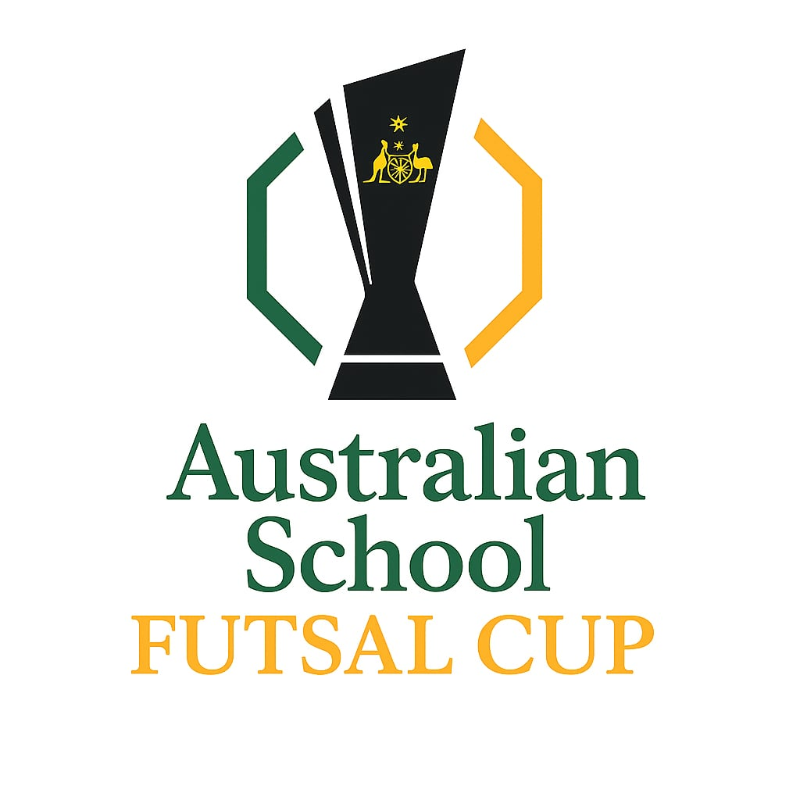

16th – 20th November
Coomera ISC, Gold Coast, Queensland

Table of Contents

Competition details | ……………………………………….. | 3
Tournament Format | ………………………………………… | 4
Sample Draw | ……………………………………….. | 5
Nominations | ………………………………………. | 7
Procedure and Rules | ……………………………………….. | 8
Match Rules | ……………………………………….. | 10
Costs | ……………………………………….. | 11
Referees / Results | ……………………………………….. | 12
Documents | ……………………………………….. | 13
Team / Squad Lists | ……………………………………….. | 14
Communication | ………………………………………. | 15
Staff | ………………………………………. | 16
Social media | ………………………………………. | 17
Sponsors | ………………………………………. | 18
Accommodation | ………………………………………. | 19
2025 QSF Calendar | ………………………………………. | 20

Competition Details

This is an Australian school 14 and 16 years, boys and girls

3 - 5 Day Futsal tournament organized be the QSF committee to bring together the best school Futsal teams in Australia.

The ASF Cup provides the opportunity for all schools to participate and compete against other schools within Australia, New Zealand and Asia

The 3-5 day tournament allows teams of differing levels to play each other on Day 1.

At the end of the round matches on Day 1 and 2, teams will then qualify for the “Cup” and “Shield” competition on Day 4 and 5. (rest day on Day 4)

The ASF Cup is open to all schools in Australia, New Zealand and Asia but restricted to a maximum of four Queensland Girls and Boys teams. As this is the inaugural ASF Cup, nominations will be open to all teams in other states in Australia with preference given to “overseas” teams

AGE GROUPS: Boys and Girls
14 Years - Students must be in Secondary School and cannot turn 15 or older in the year of competition.
16 Years - Students must be in Secondary School and cannot turn 17 or older in the year of competition.

Girls are allowed to play in the Boys divisions but only if the school has not entered a Girls team

ASF Cup & Shield - Tournament Format

5 Day QSF Cup Format
Once nominations are finalized, the 16 schools will be systematically placed in 2 Pools of 8 teams.
- The 16 teams will “randomly” be drawn at an online meeting and placed in 2 pools of 8 teams.
- Each team in their respective pools will play each other once over 3 days and then be ranked according to points from wins, draws and goal difference.
- Teams that finish in the top 4 places from the round matches will be placed in the ASF Cup competition.
- Teams that finish in 5th to 8th position from the round matches will be placed into the ASF Shield competition.
- Each team in the Cup and Shield competition on Day 5 will play elimination quarter finals, semifinals and Grand finals.
- The losing teams form the Quarter final and Semifinals will play consolation finals for medals and final positions.


DRAWS
The Draws for both the Boys and Girls ASF Cups will be made after nominations have been finalised, and available in Week 1, Term 3, 2026 on the QSF Website.

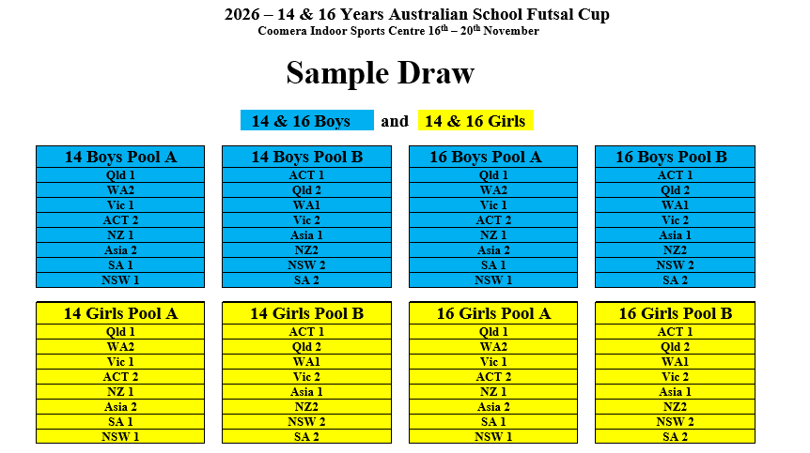

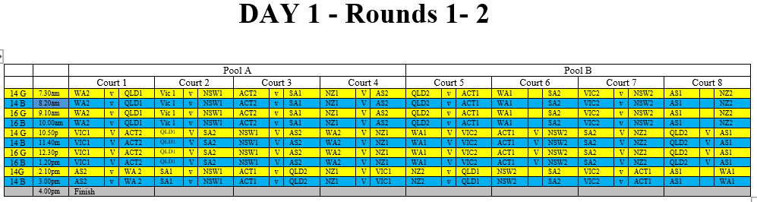

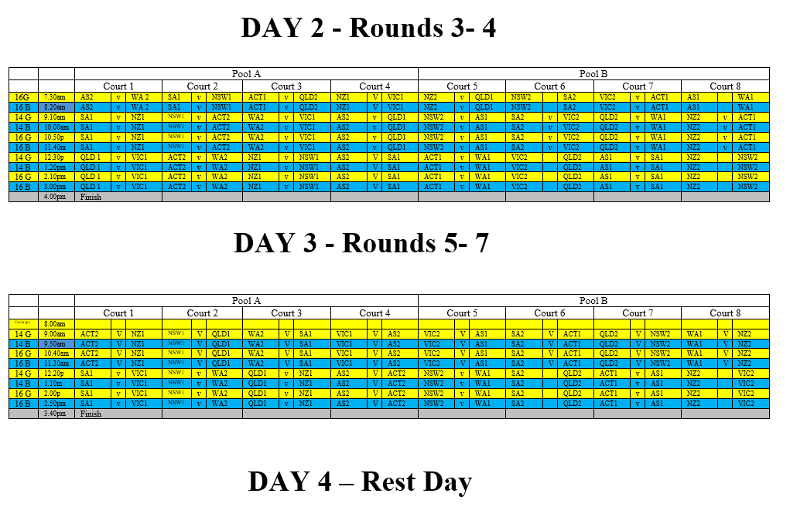

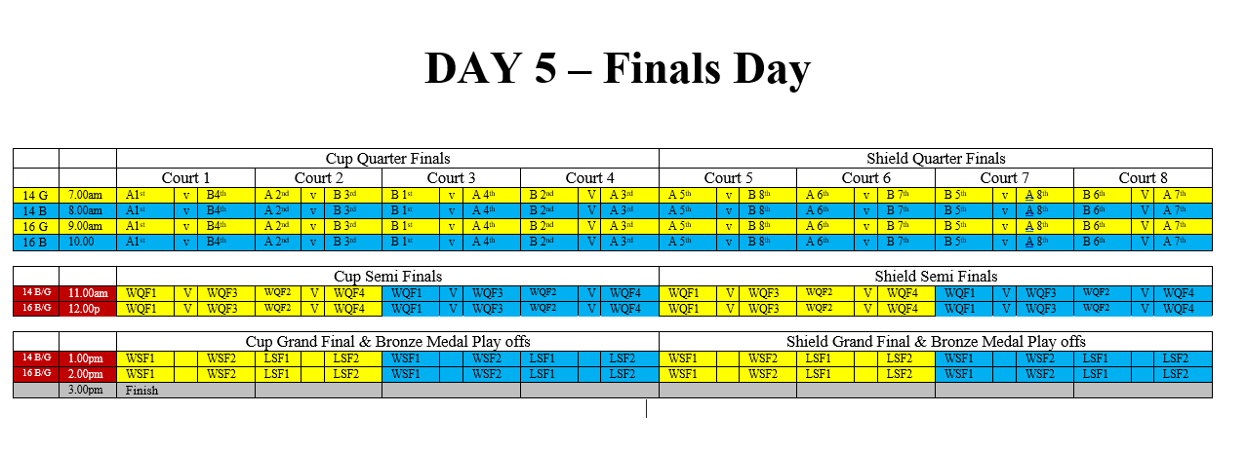

NOMINATIONS
Nomination forms are available on the QSF website (queenslandschoolfutsal.com)
Nominations close on Friday 26th June 2026
The 14 & 16 Years ASF Cup will have maximum of 16 Boys and 16 Girls teams. 4 of the positions will be allocated to the 4 Qld teams and the other 12 positions will be offered to the first 12 international or interstate teams to nominate.
If there are insufficient interstate teams nominating, then available positions will be offered to Regional Queensland school teams.
If there are more than 16 teams nominating, then schools nominating after the competition limits have been filled, will be placed on "Reserve" lists.

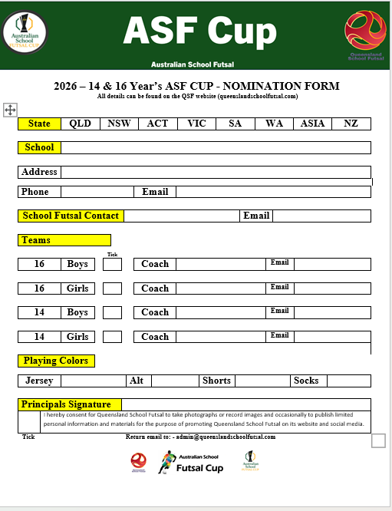
Procedures and Rules
1. | Each game shall consist of two periods of 20 minutes with 5 min half time break
2. | Normal "FIFA" Futsal rules will apply to all matches (except that the clock will not be stopped every time the ball goes out of play and restarted when play resumes)
3. | Teams are entitled to a one-minute time-out in each period. A team that does not request a time out in the first half of the match is only entitled to one time-out during the second half. Time outs can be taken at any time during both halves. The clock will stop for all timeouts. In the last 2 minutes of the match, if referees believe teams are wasting time intentionally, they have the right to stop the clock.
4. | A maximum of 10 players are allowed in each team on match day. (School squads can have a maximum of 24 players.)  All 10 players can be used in unlimited interchange. All substitutions are to be Rolling substitutions. Substitutions may be made at any time, whether the ball is in play or not, but only in the specially demarcated substitution zones. (Goalkeepers should only be substituted during a stoppage in play).
5. | Yellow Cards - Two yellow cards in the same game will mean the player is sent from the field an automatic suspension for the next game plus any punishment met by Disputes committee. Three yellow cards awarded in separate matches will also mean suspension of one match.  Red cards - Sent off and automatic suspension for next game plus any punishment meted by the Disputes committee.  (Dispute committee will be the gala day convenors and the referee coordinator)
6. | All players must wear non marking soled shoes, shin pads covered by long socks and matching numbered shirts and shorts (except goalkeepers). (referees can prevent players entering the court if not dressed correctly)  If there is a clash of colors, it is the "HOME" teams (first named on the draw) responsibility to have an alternate strip or wear bibs.
7. | Home teams will run left to right of the team benches and kick off all matches.
8. | Any Team not on court 5 mins after the scheduled kick off time will start with a 2-goal deficit. ie., 2 goals will automatically be awarded to the opposition. If there are circumstances out of the team’s control, then the match time will be reduced to allow a result
9. | If a match is drawn at full time in a Semi Final or Grand Final there will be two periods of 5 minutes extra time with no intervals or time outs, then FFA rules of penalty kicks to decide the winner. There are no time outs in “extra time”
10. | There will be a “10 Goal Max Goal difference for all results ie., a 16–1 result will be entered as 11-1.



https://assets.the-afc.com/downloads/referees/Futsal-Laws-of-the-Game-2024-25.pdf

COSTS

Schools will be invoiced by QSF once nominations are received in 2026

Approx $480 per team

(covers venue hire, referees, sports trainers, admin fees)
Competition Invoices will be sent as nominations are received and will then be finalised after nomination fees payment.

ACCOMMODATION PACKAGES

PRO-PLAYER can provide full tournament accommodation, transport, meals and activity packages – see link below


REFEREES

1 -2 Football Queensland Referees will be supplied for all matches.

DISCIPLINE COMMITTEE
A discipline committee of 3 teachers will be selected before the start of the season that will decide on all consequences from disciplinary reports. Incident report sheets can be found on the QSF Website and must be completed by both coaches and sent to the committee by the end of the following day after the match
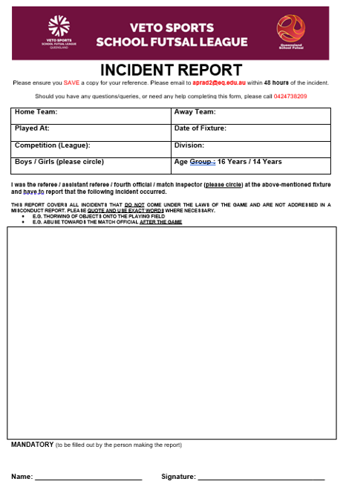
RESULTS and TABLES

All results for the tournament matches will be recorded on the Referee Match templates and then transferred to a Results sheet in the foyer of the venue.

There will be a “10 goal” max winning GD applied to all matches.

Results for all matches and updated tables can be found on QSF Website and results will be updated on the website.
A Disciplinary Spreadsheet to track “cautions” will be available on the QSF website.

TROPHIES, MEDALS and AWARDS
ASF Cup champions will receive a Perpetual Premiers trophy and a take-home trophy
Runners up and 3rd place getters will receive medals
ASF Cup Shield winners will receive the Veto Sports Perpetual trophies. Runners up and 3^{rd.} place getters will receive medals

DOCUMENTS
All ASF Cup documents can be found on the QSF Website page

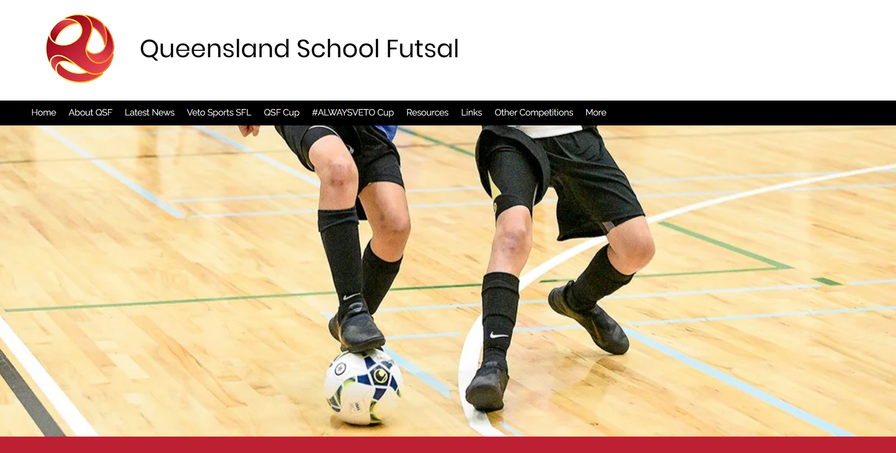

QSF Website – queenslandschoolfutsal.com

TEAM LISTS
It is requested that schools complete team and squad lists with names, birthdates and principals’ signature and send to
(admin@queenslandschoolfutsal.com)
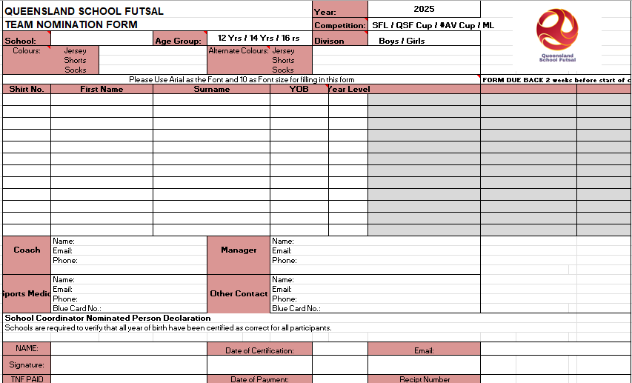
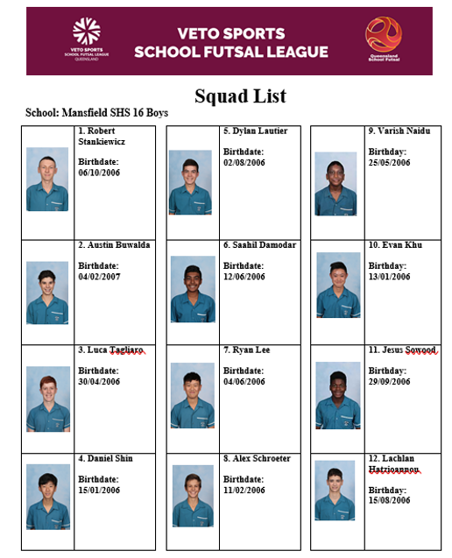
COMMUNICATION
All Coaches and managers are required to join for the ASF WhatsApp group for quick communication purposes before and during the season and will provide updated results, Contact points and news
(links will provided after nominations are confirmed)

QSF WhatsApp Group


STAFF
Competition Convenor Referee Coordinator
Alan Pradella Fiona Stevenson


Match Day Coordinators (admin@queenslandschoolfutsal.com)
Raul Ocan Villegas Gervais Morton


SOCIAL MEDIA
QSF has a Facebook page and Instagram account for results posts, videos and general advertising purposes. We would like everyone to invite school staff, students, parents and friends to follow the pages.
We also encourage coaches and managers to complete the “Player” and “Coach” Profiles and forward them to the QSF Social Media Coordinator – Matt Pickham at mpick68@eq.edu.au

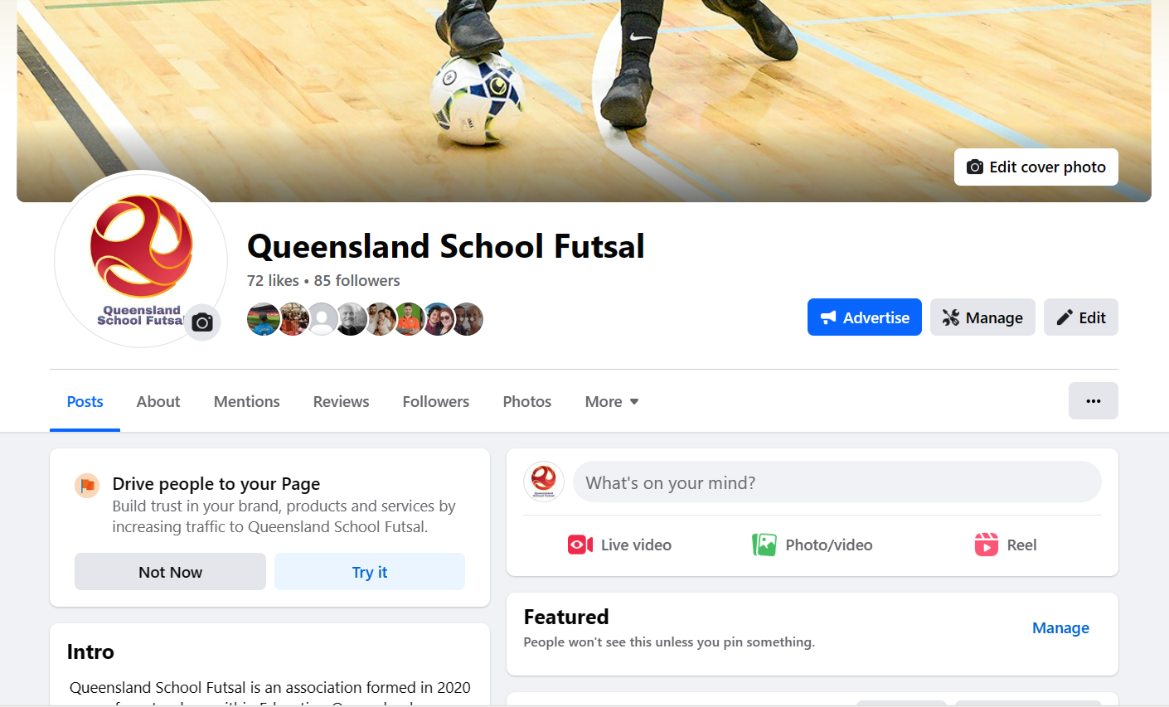



SPONSORS
VETO SPORTS, DEPLO, PRO-PLAYER FOOTBALL TOURS & FUTSAL KINGDOM are the official sponsors of the ASF Cup.






ACCOMMODATION PACKAGES

