2027
VETO SPORTS
SCHOOL FUTSAL LEAGUE

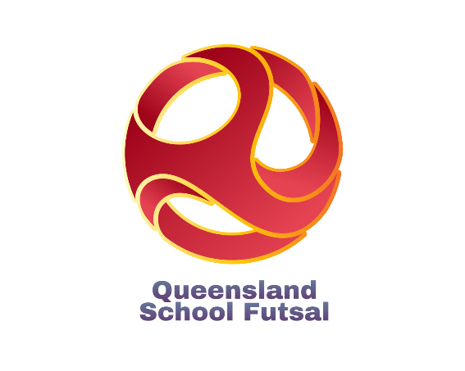

Information
(Updated 1st August) )
Table of Contents

Competition details | ……………………………………….. | 3
2026 Conference Pools & Finals
Open Years | ………………………………………… | 5
16 Years | ……………………………………….. | 7
14 Years | ……………………………………….. | 9
12 Years | ……………………………………….. | 11
Competition Dates
Central Conference | ………………………………………… | 19
Western Conference | ……………………………………….. | 20
Northern Conference | ……………………………………….. | 21
Southern Conference | ……………………………………….. | 22
Match Rules  Costs/ Referees | ………………………………………..  ……………………………………….. | 23  26
Draws and Results | ……………………………………….. | 27
Documents | ……………………………………….. | 28
Squad & Team Lists | ………………………………………. | 29
Communication | ………………………………………. | 31
Staff | ………………………………………. | 32
Social media | ………………………………………. | 33
Sponsors | ………………………………………. | 34
2027 QSF Calendar | ………………………………………. | 39
2027 Gala Day Dates | ………………………………………. | 40
Competition Details

The VETO SPORTS 2027 School Futsal League is a competition for Boys and Girls in four age divisions – 12, 14, 16 & Open divided into 2 Divisions – Premier League and League One.
The competition runs across 4 Conferences –
Central, Western, Northern & Southern
Each age division will be comprised of pools of 10 or 6 teams and will play “1 round of 9” or “2 rounds of 5” matches over 3 Gala Days (3 -4 Rounds per Gala Day).
There will be 1 Gala Day in terms 1, 2 & 3 & Finals in Term 4.
The Open & 14 Years and 16 & 12 Years Premier League & League One Boys and girl’s rounds will be designed to be grouped to be played together on the same Gala Days.
The Finals qualifying format will be dependent on the number of teams in each of the four conferences. (See following pages)

AGE GROUPS: Boys and Girls
12 Years (Students cannot turn 13 or older in 2027)
14 Years (Students cannot turn 15 or older in 2027)
16 Years (Students cannot turn 17 or older in 2027)
Opens (The open competition will play in Semester 1 only)
Note:
1. Girls cannot play in Boys divisions except in the 12 years age division and only if the school cannot field a girls’ team.
2. Players are allowed to play in more than ONE division for the season. ie., a 16 year can play in both the 16 years age division and the Open division etc.,

CONFERENCE PREMIERS & FINALS FORMAT:
Teams finishing first in each conference pool after the round matches will be crowned “Conference Premiers”.
The overall VETO SPORTS SFL Champions will be decided in each age group and division depending on the format of the individual conference pools.
If divisions have Teams in all 4 Conferences, teams finishing 1st & 2nd, 3rd & 4th & 5th & 6th in each pool will qualify for the VETO SPORTS SFL Champion, Shield & Plate finals respectively.
Finals formats will differ for divisions that do not contain pools in all “Four Conferences” (Finals format on pages 5-18)
NOMINATIONS:
Nomination forms are available on the QSF website. Nominations close at the end of Week 6 of Term 4, 2026.
(Year 12 Years competition close Week 3, Term 1, 2027)
All divisions will have a maximum of 10 or 6 Boys and Girls teams, so schools nominating after the competition limits have been filled, will be placed on "Reserve" lists.
Schools may nominate teams in any of the divisions, in all age brackets (i.e., a school can nominate a 14 Boys team in the Premier League and a separate 14 Boys team in League One) but schools can only nominate “One” team in each separate division (unless there are “Bye” positions).
Schools must supply 2 separate team lists and nominated League One players may play up in the Premier League but nominated Premier League players cannot play down. (If a registered PL player is found playing in a L1 team the team will forfeit the points)
After receiving all nominations, QSF will allocate teams from each age division into pools. Schools will then be given the right of reply to the organised divisions and rearrangement will occur if needed.
2026 OPEN BOYS (Premier League)

Northern |  | Southern |  | Western |  | Central
Albany Creek SHS |  | Coomera Anglican College |  | Kenmore SHS |  | Islamic College Brisbane
Bray Park SHS |  | Foxwell SSC |  | Ripley Valley SSC |  | Mabel Park SHS
Murrumba SSC |  | Men of Business Academy |  | St Peter Claver College |  | Mansfield SHS
 |  | Mullumbimby SHS |  |  |  | Redbank Plains SHS
 |  | Ormeau Woods SHS |  |  |  | St James College
 |  | St Andrew's College |  |  |  | Shailer Park SHS
Competition Format
Combine with L 1 |  | 1 Pool of 6 |  | Combine with L 1 |  | 1 Pool of 6
2 Pools of 6 |  | 2 Rounds of matches |  | 1 Pool of 10 |  | 2 Rounds of matches
10 Matches |  | 10 Matches |  | 1 Round of 9 Matches |  | 10 Matches
3 Gala Days |  | 3 gala Days |  | 3 Gala Days |  | 3 gala Days
Champions Finals Qualification
1st & 2nd |  | 1st & 2nd |  | 1st & 2nd |  | 1st & 2nd
Shield Finals Qualification
3rd |  | 3rd, 4th & 5th |  | 3rd |  | 3rd, 4th & 5th
Plate Finals Qualification
No Competition

Open Boys Premier – Competition & Finals Format
The Central and Southern Conference will play 2 rounds (10 matches) within 3 Gala days
The Northern Conference will combine with their L1 teams to make 2 pools of 6, and the
Western Conference will join their L1 teams to make a pool of 10 and play 9 matches
The teams finishing 1st and 2nd in ALL 4 Conferences will qualify for the Champions Finals.
Teams finishing 3rd, 4th & 5th in the Central & Southern Conference and 3rd in the Northern
and Western Conferences will qualify for the Shield Finals. There will be NO PLATE Finals.
2026 OPEN BOYS (League One)

Northern |  | Southern |  | Western |  | Central
Pool A |  | Beaudesert SHS |  | Woodridge SHS |  | Brisbane Adventist College
Albany Creek SHS (PL) |  | Kings College (Pimpama) |  | Bremer SHS |  | Calamvale CC
Beenleigh SHS |  | Kingscliff HS |  | Concordia Lutheran College |  | Kimberley College
Bray Park (PL) |  | Miami SHS |  | Darling Downs Adv College |  | Mabel Park SHS
Bribie Island SHS |  | Ormeau Woods SHS |  | Highfields SHS |  | Mansfield SHS
Good Samaritan Coll |  | Pimpama SSC |  | Kenmore SHS (PL) |  | Mt Gravatt SHS
Murrumba SSC (PL) |  |  |  | Lowood SHS |  | Bye
Pool B |  |  |  | Loganlea SHS |  | Rochedale SHS
Bray Park SHS |  |  |  | Ripley Valley SSC (PL) |  | St James College
Fortitude Valley SSC |  |  |  | St Peter Claver (PL) |  | Wisdom College
Indooroopilly SHS
James Nash SHS
Brisbane South SSC
Redlands College
Competition Format
Combine with PL |  | 1 Pool of 6 |  | Combine with PL |  | 1 Pool of 10
2 Pools of 6 |  | 2 Rounds of matches |  | 1 Pool of 10 |  | 1 Rounds of matches
2 Rnds of matches |  | 10 Matches |  | 1 Round of 9 Matches |  | 9 Matches
3 Gala Days |  | 3 gala Days |  | 3 Gala Days |  | 3 gala Days
Champions Finals Qualification
1st in each Pool |  | 1st & 2nd |  | 1st & 2nd |  | 1st & 2nd
Shield Finals Qualification
2nd in each Pool |  | 3rd & 4th |  | 3rd & 4th |  | 3rd & 4th
Plate Finals Qualification
3rd in each Pool |  | 5th & 6th |  | 5th & 6th |  | 5th & 6th

Open Boys League One - Finals Format
The Central Conference will play 9 matches & Southern Conference will play 2 rounds (10 matches) within 3 Gala days. The Northern Conference will combine with their PL teams to make 2 pools of 6, and the Western Conference will join their PL teams to make a pool of 10 and play 9 matches within 3 Gala Days. The teams finishing 1st and 2nd in the Central, Southern and Western Conferences and 1st in the two Northern pools will qualify for the Champions Finals. The teams finishing 3rd & 4th in the Central, Southern and Western Conferences and 2nd in the two Northern pools will qualify for the Shield Finals. The teams finishing 5th & 6th in the Central, Southern and Western Conferences and 3rd the two Northern pools will qualify for the Plate Finals

2026 OPEN Girls (Premier League)

Northern |  | Southern |  | Western |  | Central
Albany Creek SHS |  | Coomera Anglican College |  | Lowood SHS |  | Kimberley College
 |  | Mullumbimby SHS |  | St Ursula's College
Open Girls Premier - Finals Format
Competition Format
Combine with L1 |  | Combine with L1 |  | Combine with Nth L1 |  | Combine with L1
1 Pools of 6 |  | 1 Rounds of matches |  | 1 Pool of 6 |  | 1 Pool of 10
2 Rounds of matches |  | 4 Matches |  | 2 Round of Matches |  | 1 Round of Matches
10 Matches |  | 1 Gala Day |  | 10 Matches |  | 9 matches
3 Gala Days |  |  |  | 3 Gala Days |  | 3 Gala Days
Champions Finals Qualification
Albany Creek |  | 1st & 2nd |  | 1st & 2nd |  | Kimberley Coll
Shield Finals Qualification
No Competition
Plate Finals Qualification
No Competition

Open Girls Premier League - Finals Format
The Southern Conference will combine with their L1 teams to make a pool of 4 & play 1 Gala Day. The Northern and Western PL teams will combine with their L1 teams in pools of 6. The Central Conference only had 1 PL nomination, so Kimbereley College will play in the Central L1 and will only qualify if they finish 1st in the Pool of 10 teams. The Southern teams will play for 1st & 2nd positions and qualify for the Champions Finals. 6 Teams (1 Central, 2 Southern, 2 Northern & 1 Western will qualify for the Champions Finals There will be NO SHIELD OR PLATE FINALS
2026 OPEN Girls (League One)

Northern |  | Southern |  | Western |  | Central
Redlands College |  | Coomera AC (PL) |  | Woodridge SHS |  | Redeemer L College
Lowood SHS (PL) |  | Mullumbimby HS (PL) |  | St Ursulas Coll (PL) |  | St James College
Albany Creek (PL) |  | Ormeau Woods |  | Ripley Valley SSC |  | BYE
Fortitude Valley SSC |  | Pimpama SSC |  | Bremer SHS |  | Wisdom College
Good Samaritan Coll |  |  |  | Bye |  | Calamvale CC
Brisbane South SSC |  |  |  | Darling Downs C Coll |  | Kimberley Coll (PL)
 |  |  |  |  |  | Islamic Coll Brisbane
 |  |  |  |  |  | Rochedale SHS
 |  |  |  |  |  | Bris Adv College
 |  |  |  |  |  | Mansfield SHS
Competition Format
Combine with PL |  | Combine with PL |  | Combine with PL |  | Combine with PL
1 Pools of 6 |  | 1 Rounds of matches |  | 1 Pool of 6 |  | 1 Pool of 10
2 Rounds of matches |  | 4 Matches |  | 2 Round of Matches |  | 1 Round of Matches
10 Matches |  | 1 Gala Day |  | 10 Matches |  | 9 matches
3 Gala Days |  |  |  | 3 Gala Days |  | 3 Gala Days
Champions Finals Qualification
1st & 2nd |  | 1st & 2nd |  | 1st & 2nd |  | 1st & 2nd
Shield Finals Qualification
3rd & 4th |  |  |  | 2nd & 3rd |  | 3rd, 4th , 5th & 6th
Plate Finals Qualification
No Competition

Open Girls League One - Finals Format
The Southern Conference will combine with their PL teams to make a pool of 4 & play 1 Gala Day. The Northern and Western L1 teams will combine with their PL teams in pools of 6. The Western and Northern Conference Pools with 6 teams will play 10 round within 3 Gala days. The Southern teams will play for 1st & 2nd positions and qualify for the Champions Finals. The teams finishing 1st & 2nd in the Central, Northern & Western Conference Pools will qualify for the Champions Finals.
Teams finishing 3rd, 4th, 5th & 6th in the Central, 3rd & 4th in the Western and Northern will qualify for Shield Finals. There will be NO PLATE FINALS

2026 - 16 BOYS (Premier League)

Northern |  | Southern |  | Western |  | Central
Albany Creek SHS |  | Beaudesert SHS |  | Kenmore SHS |  | Brisbane Adventist College
Murrumba SSC |  | Coomera Anglican College |  | Ripley Valley SSC |  | Islamic Coll Brisbane
Redcliffe SHS |  | Foxwell SSC |  | St Peter Claver College |  | Mabel Park SHS
 |  | Helensvale SHS |  |  |  | Mansfield SHS
 |  | Kings College |  |  |  | Bye
 |  | Livingstone College |  |  |  | Bye
 |  | Ormeau Woods SHS
 |  | St Andrews College
 |  | Tweed River HS
 |  | Bye

Competition Format
Combine with L1 |  | Pool of 10 |  | Combine with L1
1 Pools of 10 |  | 1 Rounds of matches |  | 2 Pools of 6 |  | 1 Pool of 4
1 Rounds of matches |  | 9 Matches |  | 2 Round of Matches |  | 1 Round of Matches
9 Matches |  | 3 Gala Day |  | 10 Matches |  | 3 matches
3 Gala Days |  |  |  | 3 Gala Days |  | 1 Gala Days
Champions Finals Qualification
1st & 2nd |  | 1st & 2nd |  | 1st & 2nd |  | 1st & 2nd
Shield Finals Qualification
3rd |  | 3rd, 4th ,5th & 6th |  | 3rd |  | 3rd & 4th
Plate Finals Qualification
No Competition

16 Boys Premier - Finals Format
The 3 Northern teams and 3 Western teams will combine with the Northern L1 teams and Western L1 teams to play in a pool of 10 teams and 2 pools of 6 (resp). All Pools will play 3 Gala days – 10 team pool - 9 rounds / 6 team pools – 10 rounds (2 rounds of 5).
Teams finishing 1st and 2nd in all 4 Conference will qualify for the Champions Finals. Teams finishing 3rd in the Northern & Western Conference, 3rd & 4th in the Central and 3rd, 4th,5th &6th in the Southern will qualify for the Shield.
There will be no Plate Competition.
2026 16 BOYS (League One)

Northern |  | Southern |  | Western |  | Central
Albany Creek SHS (PL) |  | Ballina Coast HS |  | Bellbird Park SHS |  | Aust Christ College
Bribie Island SHS |  | Coomera Anglican College |  | Brisbane South SSC |  | Brisbane Adventist College
Clayfield College |  | Helensvale SHS |  | Bremer SHS |  | Calamvale CC
Fortitude Valley SSC |  | Hillcrest College |  | Concordia Lutheran College |  | Redeemer College
Good Samaritan College |  | Kingscliff HS |  | Ripley Valley SSC |  | Mansfield SHS
Indooroopilly SHS |  | Luth Ormeau Rivers District |  | Loganlea SHS |  | Rochedale SHS
Kedron SHS |  | Mullumbimby HS |  | St Johns Ang Coll |  | St James College
Murrumba SSC (PL) |  | Ormeau Woods SHS |  | Ripley Valley SSC (PL) |  | Wisdom College
Redcliffe SHS (PL) |  | Pimpama SSC |  | Kenmore SHS (PL) |  | Bye
Kimberley College |  | Coombabah SHS |  | St Peter Cl Coll (PL) |  | Highfields SHS
Competition Format
Combine with PL |  | Pool of 10 |  | Combine with PL
1 Pools of 10 |  | 1 Rounds of matches |  | 2 Pools of 6 |  | 1 Pool of 10
1 Rounds of matches |  | 9 Matches |  | 2 Round of Matches |  | 1 Round of Matches
9 Matches |  | 3 Gala Days |  | 10 Matches |  | 9 matches
3 Gala Days |  |  |  | 3 Gala Days |  | 3 Gala Days
Champions Finals Qualification
1st & 2nd |  | 1st & 2nd |  | 1st & 2nd |  | 1st & 2nd
Shield Finals Qualification
3rd & 4th |  | 3rd & 4th |  | 3rd & 4th |  | 3rd & 4th
Plate Finals Qualification
5th & 6th |  | 5th & 6th |  | 5th & 6th |  | 5th & 6th

16 Boys League One - Finals Format
All 5 Pools will play 3 Gala days – 10 team pool - 9 rounds / 6 team pools – 10 rounds (2 rounds of 5). Teams finishing 1st and 2nd in all conferences will qualify for the Champions Finals.
Teams finishing 3rd & 4th in all conference pools will qualify for the Shield finals.
Teams finishing 5th & 6th in all conference pools will qualify for Plate finals. Teams finishing below those position will not qualify for Finals and will be refunded for finals day fees.

2026 - 16 Girls (Premier League)

Northern |  | Southern |  | Western |  | Central
Albany Creek SHS |  | Pimpama SSC |  | Albany Creek SHS
Murrumba SSC |  | Livingstone Coll |  | Kenmore SHS
 |  | St Andrews Coll |  | Murrumba SSC
 |  |  |  | Ripley Valley SSC
 |  |  |  | St Peter Claver College
 |  |  |  | St Ursula's College

Competition Format
North C to join West C |  | Combine with L1 |  | Combine with NC |  | No teams
 |  | 2 Pools of 6 |  | 1 Pool of 6
 |  | 2 rounds of Matches |  | 2 Rounds of Matches
 |  | 10 Matches |  | 10 Matches
 |  | 3 Gala days |  | 3 Gala Days
Champions Finals Qualification
 |  | 1st ,2nd & 3rd |  | 1st ,2nd ,3rd, 4th & 5th
Shield Finals Qualification
No Competition
Plate Finals Qualification
No Competition

16 Girls Premier - Finals Format
The 2 Northern PL teams will combine with the 4 Western PL teams to play in the Western Conference pool. The Southern PL teams will join the L1 teams and make 2two pools of 6. Both Pools will then play 3 Gala days – 6 team pools – 10 rounds (2 rounds of 5). Teams finishing 1st, 2nd, 3rd , 4th & 5th in the Western/Northern and the three PL teams from the Southern Conferences pools will qualify for the Champions Finals. There will be no Shield or Plate Final.

2026 - 16 Girls (League One)

Northern |  | Southern |  | Western |  | Central
 |  | Pool A |  | Bye |  | Australian C College
 |  | Mullumbimby HS |  | Brisbane South SSC |  | Brisbane Adventist College
 |  | Hillcrest College |  | Bremer SHS |  | Calamvale CC
 |  | Kingscliff HS |  | Indooroopilly SHS |  | Redeemer College
 |  | Helensvale SHS |  | St Johns Anglican College |  | Islamic College Brisbane
 |  | Pimpama SSC (PL) |  | Ripley Valley SSC |  | Mansfield SHS
 |  | St Andrews Coll (PL) |  |  |  | Rochedale SHS
 |  | Pool B |  |  |  | St James College
 |  | Loganlea SHS |  |  |  | St Saviours College
 |  | Livingstone Coll (PL) |  |  |  | Wisdom College
 |  | Ballina Coast HS
 |  | Beaudesert SHS
 |  | Ormeau Woods
 |  | Tweed River HS
Competition Format
No Teams |  | Combine with PL
 |  | 2 Pools of 6 |  | 1 Pool of 6 |  | 1 Pool of 10
 |  | 2 Rounds of matches |  | 2 Round of Matches |  | 1 Round of Matches
 |  | 10 Matches  3 |  | 10 Matches |  | 9 matches
 |  | 3 Gala Days |  | 3 Gala Days |  | 3 Gala Days
Champions Finals Qualification
 |  | 1st ,2nd from each pool |  | 1st & 2nd |  | 1st & 2nd
Shield Finals Qualification
 |  | 3^{rd &} 4th from each pool pool |  | 3rd & 4th |  | 3rd & 4th
Plate Finals Qualification
No Competition

16 Girls League One - Finals Format
The Central Conference Pools will play 3 Gala days – 9 rounds. The 2 Southern pools and the Western pool will play 2 rounds – 10 matches. Teams finishing 1st & 2nd in each of the pools will qualify for the Champions Finals. Teams finishing 3rd & 4th from each pool will qualify for the Shield Finals. There will be NO Plate Final.

2026 - 14 BOYS (Premier League)

Northern |  | Southern |  | Western |  | Central
Albany Creek SHS |  | Coomera Anglican College |  | Ripley Valley SSC |  | Islamic College Brisbane
Woodridge SHS |  | Helensvale SHS |  | St Peter Claver College |  | Kimberley College
Good Samaritan College |  | Kings College |  |  |  | Mabel Park SHS
Grace College |  | Lutheran Ormeau Rivers |  |  |  | Mansfield SHS
Murrumba SSC |  | Ormeau Woods SHS |  |  |  | Shailer Park SHS
Redlands College |  | Pimpama SSC |  |  |  | Wisdom College
 |  | St Andrews College
 |  | St Stephens college
 |  | Mullumbimby HS
 |  | CAC2

Competition Format
 |  | 1 Pool of 10 |  | Combine with L1
1 Pools of 6 |  | 1 Rounds of matches |  | 1 Pool of 10 |  | 1 Pool of 6
2 Rounds of matches |  | 9 Matches |  | 1 Round of Matches |  | 2 Round of Matches
10 Matches |  | 3 Gala Days |  | 9 Matches |  | 10 matches
3 Gala Days |  |  |  | 3 Gala Days |  | 3 Gala Days
Champions Finals Qualification
1st & 2nd |  | 1st & 2nd |  | 1st & 2nd |  | 1st & 2nd
Shield Finals Qualification
3rd & 4th |  | 3rd, 4th 5th & 6th |  |  |  | 3rd & 4th
Plate Finals Qualification
5th & 6th |  | 7th 8th, 9th & 10th |  |  |  | 5th & 6th

14 Boys Premier - Finals Format
The 2 Western PL teams will play in the Western L1 competition. All 3 PL Pools will play 3 Gala days – 10 team pool - 9 rounds / 6 team pools – 10 rounds (2 rounds of 5). Teams finishing 1st, 2nd in the Northern, Southern and Central pools and the two Western PL Teams will qualify for the Champions Finals.
Teams finishing 3rd & 4th in the Northern & Central Pool and teams finishing 3rd, 4th 5th & 6th in the Southern Pools will qualify for the Shield. Teams finishing 5th & 6th in the Northern & Central pools and teams finishing 7th, 8th, 9th & 10th in the Southern Pool will qualify for the Plate Finals.
2026 - 14 BOYS (League One)

Northern |  | Southern |  | Western |  | Central
Beenleigh SHS |  | POOL A |  | Bellbird Park SHS |  | Brisbane Adventist College
Clayfield College |  | Bye |  | Bremer SHS |  | Calamvale CC
Bribie Island SHS |  | Beaudesert SHS |  | Concordia Lutheran College |  | Calamvale CC 13s
Fortitude Valley SSC |  | Coomera Anglican College |  | Darling Downs Adv College |  | Kimberley College
Good Samaritan College |  | Foxwell SSC |  | Kenmore SHS |  | Mansfield SHS
Indooroopilly SHS |  | Helensvale SHS |  | Lowood SHS |  | Redbank Plains SHS
James Nash SHS |  | Hillcrest College |  | St Johns Anglican College |  | Redeemer College
Mt Gravatt SHS |  | POOL B |  | Ripley Valley SSC (PL) |  | Bye
Brisbane South SSC |  | Kings College |  | Ripley Valley SSC |  | Rochedale SHS
Murrumba SSC |  | Kingscliff HS |  | St Peter Cl Coll (PL) |  | St James College
 |  | Mullumbimby HS
 |  | Ormeau Woods SHS
 |  | Pimpama SSC
 |  | St Stephens College
Competition Format
 |  | 2 Pools of 6 |  | Combine with PL
1 Pools of 10 |  | 2 Rounds of matches |  | 1 Pool of 10 |  | 1 Pool of 10
1 Rounds of matches |  | 10 Matches |  | 1 Round of Matches |  | 1 Round of Matches
9 Matches |  | 3 Gala Day |  | 9 Matches |  | 9 matches
3 Gala Days |  |  |  | 3 Gala Days |  | 3 Gala Days
Champions Finals Qualification
1st & 2nd |  | 1st in each pool |  | 1st & 2nd |  | 1st & 2nd
Shield Finals Qualification
3rd & 4th |  | 2nd in each pool |  | 3rd & 4th |  | 3rd & 4th
Plate Finals Qualification
5th & 6th |  | 3rd in each pool |  | 5th & 6th |  | 5th & 6th

14 Boys League One - Finals Format
The Southern conference will be divided into 2 pools of 6. All 5 Pools will play 3 Gala days – 10 team pool - 9 rounds / 6 team pools – 10 rounds (2 rounds of 5). (continued next page)
Teams finishing 1st and 2nd in the Northern, Western and Central conferences and teams finishing 1st in each of the Southern Conference pools will qualify for the Champions Finals.
Teams finishing 3rd and 4th in the Northern, Western and Central conferences and teams finishing 2nd in each of the Southern Conference pools will qualify for the Shield Finals. Teams finishing 5th and 6th in the Northern, Western and Central, 3rd in each of the Southern pools will qualify for the Plate Finals. Teams that do not qualify for Finals and will be refunded for finals day fees.

2026 - 14 Girls (Premier League)

Northern |  | Southern |  | Western |  | Central
Albany Creek SHS |  | Coomera Anglican College |  | Kenmore SHS
Good Samaritan College |  | Kings College |  | Ripley Valley SSC
Murrumba SSC |  | Ormeau Woods SHS |  | St Ursula's College
 |  | Pimpama SSC

Competition Format
Combine with L1 |  |  |  | Combine with L1 |  | No teams
1 Pools of 10 |  | 1 Rounds of matches |  | 1 Pool of 10
1 Rounds of matches |  | 3 Matches |  | 1 Round of Matches
9 Matches |  | 1 Gala Day |  | 9 Matches
3 Gala Days |  |  |  | 3 Gala Days
Champions Finals Qualification
1st ,2nd |  | 1st ,2nd |  | 1st ,2nd |  | + two BP 3rds
Shield Finals Qualification
No Competition
Plate Finals Qualification
No Competition

14 Girls Premier - Finals Format
The 3 Western PL teams and the 3 Northern PL teams will combine to play with the Western L1 & Northern L1 teams to play in pools of 10. The Southern Conference Pools will play 1 Gala Day to decide positions. The top 2 teams in the Southern conference and the 2 highest placed Northern & Western PL teams and the two best placed 3rd s from the 3 conferences will qualify for the Champions Finals.
There will be no Shield or Plate Finals.
2026 - 14 Girls (League One)

Northern |  | Southern |  | Western |  | Central
Brisbane South SSC |  | Beaudesert SHS |  | Bye |  | Brisbane Adventist College
Bribie Island SHS |  | Foxwell SSC |  | Bremer SHS |  | Calamvale CC
Fortitude Valley SSC |  | Helensvale SHS |  | Darling Downs Adv College |  | Islamic College Brisbane
Good Samaritan College |  | Hillcrest College |  | Lowood SHS |  | Kimberley College
St Saviours College |  | Kings College |  | Ripley Valley SSC |  | Mabel Park SHS
Mt Gravatt SHS |  | Kingscliff HS |  | St Johns Anglican College |  | Mansfield SHS
Albany Creek SHS (PL) |  | Luth Ormeau Rivers District |  | St Peter Claver College |  | Bye
Good Sam Coll (PL) |  | Mullumbimby HS |  | Ripley Valley SSC (PL) |  | Rochedale SHS
Murrumba SSC (PL) |  | Ormeau Woods SHS |  | St Ursulas Coll (PL) |  | St James College
Redlands College |  | Bye |  | Kenmore SHS (PL) |  | Wisdom College
Competition Format
Combine with PL |  | 1 Pool of 10 |  | Combine with PL
1 Pools of 10 |  | 1 Rounds of matches |  | 1 Pool of 10 |  | 1 Pool of 10
1 Rounds of matches |  | 9 Matches |  | 1 Round of Matches |  | 1 Round of Matches
9 Matches |  | 3 Gala Day |  | 9 Matches |  | 9 matches
3 Gala Days |  |  |  | 3 Gala Days |  | 3 Gala Days
Champions Finals Qualification
1st & 2nd |  | 1st & 2nd |  | 1st & 2nd |  | 1st & 2nd
Shield Finals Qualification
3rd & 4th |  | 3rd & 4th |  | 3rd & 4th |  | 3rd & 4th
Plate Finals Qualification
5th & 6th |  | 5th & 6th |  | 5th & 6th |  | 5th & 6th

14 Girls League One - Finals Format
All 4 Pools will play 3 Gala days – 10 team pool - 9 rounds / 6 team pools – 10 rounds (2 rounds of 5). Teams finishing 1st and 2nd pools will qualify for the Champions Finals. Teams finishing 3rd & 4th in each of the pools qualify for the Shield finals.
Teams finishing 5th & 6th in the pools qualify for Plate finals.

2026 - 12 BOYS (Premier League & League One)

Northern |  | Southern |  | Western |  | Central
Brighton SS (L1) |  | Coomera Anglican (PL) (PL)College |  |  |  | Islam Coll Bris (L1)
Carole Park SS (L1) |  | Kings College (PL) |  |  |  | Eatons Hill SS (PL)
Bye |  | Lutheran Ormeau (PL) (PL)Rivers |  |  |  | Eatons Hill SS (L1)
Bremer SHS (L1) |  | St Andrews Coll (PL) |  |  |  | Brisb Adv Coll (L1)
Ripley Valley SSC (PL) |  | Hillcrest College (L1) |  |  |  | Ithaca SS (L1)
Fortitude Vall SSC (L1) |  | Pimpama SSC (L1) |  |  |  | Calamvale CCC (L1)
 |  | Coomera AC (L1) |  |  |  | St James Coll (L1)
 |  | Kings College (L1) |  |  |  | Wisdom Coll (L1) (L1)(L1)
 |  | St Andrews Coll (L1) |  |  |  | Good Sam Coll (L1)
 |  | Gold Coast CC (L1) |  |  |  | Redeemer College
Competition Format
PL & L1 Combined |  | PL & L1 Combined |  | Combined with North |  | PL & L1 Combined
1 Pools of 6 |  | 1 Pool of 10 |  |  |  | 1 Pool of 10
2 Rounds of matches |  | 1 Round of Matches |  |  |  | 1 Round of Matches
10 Matches |  | 9 matches |  |  |  | 9 matches
3 Gala Days |  | 3 Gala Days |  |  |  | 3 Gala Days
Champions Finals Qualification
1st & 2nd |  | 1st ,2nd & 3rd |  |  |  | 1st ,2^{n} & 3rd
Shield Finals Qualification
3rd & 4th |  | 4th, 5th & 6th |  |  |  | 4th, 5th & 6th
Plate Finals Qualification
5th |  | 7th ,8th ,9th & 10th |  |  |  | 7th, 8th & 9th

12 Boys Premier League and League One - Finals Format
All 3 Pools will play 3 Gala days – 10 team pool - 9 rounds / 6 team pools – 10 rounds (2 rounds of 5).
All PL and L1 teams will play each other and then according to final positions will qualify for the Champions, Shield ad Plate Finals.

2026 - 12 Girls (Premier League & League One)

Northern |  | Southern |  | Western |  | Central
 |  | Bye |  |  |  | Brisbane Adv College
 |  | Coomera Ang College |  |  |  | Islamic College Brisbnae
 |  | Hillcrest College (L1) |  |  |  | Ithaca SS
 |  | Kings College (L1) |  |  |  | Wisdom College
 |  | Luth Ormeau Rivers D (L1) |  |  |  | St James College
 |  | Coomera Ang College (L1) |  |  |  | Eatons Hill SS
 |  |  |  |  |  | Eatons Hill SS (L1)
 |  |  |  |  |  | Redeemer College
 |  |  |  |  |  | Australian Christian College
 |  |  |  |  |  | Good Samaritan College

Competition Format
No teams |  | PL & L1 Combined |  | No Teams |  | PL & L1 Combined
 |  | 1 Pool of 6 |  |  |  | 1 Pool of 10
 |  | 2 Rounds of Matches Matches |  |  |  | 1 Round of Matches
 |  | 10 Matches |  |  |  | 9 matches
 |  | 3 Gala days |  |  |  | 3 Gala Days
Champions Finals Qualification
 |  | 1st ,2nd, 3rd & 4th |  |  |  | 1st ,2nd, 3rd & 4th
Shield Finals Qualification
 |  | 5th |  |  |  | 5th, 6th ,7th, 8th & 9th
Plate Finals Qualification
No Competition

12 Girls League One - Finals Format
Both Southern and Central Conferences will play 3 Gala days – 10 team pool - 9 rounds / 6 team pools – 10 rounds (2 rounds of 5).
All PL and L1 teams will play each other and then according to final positions will qualify for the Champions, Shield Finals. There will be no Plate Finals

Competition Dates

Central Conference Details
VENUE: Nissan Arena Indoor Sports Centre – Mains Rd Macgregor
DATES: TBC Week 8, 2026
14 Years
PL & L1 | B & G | Grading Day | Thursday | 11th February
PL & L1 | B & G | Gala Day 1 | Thursday | 18th February
PL & L1 | B & G | Gala Day 2 | Wed | 28th April
PL & L1 | B & G | Gala Day 3 | Wed | 11th August
 |  | Final Days | Tue-Thurs | 26 -28th Oct
Opens
PL & L1 | B & G | Grading Day | Thursday | 11th February
PL & L1 | B & G | Gala Day 1 | Thursday | 18th February
PL & L1 | B & G | Gala Day 2 | Friday | 12th March
PL & L1 | B & G | Gala Day 3 | Wed | 28th April
 |  | Finals Days | Wed-Thur | 26-28th May
12 Years
PL & L1 | B & G | Grading Day | Thursday | 11th February
PL & L1 | B & G | Gala Day 1 | Weds | 17th March
PL & L1 | B & G | Gala Day 2 | Thurs | 20th May
PL & L1 | B & G | Gala Day 3 | Thurs | 19th August
 |  | Finals Days | Mon | 18th Oct
16 Years
PL & L1 | B & G | Grading Day | Thursday | 11th February
PL & L1 | B & G | Gala Day 1 | Weds | 17th March
PL & L1 | B & G | Gala Day 2 | Thurs | 20th May
PL & L1 | B & G | Gala Day 3 | Thurs | 19th August
 |  | Finals Day | Thurs-Fri | 21-22nd Oct

Western Conference Details
VENUE: Nissan Arena Indoor Sports Centre – Mains Rd Macgregor

DATES: TBC Week 8, 2026
14 Years
PL & L1 | B & G | Grading Day | Friday | 12th February
PL & L1 | B & G | Gala Day 1 | Wed | 17th February
PL & L1 | B & G | Gala Day 2 | Tues | 27th April
PL & L1 | B & G | Gala Day 3 | Thursday | 12th August
 |  | Final Days | Tue-Thurs | 26 -28th Oct
Opens
PL & L1 | B & G | Grading Day | Friday | 12th February
PL & L1 | B & G | Gala Day 1 | Wed | 17th February
PL & L1 | B & G | Gala Day 2 | Thurs | 11th March
PL & L1 | B & G | Gala Day 3 | Tues | 27th April
 |  | Finals Days | Wed-Thur | 26-28th May
12 Years
PL & L1 | B & G | Grading Day | Friday | 12th February
PL & L1 | B & G | Gala Day 1 | Monday | 15th March
PL & L1 | B & G | Gala Day 2 | Tuesday | 18th May
PL & L1 | B & G | Gala Day 3 | Tues | 17th August
 |  | Finals Days | Mon | 18th Oct
16 Years
PL & L1 | B & G | Grading Day | Friday | 12th February
PL & L1 | B & G | Gala Day 1 | Monday | 15th March
PL & L1 | B & G | Gala Day 2 | Tuesday | 18th May
PL & L1 | B & G | Gala Day 3 | Tues | 17th August
 |  | Finals Day | Thurs-Fri | 21-22nd Oct

Northern Conference Details
VENUE: Caloundra ISC – North St, Golden Beach
DATES: TBC Week 8, 2026
14 Years
PL & L1 | B & G | Grading Day | Tuesday | 9th February
PL & L1 | B & G | Gala Day 1 | Wednesday | 17th February
PL & L1 | B & G | Gala Day 2 | Tuesday | 27th April
PL & L1 | B & G | Gala Day 3 | Thursday | 22nd July
 |  | Final Days | Tue-Thurs | 26 -28th Oct
Opens
PL & L1 | B & G | Grading Day | Tuesday | 9th February
PL & L1 | B & G | Gala Day 1 | Thursday | 18th February
PL & L1 | B & G | Gala Day 2 | Tuesday | 10th March
PL & L1 | B & G | Gala Day 3 | Wednesday | 28th April
 |  | Finals Days | Wed-Thur | 26-28th May
12 Years
PL & L1 | B & G | Grading Day | Tuesday | 9th February
PL & L1 | B & G | Gala Day 1 | Tuesday | 16th March
PL & L1 | B & G | Gala Day 2 | Wednesday | 19th May
PL & L1 | B & G | Gala Day 3 | Wednesday | 18th August
 |  | Finals Days | Mon | 18th Oct
16 Years
PL & L1 | B & G | Grading Day | Tuesday | 9th February
PL & L1 | B & G | Gala Day 1 | Fri | 19th February
PL & L1 | B & G | Gala Day 2 | Thursday | 29th April
PL & L1 | B & G | Gala Day 3 | Tuesday | 10th August
 |  | Finals Day | Thurs-Fri | 21-22nd Oct

Southern Conference Details
VENUE: Coomera Indoor Sports Centre – Beattie Rd Coomera
DATES: TBC Week 8, 2026
14 Years
PL & L1 | B & G | Grading Day | Wednesday | 10th February
PL & L1 | B & G | Gala Day 1 | Tuesday | 16th February
PL & L1 | B & G | Gala Day 2 | Friday | 30th April
PL & L1 | B & G | Gala Day 3 | Mon | 9th August
 |  | Final Days | Tue-Thurs | 26 -28th Oct
Opens
PL & L1 | B & G | Grading Day | Wednesday | 10th February
PL & L1 | B & G | Gala Day 1 | Tuesday | 16th February
PL & L1 | B & G | Gala Day 2 | Tuesday | 9th March
PL & L1 | B & G | Gala Day 3 | Friday | 30th April
 |  | Finals Days | Wed-Thur | 26-28th May
12 Years
PL & L1 | B & G | Grading Day | Wednesday | 10th February
PL & L1 | B & G | Gala Day 1 | Thursday | 18th March
PL & L1 | B & G | Gala Day 2 | Monday | 17th May
PL & L1 | B & G | Gala Day 3 | Monday | 16th August
 |  | Finals Days | Mon | 18th Oct
16 Years
PL & L1 | B & G | Grading Day | Wednesday | 10th February
PL & L1 | B & G | Gala Day 1 | Thursday | 18th March
PL & L1 | B & G | Gala Day 2 | Monday | 17th May
PL & L1 | B & G | Gala Day 3 | Monday | 16th August
 |  | Finals Day | Thurs-Fri | 21-22nd Oct

Procedures and Rules
1. | Each game shall consist of two periods of 20 minutes with a maximum 5 minute half time break
2. | Normal "FIFA - Laws of the Game” will apply to all matches (except that the clock will not be stopped every time the ball goes out of play and restarted when play resumes)
3. | Teams are entitled to a one-minute time-out in each period. A team that does not request a time out in the first half of the match is only entitled to one time-out during the second half. Time outs can be taken at any time during both halves. The clock will not stop for all timeouts in 50-minute match timeslots but will stop in 60 mins timeslots. In the last 2 minutes of the match, extra time will be determined at the referee’s discretion.
4. | A maximum of 10 players is allowed in each team on match days. (School squads can have a maximum of 24 players and can use different players from the squads in separate matches)  All 10 players can be used in unlimited interchange. All substitutions are to be Rolling substitutions. Substitutions may be made at any time, whether the ball is in play or not, but only in the specially demarcated substitution zones. (G/K's should only be substituted during a stoppage in play).
5. | Yellow Cards - Two yellow cards in the same game will mean the player is sent from the field an automatic suspension for next game plus any punishment meted by Disputes committee. Three yellow cards awarded in separate matches will also mean suspension of one match.  Red cards - Sent off and automatic suspension for next game plus any punishment meted by the Disputes committee.  (Dispute committee will be the gala day convenors and the referee coordinator)
6. | All players must wear non marking soled shoes, shin pads covered by long socks and matching numbered shirts and shorts (except goalkeepers). (referees can prevent players entering the court if not dressed correctly) If there is a clash of colors, it is the "HOME" teams (first named on the draw) responsibility to have an alternate strip or wear bibs.
7. | Home teams will run left to right of the team benches and kick off all matches.
8. | Any Team not on court 5 mins after the scheduled kick off time will start with a 2-goal deficit. ie., 2 goals will automatically be awarded to the opposition. If there are circumstances out of the team’s control, decided by the dispute committee, then the match time will be reduced to allow a result.
9. | Positions in pools will be determined by Points / GD/ GF / R&Y Cards / Result of the rounds match/ then either a 3 Penalty shootout if time permits or “flip” of a coin.  If a match is drawn at full time in a Quarter Final, Semi Final or Grand Final there will be two periods of 5 minutes extra time with no intervals or time outs, then “FIFA - Laws of the Game” penalty kicks to decide the winner. There are no time outs in “extra time”, and fouls continue into extra time from the second half of the match.
10. | There will be a “10 Goal Max Goal difference for all results ie., a 16–1 result will be entered as 11-1.


ef303b9de23b797d2c74e1902b9f8ee2d07a6da4.pdf

DRAWS
The Draws for all 4 Conferences will be conducted at the 2027 QSF Term 1 Online meeting in Week 2, Term 1, (Week 4 for the 12 Years) and then posted on the QSF Website.
COSTS

Schools will be invoiced by QSF in Term 1, 2027 for all three gala days and the Champions and Shield Finals Day.

Team Nomination fee for 3 Gala Days and Finals Day - $800 per team
(GST not included)

Nomination fees cover venue hire, referees, sports trainers, convenors and admin fees.
Competition Invoices will be sent in Week 1, Term 1, 2027.
(Once nomination fees have been paid, any withdrawals from the competition will incur cancellation fees unless substitute schools are found)

REFEREES

It is intended to have 1-2 FQ Referees for all matches, with 2 referees allocated to Premier League matches.

DISCIPLINE COMMITTEE
A discipline committee will decide consequences on all incidents. Incident report sheets can be found on the QSF Website and must be completed by both coaches and sent to the committee by the end of the following day after the match.
Futsal Kingdom are proud sponsors of the QSF referees and provide an exclusive and ever-growing library of innovative, game-changing drills designed to elevate your coaching. Their platform also offers modern and relevant articles, presentations, and coaching insights to help you can guide your athletes with clarity and purpose.


RESULTS and TABLES

Results for Gala Day Conference matches will be recorded on the Referee Match templates and then transferred and recorded on “Squadi” and/ or the QSF Website.
Results for all matches and updated tables can be found on “Squadi” and the QSF Website. Results will be updated after each gala day. (A Squadi link via a QR code will be available at the convenors desk at each venue)

A “10 goal” max winning GD applied to all matches.

Squadi guides available on the QSF website

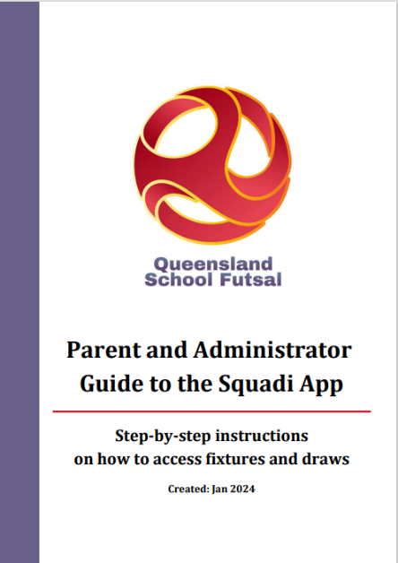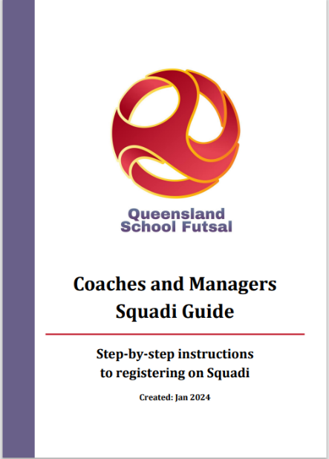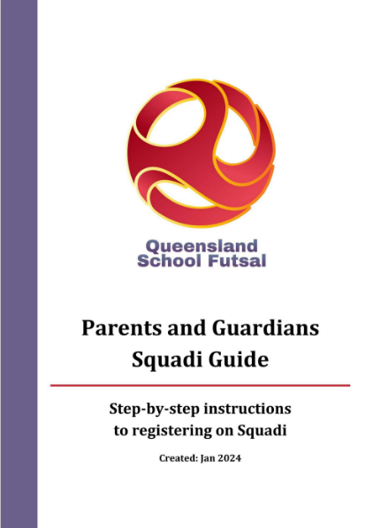
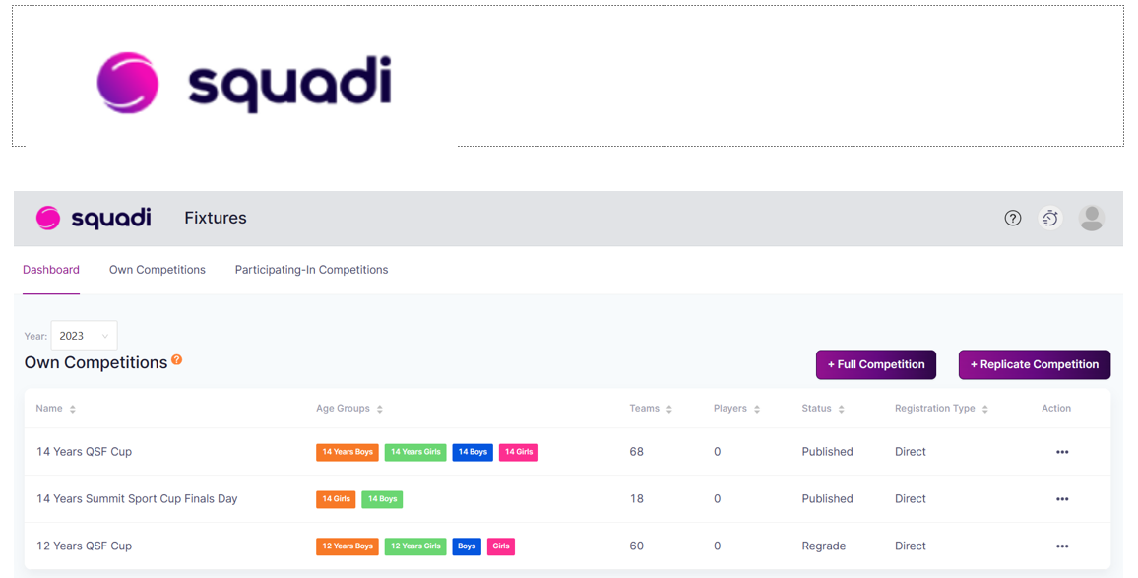

DOCUMENTS
All SFL documents can be found on the QSF Website page



QSF Website – queenslandschoolfutsal.com

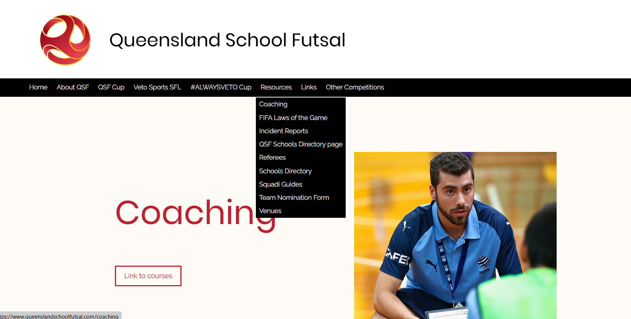

TEAM LISTS
Schools are to complete the QSF competition team list form with names, birthdates and principals’ signature and be brought to every Gala Day and be handed to the convenors on each Gala Day (admin@queenslandschoolfutsal.com)
Team lists are available on the QSF Website.
QSF Team Nomination Form | Queensland School Futsal

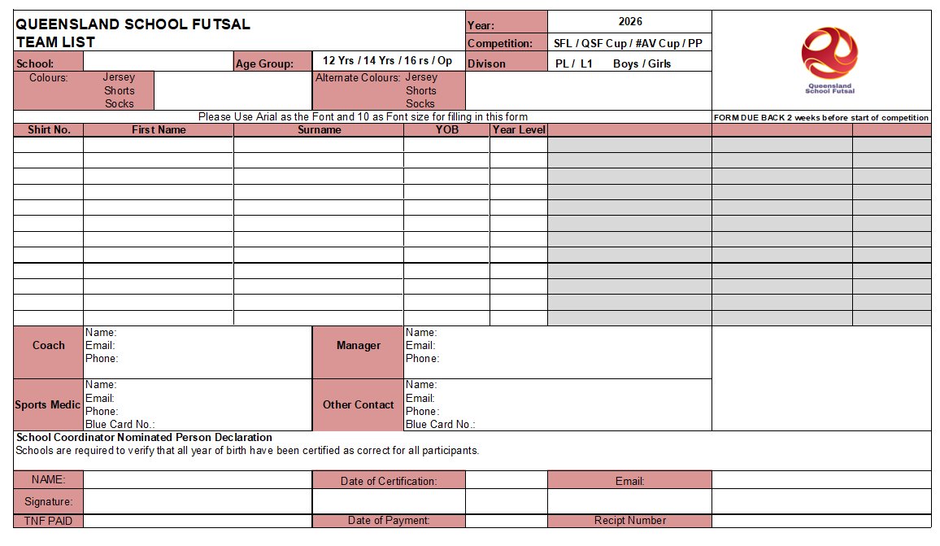

SQUAD LISTS
It is requested that “School Squad lists” be completed with names, birthdates and photos and sent to the convenors (admin@queenslandschoolfutsal.com) before the beginning of the season.

Squad lists are available on the QSF Website

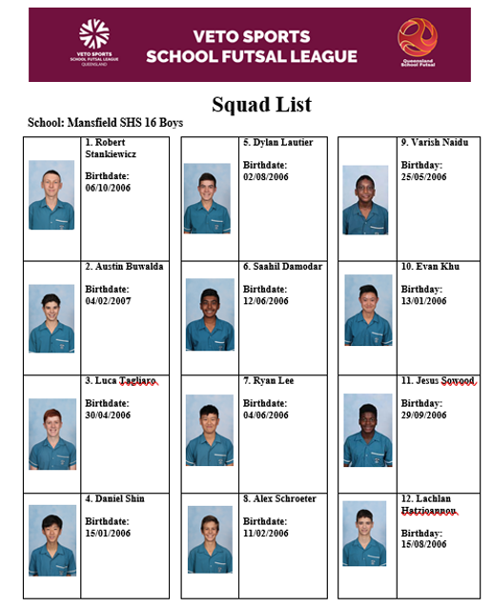

COMMUNICATION
All Coaches and managers are required to join the QSF WhatsApp group for quick communication purposes before and during the season and will provide updated results, Contact points and news

QSF WhatsApp Group


STAFF

Competition Coordinator Referee Coordinator
Alan Pradella Fiona Stevenson



Gala Day Convenors
Stephanie Stanyer Gervais Morton


SOCIAL MEDIA
QSF has a Facebook page and Instagram account for results posts, videos and general advertising purposes. We would like everyone to invite school staff, students, parents and friends to follow the pages.
We also encourage coaches and managers to complete the “Player” and “Coach” Profiles and forward them to the QSF Social Media Coordinator – Matt Pickham at mpick68@eq.edu.au

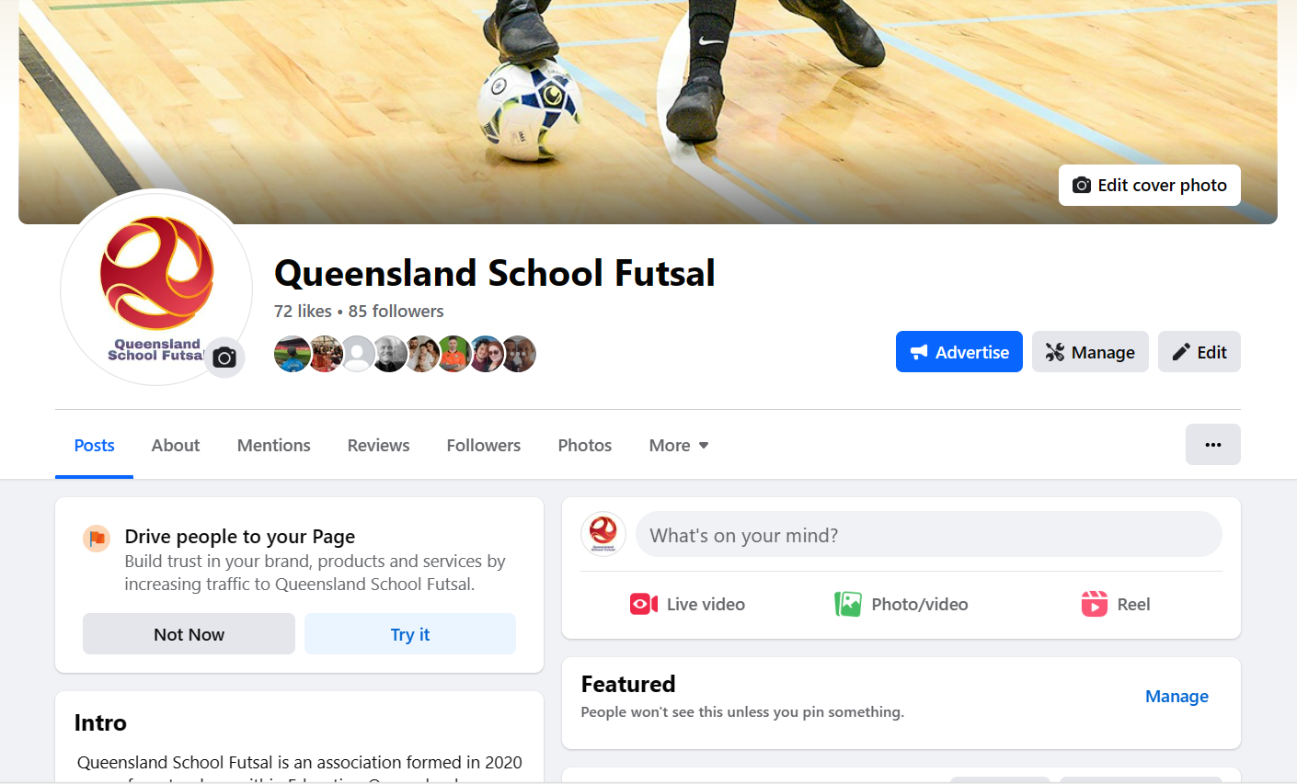


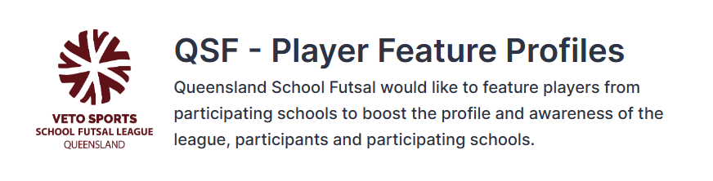
A QSF – Player Feature profile form will be available on the QSF website. Please fill in the questions on behalf of one player who participates in the VETO Sports SFL to be highlighted by QSF on the social media channels. Each school will be featured once throughout the year.
This form must be supplied via email with an image of the feature player – a headshot or action shot. Preferably in portrait version
By submitting this form, you accept that the player and their guardian has given their permission to be featured and for their image to be shared on QSF social media channels and/or the QSF website.
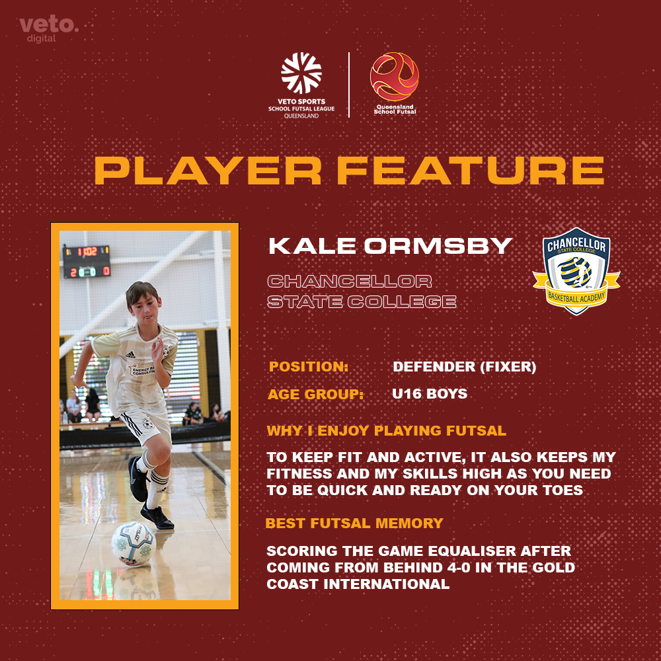
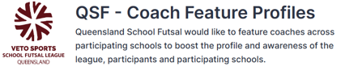
A QSF – Coach Feature profile form will be available on the QSF website. Please fill in the questions on behalf of one teacher or HOD who participates in the VETO Sports SFL to be highlighted by QSF on the social media channels. Each school will be featured once throughout the year.
This form must be supplied via email with an image of the feature player – a headshot or action shot. Preferably in portrait version
By submitting this form, you accept that the player and their guardian has given their permission to be featured and for their image to be shared on QSF social media channels and/or the QSF website.
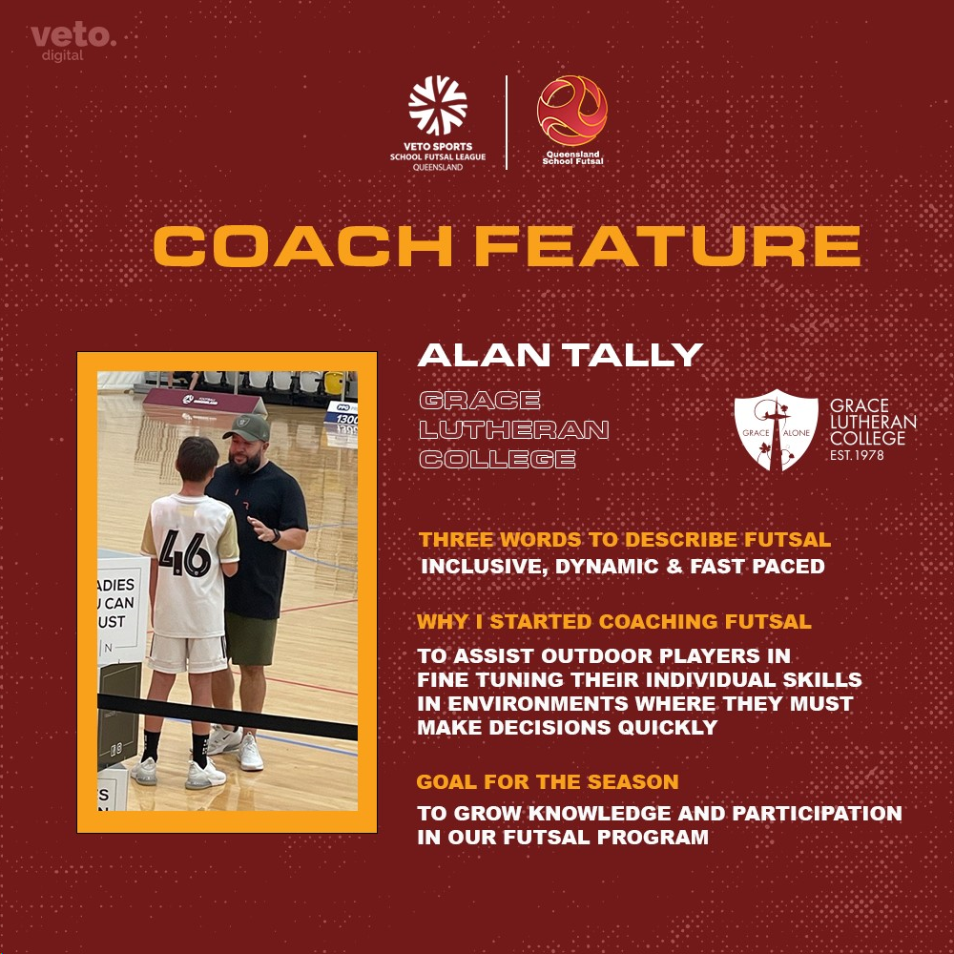

SPONSORS
VETO SPORTS are the official sponsors of the SFL and will supply match balls and official’s polos with SFL logo and School crests. VETO Sports can supply team uniforms and all Futsal related training equipment
Trophies, Medals and Awards
Conference Premiers will receive a Perpetual Premiers trophy.
Veto Sports Champions will receive the Veto Sports Perpetual trophy. Champions, Runners up and third place getters will receive medals.

Veto Sports Shield and Plate winners will receive the Veto Sports Perpetual trophy. Shield and Plate Champions, Runners up and third place getters will receive medals

League one Champions will receive a perpetual trophy. Winner and runners up will receive medals.

A Veto $50 voucher will be awarded to the Player of the Grand Final








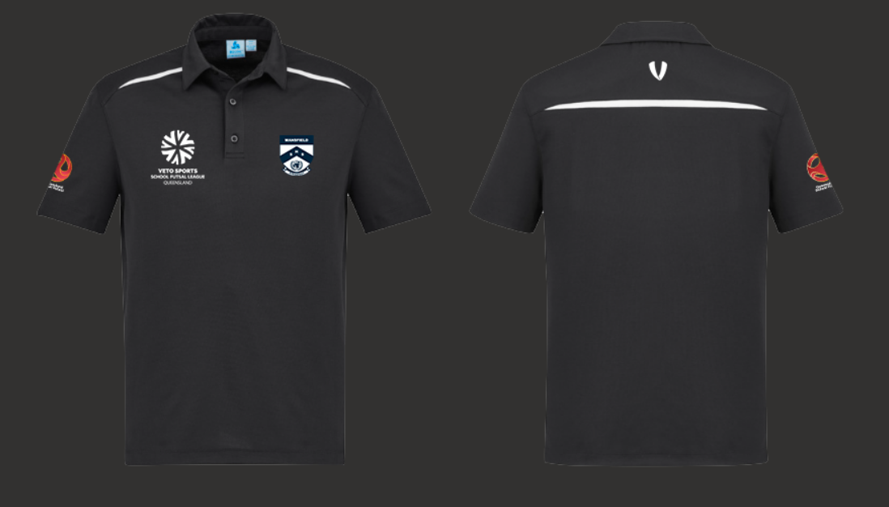

All schools are provided with 2 FREE polo shirts which include the school logo heat pressed on the polo with the Queensland School Futsal logo.
Additional polo shirts are $30 inc GST each.

PRO-PLAYER are secondary sponsors of the SFL and will provide school tours and coaching programs to all schools

PRO-PLAYER offer unparalleled support to schools through specialised coaching programs and consultancy services. This unique opportunity brings the expertise of ex-professional player directly into the training environment, enhancing the development of young and aspiring players.
The PRO-PLAYER team, comprised of experienced professionals from various football backgrounds, focuses on delivering high-quality training, expert knowledge and the advice for future careers in football or the football industry.
Partnership with PRO-PLAYER not only boosts the skill level of individual athletes but also elevates the overall standard of sports programs, fostering a culture of excellence and ambition. This collaboration represents a significant step forward in nurturing talent and promoting sports as a career path for the youth.



