2026

#ALWAYSVETO
12 Years CUP
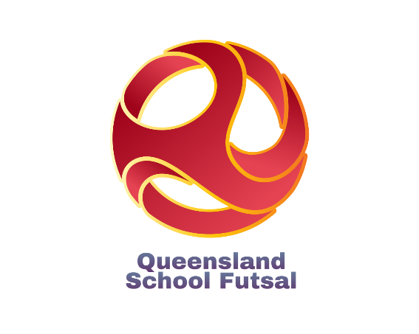

15th & 16th September , Coomera ISC

Information

(Updated 17 April 2026)
Table of Contents

Competition details | ……………………………………….. | 3
Age Groups, Formats, Nominations, Draws
2 Day Tournament | ………………………………………… | 4
1 Day Tournament | ……………………………………….. | 6
Nomination & draws | ……………………………………….. | 7
Procedures & Rules | ……………………………………….. | 8
FIFA Laws of the Game | ……………………………………….. | 10
Costs/ Referees | ……………………………………….. | 11
Results & Trophies | ……………………………………….. | 12
Documents | ……………………………………….. | 13
Team Lists | ……………………………………….. | 14
Squad Lists | ………………………………………. | 15
Communication | ………………………………………. | 16
Staff | ………………………………………. | 17
Social media | ………………………………………. | 18
Sponsors | ………………………………………. | 19
2025 QSF Calendar | ………………………………………. | 20
Competition Details
The #ALWAYSVETO Cup is a Queensland schools 12 Years boys and girls Futsal tournament organized by the QSF committee open to all schools in Queensland.
Teams of all abilities compete against each other on day 1 and depending on results are then placed into a “Champions” and “Shield” competition in Day 2 where teams play against teams of similar abilities to play for two separate trophies and gold, silver and bronze medallions.
The #ALWAYSVETO Cup provides the opportunity for all schools to participate and compete against other schools within their district, region, state and nation.
Although the #ALWAYSVETO Cup is open to all schools in the state, due to time and venue constraints, a restricted number teams nominating in each division can be accepted. (Schools may be asked to play qualifying matches be placed on waiting lists.)


AGE GROUPS: Boys and Girls
12 Years (Students cannot turn 13 or older in 2025)
Note: Girls may play in the Boys divisions only if the school has not nominated a Girls team.
DATES: Monday 14th and Tuesday 15th September
VENUE: Coomera ISC, Beattie Rd, Coomera

TOURNAMENT FORMATS

The Cup Tournament will be run as either a 1 or 2 Day tournament depending on the number of nominations.

2 Day #ALWAYSVETO Cup Format (16 teams)
Once nominations are finalized, the 16 teams will be randomly placed in Pools of 4 or 4 teams.
On Day 1 each team in their respective pools will play each other once. At the end of Day 1 the first and second placed teams from the 4 pools will then compete in the Day 2 “Cup” competition. Teams finishing third and fourth in Day 1 Pools will compete in the Day 2 "Shield" competition.
On Day 2, the 8 teams in the “Cup” competition will play cross over quarter finals. Winners will proceed to the Cup semifinals and losers will play consolation playoffs. Semi Final winners will proceed to the Cup Grand Final, and losers will play in the playoff for 3rd and 4th positions. All teams will play 3 matches on Day 2.
The teams that finish third and fourth in their respective Day 1 Pools will play off for the “-Shield’ competition on Day 2 in the same format as the Cup competition.

2 Day #ALWAYSVETO Cup Format (16 teams) – Sample Draw

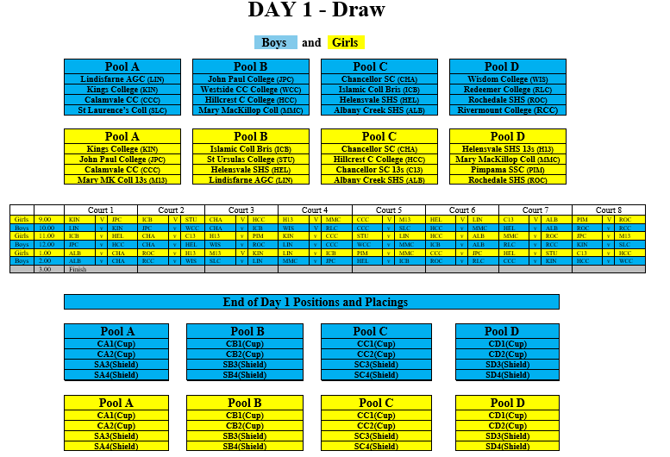

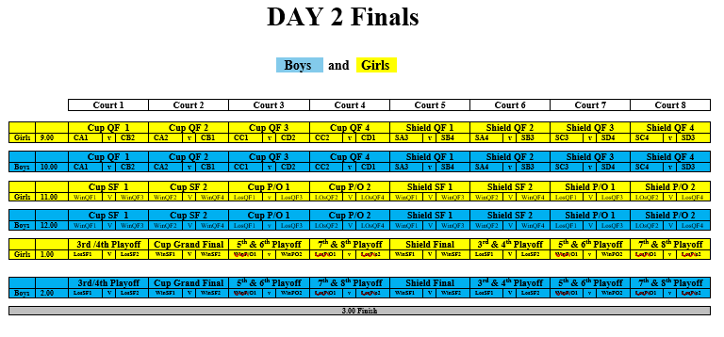

1 Day #ALWAYSVETO Cup Format (8 teams)
Once nominations are finalized, the 8 teams will be randomly placed in 2 Pools of 4 teams.
Each team in their respective pools will play each other once. At the end of Round matches the first and second placed teams from the 2 pools will then compete in the “Cup” competition. Teams finishing third and fourth in the Pools will compete in the "Shield" competition.
The 4 teams in the “Cup” competition will play cross over Semi Finals. The Semi Final winners will proceed to the Cup Grand Final, and losers will play in the playoffs for 3rd and 4th positions.
The teams that finish third and fourth in their respective Pools will play off for the “Shield’ in the same format as the Cup competition.

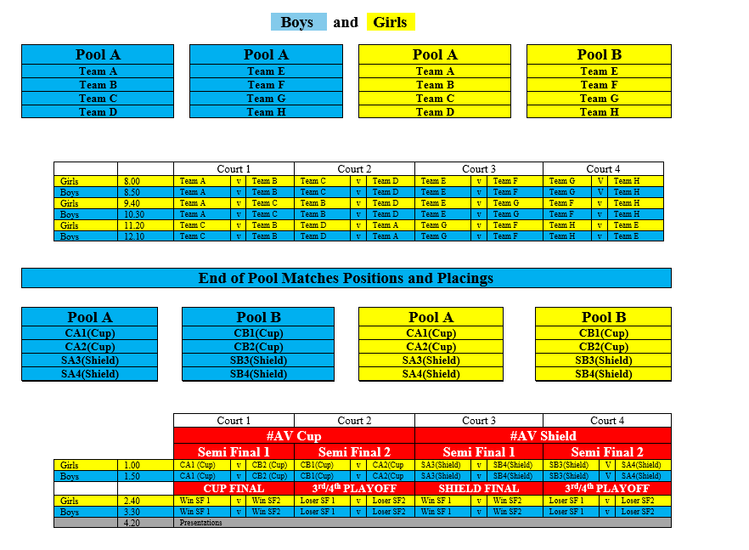

NOMINATIONS
Nomination forms are available on the QSF website and will close at the end of Week 10, Term 2, 2026.
The #ALWAYSVETO Cups will have maximum of 16 Boys and 16 Girls teams, so schools nominating after the competition limits have been filled, will be placed on "Reserve" lists.
Competition Invoices will be sent in Week 1, Term 3, 2026 and nominations will then be finalised after nomination fees have been paid.

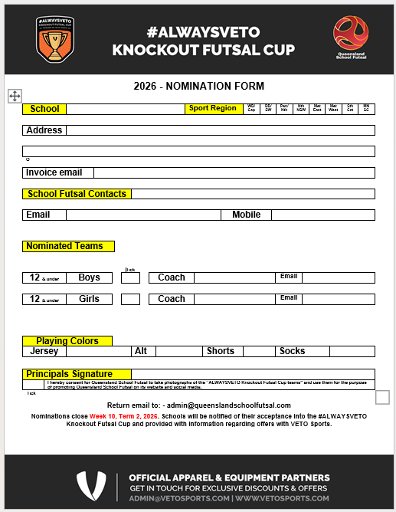

DRAWS
The Draws for the #ALWAYSVETO Cups (after nominations have been finalised) will take place at the Term 3 QSF Committee “Online - Microsoft teams” meeting in Week 2, Term 3 2026, and then made available on the QSF Website.
Procedures and Rules
1. | Each game shall consist of two periods of 20 minutes with 5 min half time break
2. | Normal "FIFA" Futsal rules will apply to all matches (except that the clock will not be stopped every time the ball goes out of play and restarted when play resumes)
3. | Teams are entitled to a one-minute time-out in each period. A team that does not request a time out in the first half of the match is only entitled to one time-out during the second half. Time outs can be taken at any time during both halves. The clock will stop for all timeouts. In the last 2 minutes of the match, if referees believe teams are wasting time intentionally, they have the right to stop the clo ck.
4. | A maximum of 10 players are allowed in each team on match day. (School squads can have a maximum of 24 players.)  All 10 players can be used in unlimited interchange. All substitutions are to be Rolling substitutions. Substitutions may be made at any time, whether the ball is in play or not, but only in the specially demarcated substitution zones. (G/K's should only be substituted during a stoppage in play).
5. | Yellow Cards - Two yellow cards in the same game will mean the player is sent from the field an automatic suspension for next game plus any punishment meted by Disputes committee. Two yellow cards awarded in separate matches will also mean suspension of one match.  Red cards - Sent off and automatic suspension for next game plus any punishment meted by the Disputes committee.  (Dispute committee will be the gala day convenors and the referee coordinator)
6. | All players must wear non marking soled shoes, shin pads covered by long socks and matching numbered shirts and shorts (except goalkeepers). (referees can prevent players entering the court if not dressed correctly)  If there is a clash of colors, it is the "HOME" teams (first named on the draw) responsibility to have an alternate strip or wear bibs.
7. | Home teams will run left to right of the team benches and kick off all matches.
8. | Any Team not on court 5 mins after the scheduled kick off time will start with a 2-goal deficit. ie., 2 goals will automatically be awarded to the opposition. If there are circumstances out of the team’s control, then the match time will be reduced to allow a result
9. | If a match is drawn at full time in a Quarter Final, Semi Final or Grand Final there will be two periods of 5 minutes extra time with no intervals or time outs, then FFA rules of penalty kicks to decide the winner. There are no time outs in “extra time”
10. | There will be a “10 Goal Max Goal difference for all results ie., a 16–1 result will be entered as 11-1.

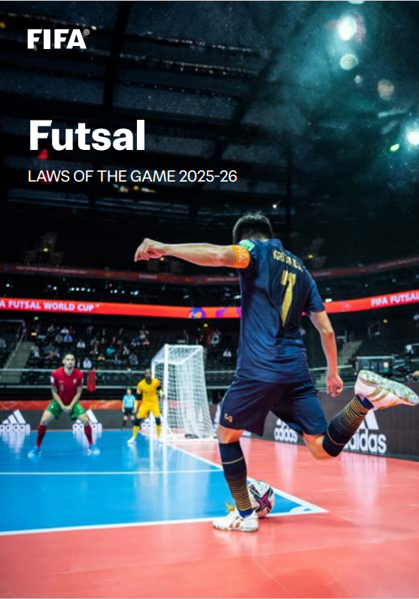

Futsal-Laws-of-the-Game-2025-2026.pdf
COSTS

Schools will be invoiced by QSF in Term 3, 2026

$200 per team (1 Day competition)
$350 per team (2 Day competition)

(covers venue hire, referees, sports trainers, admin fees)

REFEREES

1 -2 FQ Referees will be supplied for all matches.

DISCIPLINE COMMITTEE
A discipline committee of 3 teachers will be selected before the start of the season that will decide on all consequences from disciplinary reports. Incident report sheets can be found on the QSF Website and must be completed by both coaches and sent to the committee by the end of the following day after the match
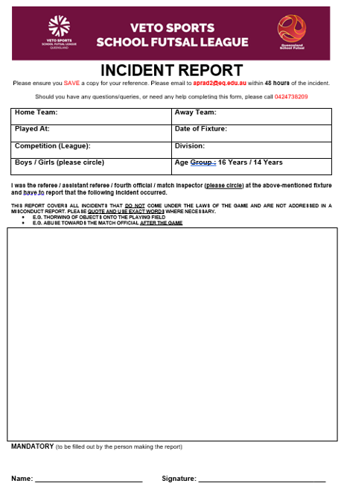
RESULTS and TABLES

All results for the tournament matches will be recorded on the Referee Match templates and then transferred to a Results sheet in the foyer of the venue.

There will be a “10 goal” max winning GD applied to all matches.

Results for all matches and updated tables can be found on QSF Website and results will be updated on the website.
A Disciplinary Spreadsheet to track “cautions” will be available on the QSF website.

TROPHIES, MEDALS and AWARDS
#ALWAYSVETO Cup champions will receive a Perpetual Premiers trophy and a take-home trophy
Runners up and 3rd place getters will receive medals
Shield winners will receive the Veto Sports Perpetual trophies. Runners up and 3^{rd.} place getters will receive medals

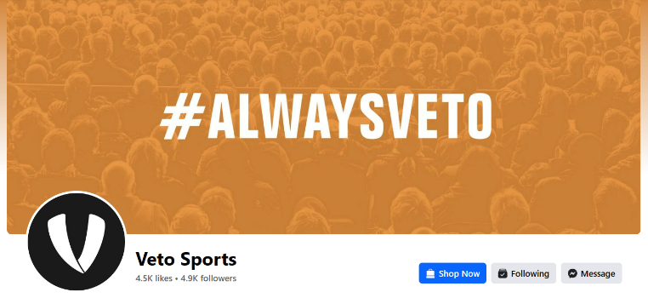

DOCUMENTS
All documents can be found on the QSF Website page

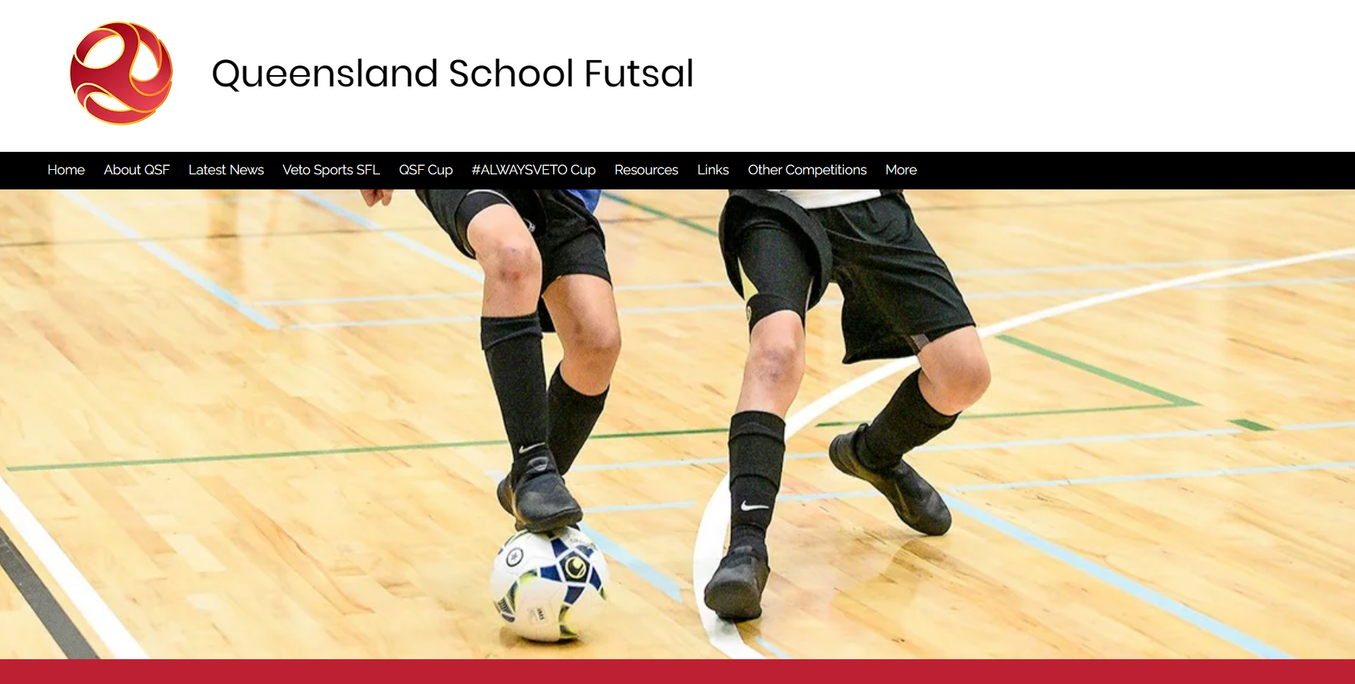

QSF Website – queenslandschoolfutsal.com

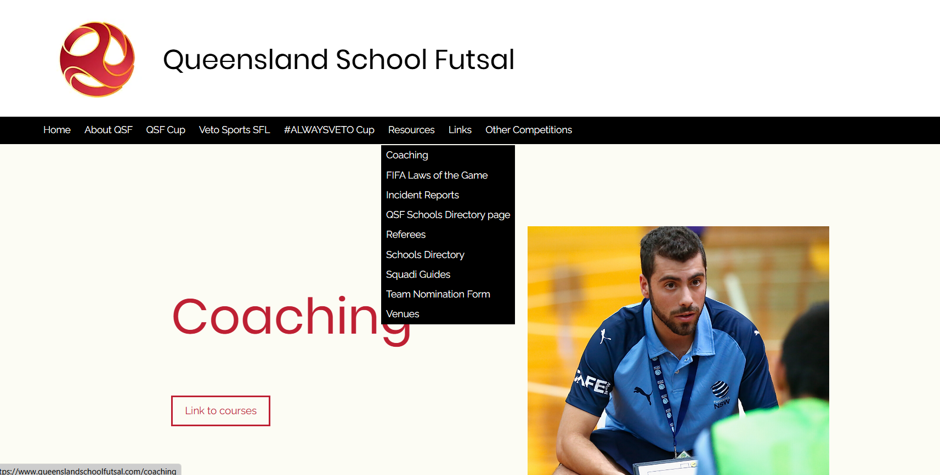

TEAM LISTS
It is requested that schools complete with names, birthdates and principals’ signature and be sent to the convenors as soon as nomination is confirmed (admin@queenslandschoolfutsal.com)

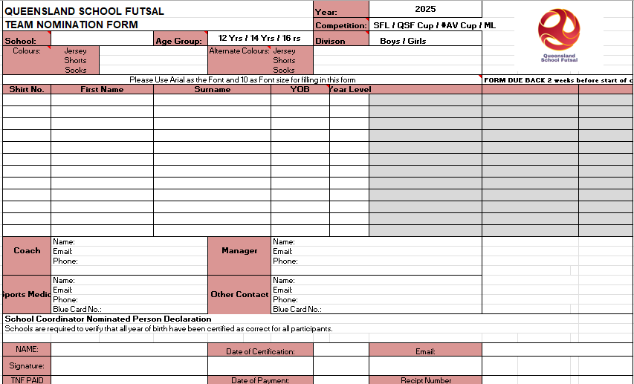

SQUAD LISTS
It is requested that schools prove “School Squad lists” completed with names, birthdates and photos and sent to the convenors (admin@queenslandschoolfutsal.com)

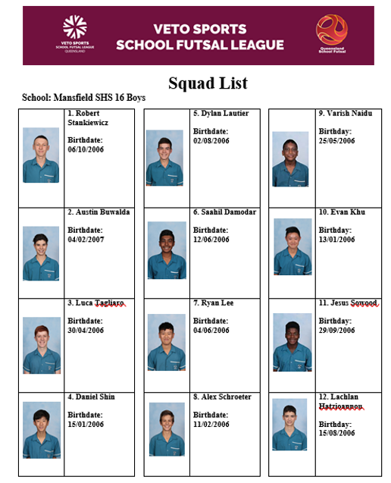

COMMUNICATION
All Coaches and managers are required to join for the QSF WhatsApp group for quick communication purposes before and during the season and will provide updated results, Contact points and news

QSF WhatsApp Group


STAFF
Competition Convenor Referee Coordinator
Alan Pradella Fiona Stevenson


Match Day Coordinators (admin@queenslandschoolfutsal.com)
Stephanie Stanyer Gervais Morton
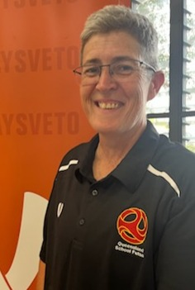

SOCIAL MEDIA
QSF has a Facebook page and Instagram account for results posts, videos and general advertising purposes. We would like everyone to invite school staff, students, parents and friends to follow the pages.
We also encourage coaches and managers to complete the “Player” and “Coach” Profiles and forward them to the QSF Social Media Coordinator – Matt Pickham at mpick68@eq.edu.au

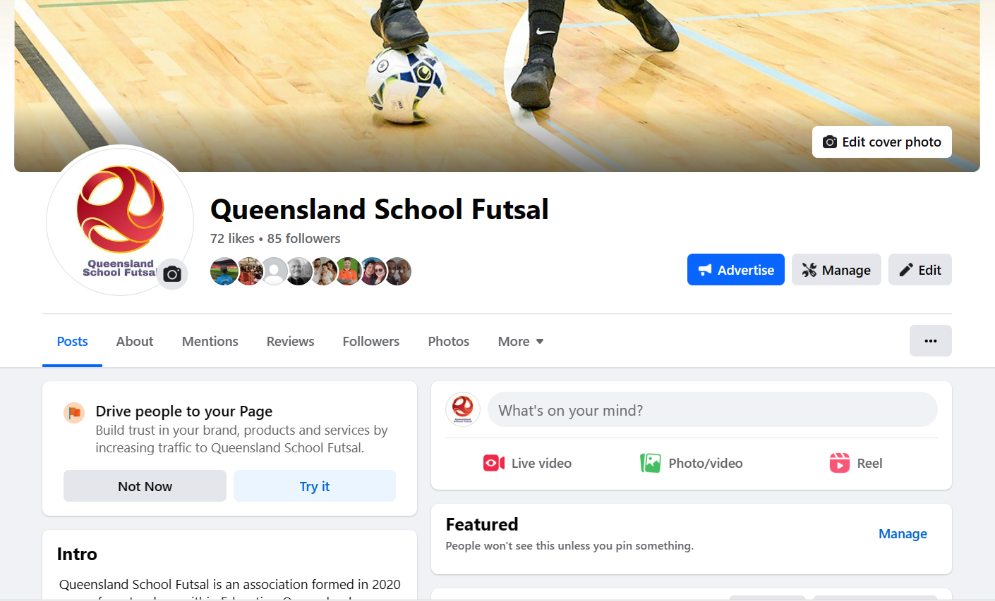


SPONSORS
VETO SPORTS are the official sponsors of the #ALWAYSVETO Cup.
Veto Sports, one of the leading sports teamwear & equipment suppliers in Australia. We’re here to support clubs, schools, teams, players & coaches from the grassroots all the way up to a national level.
Our range of products is one of the largest on offer in Australia, we like to think we’re a ‘one-stop-shop’ for sporting teams. From our FIFA regulation compliant football goal range to our streetwear inspired casual wear range, we will fulfil your needs as best we can.
We offer a wide range of fully sublimated teamwear for a variety of sports, as well as stock teamwear products. Our Graphic Designer will help those looking to create bespoke teamwear designs from any idea they have or leave it up to us to offer some creative options.

