2026
VETO SPORTS
SCHOOL FUTSAL LEAGUE



Information

Table of Contents

Competition details | ……………………………………….. | 3
Format, Age Groups, Finals, Nominations, Draws
Conference Dates
Central Conference | ………………………………………… | 5
Western Conference | ……………………………………….. | 6
Northern Conference | ……………………………………….. | 7
Southern Conference | ……………………………………….. | 8
Match Rules | ……………………………………….. | 9
Costs/ Referees | ……………………………………….. | 12
Documents / website | ……………………………………….. | 14
Team Lists | ……………………………………….. | 15
Squad Lists | ………………………………………. | 16
Communication | ………………………………………. | 17
Staff | ………………………………………. | 18
Social media | ………………………………………. | 19
Sponsors | ………………………………………. | 23
2025 QSF Calendar | ………………………………………. | 25
Competition Details

FORMAT
The VETO SPORTS 2026 School Futsal League will be divided into 2 Divisions – Premier League and League One. The competition will run in 4 Conferences – Central, Western, Northern & Southern. Each division will be comprised of 10 or 6 Boys and Girls teams and will play “1 round of 9” or “2 rounds of 5” matches over 3 Gala Days (3 -4 Rounds per Gala Day). There will be 1 Gala Day per term with Finals in Term 4.

AGE GROUPS: Boys and Girls
12 Years (Students cannot turn 13 or older in 2025)
14 Years (Students cannot turn 15 or older in 2025)
16 Years (Students cannot turn 17 or older in 2025)
Opens (The open competition will play in Semester 1 only)
Note:
1. Girls cannot play in Boys divisions except in the 12 years age division and only if the school cannot field a girls’ team.
2. Players are allowed to play in more than ONE division for the season. ie., a 16 year can play in both the 16 years age division and the Open division etc.,
FINALS:
The teams finishing first in each conference after the round matches will be crowned “Conference Premiers”.
The top 2 teams in each conference will play in the SFL Champions Final Day to decide the 2025 VETO Sports SFL Champions. Teams finishing 3rd & 4th and 5th & 6th will qualify for the VETO Sports SFL Shield & Plate finals respectively.
NOMINATIONS
Both divisions will have maximum of 10 or 6 Boys and Girls teams, so schools nominating after the competition limits have been filled, will be placed on "Reserve" lists.
Schools can nominate teams in any of the divisions, in all age brackets (ie., a school can nominate a 14 Boys team in the Premier League and a separate 14 Boys team in League One) but schools can only nominate “One” team in each separate division. Schools must supply 2 separate team lists and nominated League One players may play up in the Premier League divisions but nominated Premier League players cannot play down.
Nomination forms will be available on the QSF website and will be sent to 2025 QSF competition schools in Term 3, 2025 and will close at the end of Week 6 of Term 4. (Year 12 Years competition close Week 3, Term 1, 2026.)
After receiving and reviewing all nominations after Week 6, term 4, QSF will allocate the teams from each age division into the divisions with 10 or 6 teams in each pool. Schools will then be given the right of reply to the organised divisions and rearrangement will occur if needed.
Competition Invoices will be sent in Week 1, Term 1, 2026 and nominations will then be finalised after nomination fees have been paid. (Once nomination fees have been paid, any withdrawals from the competition will incur cancellation fees unless substitute schools are found)

DRAWS
The Draws for all 4 Conferences will be made after nominations have been finalised, and available in Week 1, Term 1, (Week 4 for the 12 Years) 2026 on the QSF Website.
Central Conference Details
VENUE: Nissan Arena Indoor Sports Centre – Mains Rd Macgregor
FORMAT:
The Central Conference will have a maximum of 6 teams in each division and will play 3 Gala Days with each Gala Day being comprised of 3 – 4 rounds over 3 terms. Premier League & League One Boys and girl’s rounds will be played together each Gala Day. Teams finishing 1st, & 2nd in each conference will qualify for Champions Final Day. Teams finishing 3rd & 4th, 5th & 6th will qualify for Shield and Plate Finals respectively.
DATES:
14 Years – | Gala Day 1 | Friday | 13th February
 | Gala Day 2 | Wednesday | 29th April
 | Gala Day 3 | Wednesday | 5th August
 | Plate Final Day | Tuesday | 27th October
 | Shield Final Day | Wednesday | 28th October
 | Champs Final D | Thursday | 29th October
Opens - | Gala Day 1 | Friday | 13th February
 | Gala Day 2 | Thursday | 12th March
 | Gala Day 3 | Wednesday | 29th April
 | Finals Days | Tuesday | 26-28th May
12 Years - | Gala Day 1 | Thursday | 19th March
 | Gala Day 2 | Thursday | 21st May
 | Gala Day 3 | Thursday | 20th August
 | Finals Days | Mon - Wed | 3-4th Nov
16 Years | Gala Day 1 | Thursday | 19th March
 | Gala Day 2 | Thursday | 21st May
 | Gala Day 3 | Thursday | 20th August
 | Finals Day | Tues,Thur,Fri | 20-23rd Oct

Western Conference Details
VENUE: Nissan Arena Indoor Sports Centre – Mains Rd Macgregor

FORMAT:
The Western Conference will have a maximum of 6 teams in each division and will play 3 Gala Days with each Gala Day being comprised of 3 – 4 rounds over 3 terms. Premier League & League One Boys and girl’s rounds will be played together each Gala Day. Teams finishing 1st, & 2nd in each conference will qualify for Champions Final Day. Teams finishing 3rd & 4th, 5th & 6th will qualify for Shield and Plate Finals respectively.
DATES:
14 Years – | Gala Day 1 | Thursday | 19th February
 | Gala Day 2 | Tuesday | 28th April
 | Gala Day 3 | Thursday | 13th August
 | Plate Final Day | Tuesday | 27th October
 | Shield Final Day | Wednesday | 28th October
 | Champs Final D | Thursday | 29th October
Opens - | Gala Day 1 | Thursday | 19th February
 | Gala Day 2 | Friday | 13th March
 | Gala Day 3 | Tuesday | 28th April
 | Finals Days | Tuesday | 26-28th May
12 Years - | Gala Day 1 | Wednesday | 18th March
 | Gala Day 2 | Tuesday | 19th May
 | Gala Day 3 | Tuesday | 18th August
 | Finals Days | Mon - Wed | 3-4th Nov
16 Years | Gala Day 1 | Wednesday | 18th March
 | Gala Day 2 | Tuesday | 19th May
 | Gala Day 3 | Tuesday | 18th August
 | Finals Day | Tues,Thur,Fri | 20-23rd Oct

Northern Conference Details
VENUE: Nissan Arena Indoor Sports Centre – Mains Rd Macgregor

FORMAT:
The Northern Conference will have a maximum of 6 teams in each division and will play 3 Gala Days with each Gala Day being comprised of 3 – 4 rounds over 3 terms. Premier League & League One Boys and girl’s rounds will be played together each Gala Day. Teams finishing 1st, & 2nd in each conference will qualify for Champions Final Day. Teams finishing 3rd & 4th, 5th & 6th will qualify for Shield and Plate Finals respectively.
DATES:
14 Years – | Gala Day 1 | Wednesday | 18th February
 | Gala Day 2 | Thursday | 30th April
 | Gala Day 3 | Tuesday | 11th August
 | Plate Final Day | Tuesday | 27th October
 | Shield Final Day | Wednesday | 28th October
 | Champs Final D | Thursday | 29th October
Opens - | Gala Day 1 | Wednesday | 18th February
 | Gala Day 2 | Wednesday | 11th March
 | Gala Day 3 | Thursday | 30th April
 | Finals Days | Tuesday | 26-28th May
12 Years - | Gala Day 1 | Friday | 20th March
 | Gala Day 2 | Wednesday | 20rd May
 | Gala Day 3 | Wednesday | 19th August
 | Finals Days | Mon - Wed | 3-4th Nov
16 Years | Gala Day 1 | Friday | 20th March
 | Gala Day 2 | Wednesday | 20rd May
 | Gala Day 3 | Wednesday | 19th August
 | Finals Day | Tues,Thur,Fri | 20-23rd Oct

Southern Conference Details
VENUE: Coomera Indoor Sports Centre – Beattie Rd Coomera

FORMAT:
The Southern Conference will have a maximum of 6 teams in each division and will play 3 Gala Days with each Gala Day being comprised of 3 – 4 rounds over 3 terms. Premier League & League One Boys and girl’s rounds will be played together each Gala Day. Teams finishing 1st, & 2nd in each conference will qualify for Champions Final Day. Teams finishing 3rd & 4th, 5th & 6th will qualify for Shield and Plate Finals respectively.
DATES:
14 Years – | Gala Day 1 | Tuesday | 17th February
 | Gala Day 2 | Tuesday | 5th May
 | Gala Day 3 | Monday | 10st August
 | Plate Final Day | Tuesday | 27th October
 | Shield Final Day | Wednesday | 28th October
 | Champs Final D | Thursday | 29th October
Opens - | Gala Day 1 | Tuesday | 17th February
 | Gala Day 2 | Tuesday | 10th March
 | Gala Day 3 | Tuesday | 5th May
 | Finals Days | Tuesday | 26-28th May
12 Years - | Gala Day 1 | Tuesday | 17th March
 | Gala Day 2 | Monday | 18th May
 | Gala Day 3 | Monday | 17th August
 | Finals Days | Mon - Wed | 3-4th Nov
16 Years | Gala Day 1 | Tuesday | 17th March
 | Gala Day 2 | Monday | 18th May
 | Gala Day 3 | Monday | 17th August
 | Finals Day | Tues,Thur,Fri | 20-23rd Oct

Procedures and Rules
1. | Each game shall consist of two periods of 20 minutes with 5 min half time break
2. | Normal "FIFA" Futsal rules will apply to all matches (except that the clock will not be stopped every time the ball goes out of play and restarted when play resumes)
3. | Teams are entitled to a one-minute time-out in each period. A team that does not request a time out in the first half of the match is only entitled to one time-out during the second half. Time outs can be taken at any time during both halves. The clock will not stop for all timeouts in 50-minute match timeslots but will stop in 60 mins timeslots. In the last 2 minutes of the match, if referees believe teams are wasting time intentionally, they have the right to stop the clock.
4. | A maximum of 10 players are allowed in each team on match days. (School squads can have a maximum of 24 players.)  All 10 players can be used in unlimited interchange. All substitutions are to be Rolling substitutions. Substitutions may be made at any time, whether the ball is in play or not, but only in the specially demarcated substitution zones. (G/K's should only be substituted during a stoppage in play).
5. | Yellow Cards - Two yellow cards in the same game will mean the player is sent from the field an automatic suspension for next game plus any punishment meted by Disputes committee. Three yellow cards awarded in separate matches will also mean suspension of one match.  Red cards - Sent off and automatic suspension for next game plus any punishment meted by the Disputes committee.  (Dispute committee will be the gala day convenors and the referee coordinator)
6. | All players must wear non marking soled shoes, shin pads covered by long socks and matching numbered shirts and shorts (except goalkeepers). (referees can prevent players entering the court if not dressed correctly)  If there is a clash of colors, it is the "HOME" teams (first named on the draw) responsibility to have an alternate strip or wear bibs.
7. | Home teams will run left to right of the team benches and kick off all matches.
8. | Any Team not on court 5 mins after the scheduled kick off time will start with a 2-goal deficit. ie., 2 goals will automatically be awarded to the opposition. If there are circumstances out of the team’s control, then the match time will be reduced to allow a result
9. | If a match is drawn at full time in a Quarter Final, Semi Final or Grand Final there will be two periods of 5 minutes extra time with no intervals or time outs, then FFA rules of penalty kicks to decide the winner. There are no time outs in “extra time”
10. | There will be a “10 Goal Max Goal difference for all results ie., a 16–1 result will be entered as 11-1.


Futsal-Laws-of-the-Game-2024-25.pdf

COSTS

Schools will be invoiced by QSF in Term1, 2026 for all three gala days and the Champions and Shield Finals Day.

Total cost approx. $700 per team for 3 Gala Days and Finals Day
(Cost will be dependent on the number of nominations)

An approx. $60 per match fee is budgeted to cover venue hire, referees, sports trainers, convenors and admin fees.
Teams that withdraw during the season will only be reimbursed if replacement teams are found.

REFEREES

1 -2 FQ Referees will be supplied for all matches.

DISCIPLINE COMMITTEE
A discipline committee of 3 teachers will be selected before the start of the season that will decide on all consequences from disciplinary reports. Incident report sheets can be found on the QSF Website and must be completed by both coaches and sent to the committee by the end of the following day after the match. A Disciplinary Spreadsheet to track “cautions” will be available on the QSF website.
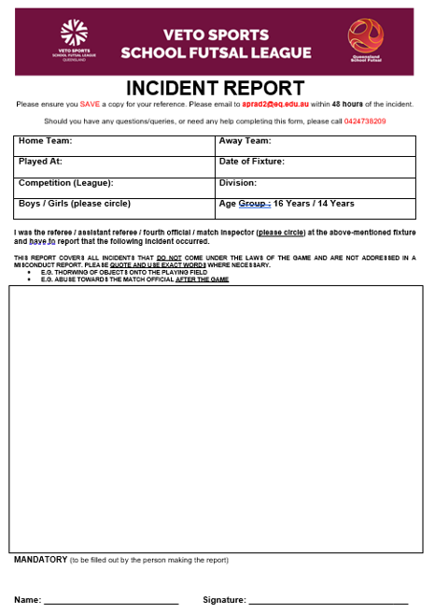
RESULTS and TABLES

All results for Gala Day Conference matches will be recorded on the Referee Match templates and then transferred and recorded on “Squadi” and the QSF Website.

There will be a “10 goal” max winning GD applied to all matches.

Results for all matches and updated tables can be found on “Squadi” and the QSF Website. Results will be updated after each gala day. Squadi guides available on the QSF website

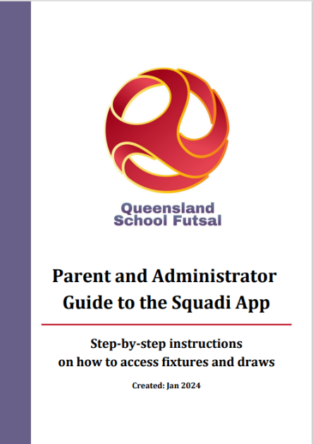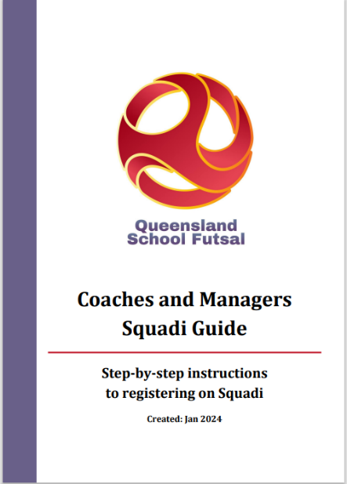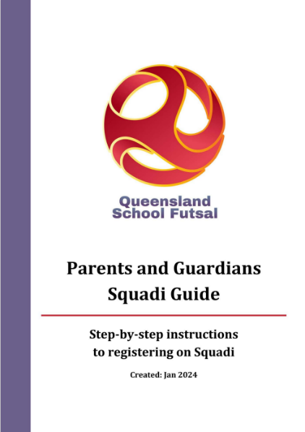
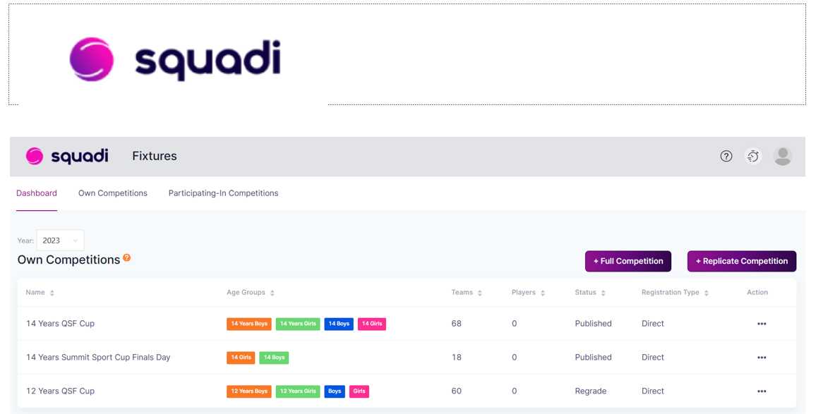

DOCUMENTS
All SFL documents can be found on the QSF Website page



QSF Website – queenslandschoolfutsal.com

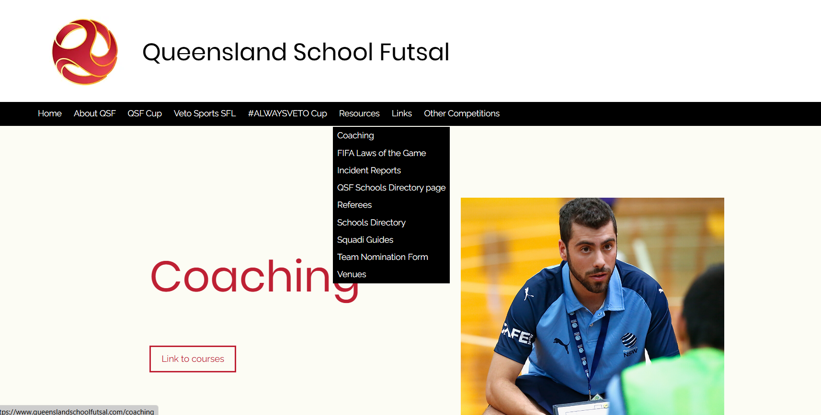

TEAM LISTS
It is requested that schools complete the QSF competition team list form with names, birthdates and principals’ signature and be sent to the convenors as soon as nomination is confirmed (admin@queenslandschoolfutsal.com)
Team lists are available on the QSF Website.

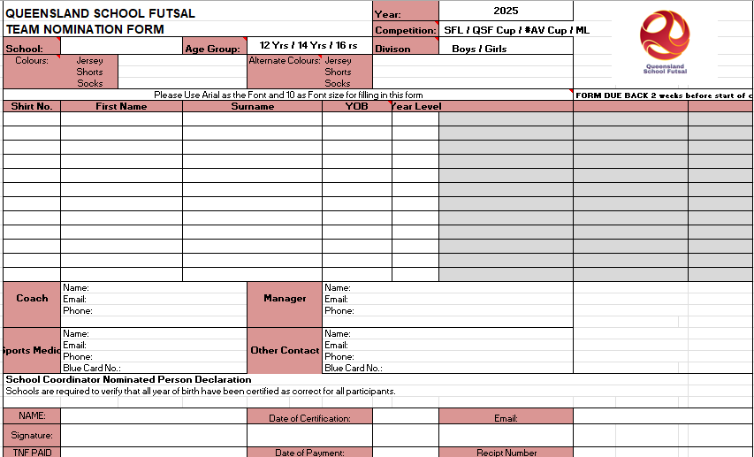

SQUAD LISTS
It is requested that “School Squad lists” be completed with names, birthdates and photos and sent to the convenors (admin@queenslandschoolfutsal.com)

Squad lists are available on the QSF Website

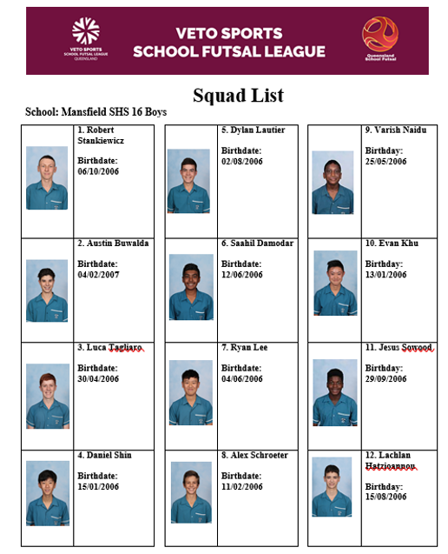

COMMUNICATION
All Coaches and managers are required to join for the QSF WhatsApp group for quick communication purposes before and during the season and will provide updated results, Contact points and news

QSF WhatsApp Group


STAFF
Competition Convenor Referee Coordinator
Alan Pradella Fiona Stevenson


Match Day Coordinators (admin@salatimefc.com)
Raul Ocan Villegas Gervais Morton


SOCIAL MEDIA
QSF has a Facebook page and Instagram account for results posts, videos and general advertising purposes. We would like everyone to invite school staff, students, parents and friends to follow the pages.
We also encourage coaches and managers to complete the “Player” and “Coach” Profiles and forward them to the QSF Social Media Coordinator – Matt Pickham at mpick68@eq.edu.au

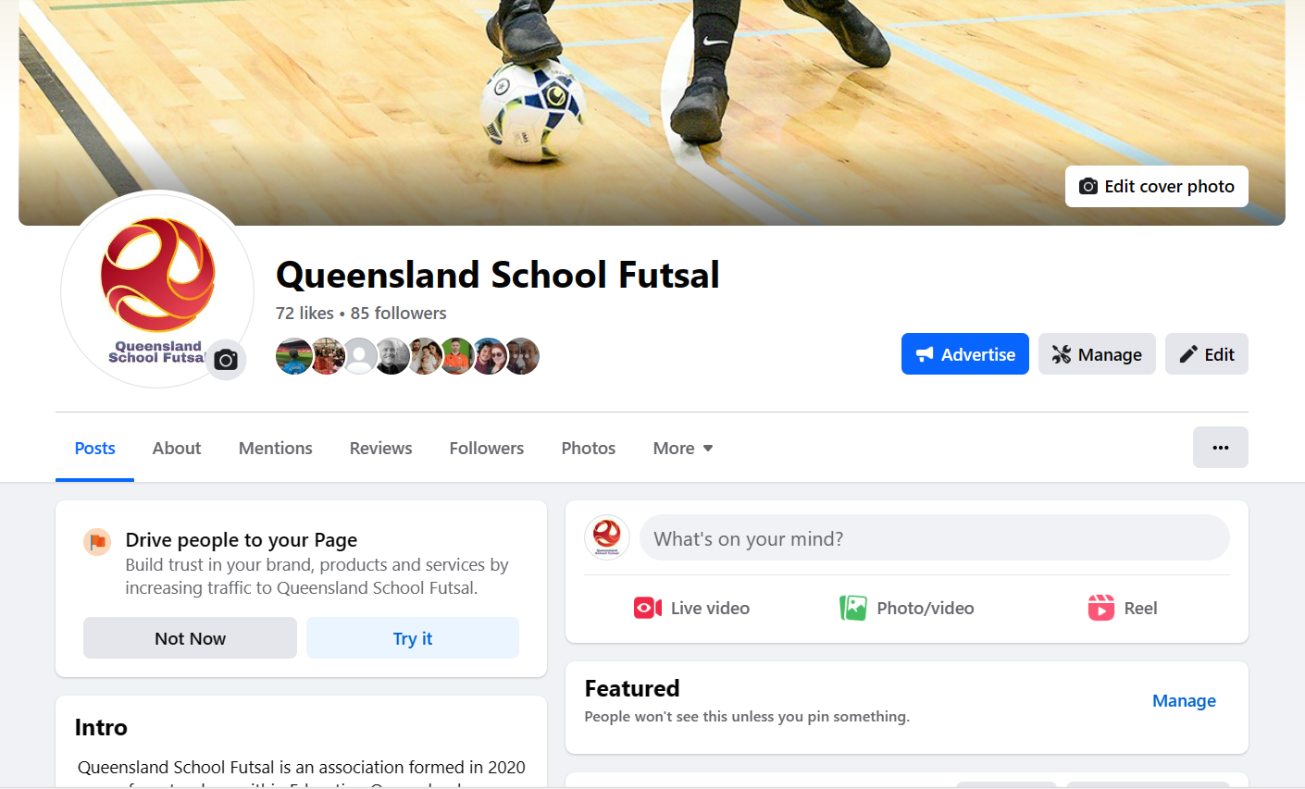


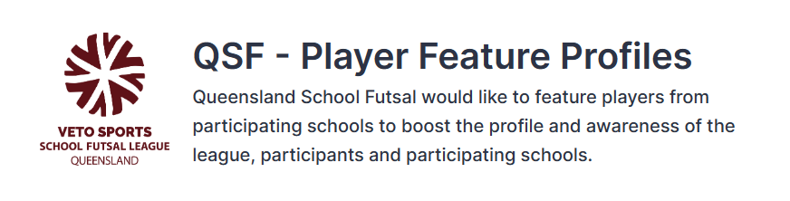
A QSF – Player Feature profile form will be available on the QSF website. Please fill in the questions on behalf of one player who participates in the VETO Sports SFL to be highlighted by QSF on the social media channels. Each school will be featured once throughout the year.
This form must be supplied via email with an image of the feature player – a headshot or action shot. Preferably in portrait version
By submitting this form, you accept that the player and their guardian has given their permission to be featured and for their image to be shared on QSF social media channels and/or the QSF website.

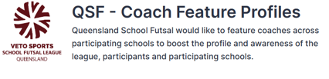
A QSF – Coach Feature profile form will be available on the QSF website. Please fill in the questions on behalf of one teacher or HOD who participates in the VETO Sports SFL to be highlighted by QSF on the social media channels. Each school will be featured once throughout the year.
This form must be supplied via email with an image of the feature player – a headshot or action shot. Preferably in portrait version
By submitting this form, you accept that the player and their guardian has given their permission to be featured and for their image to be shared on QSF social media channels and/or the QSF website.
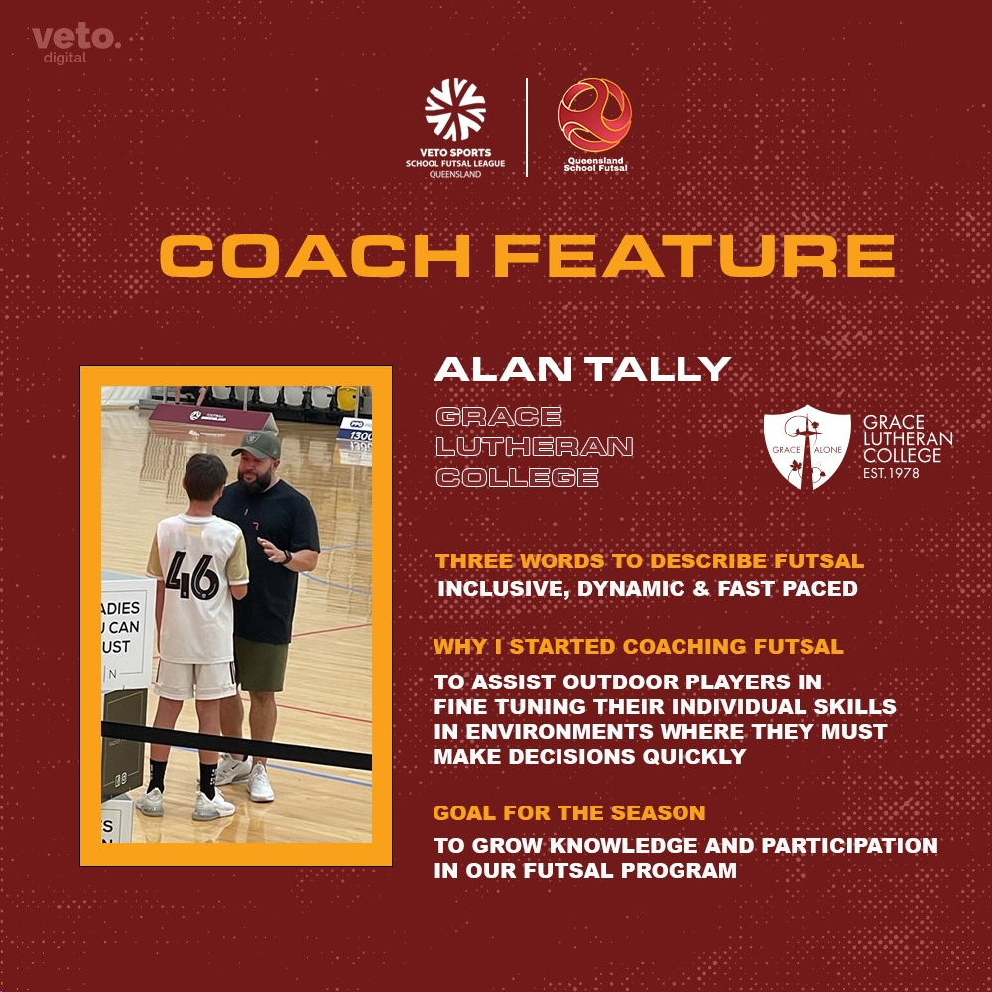
SPONSORS
VETO SPORTS are the official sponsors of the SFL and will supply match balls and official’s polos with SFL logo and School crests. VETO Sports can supply team uniforms and all Futsal related training equipment
Trophies, Medals and Awards
Conference Premiers will receive a Perpetual Premiers trophy and a take-home trophy

Veto Sports Champions will receive the Veto Sports Perpetual and a take-home trophy. Champions, Runners up and 3rd place getters will receive medals

Veto Sports Shield winners will receive the Veto Sports Perpetual trophy.
Champions, Runners up and 3^{rd.} place getters will receive medals

A Veto $50 voucher will be awarded to the Player of the Grand Final








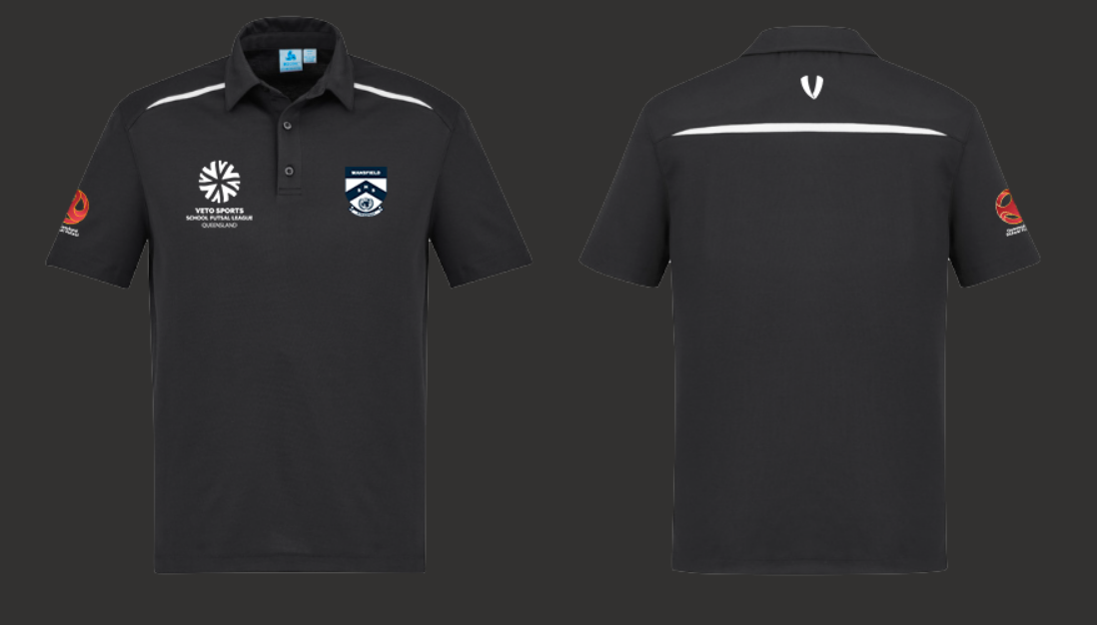

All schools are provided with 2 FREE polo shirts which include the school logo heat pressed on the polo with the Queensland School Futsal logo.
Additional polo shirts are $30 inc GST each.
