2026
VETO SPORTS
SCHOOL FUTSAL LEAGUE



Information
(Updated 23 January ) )
Table of Contents

Competition details | ……………………………………….. | 3
Conference Pools & Finals
Open Years | ………………………………………… | 5
16 Years | ……………………………………….. | 7
14 Years | ……………………………………….. | 9
12 Years | ……………………………………….. | 11
Competition Dates
Central Conference | ………………………………………… | 12
Western Conference | ……………………………………….. | 13
Northern Conference | ……………………………………….. | 14
Southern Conference | ……………………………………….. | 15
Match Rules  Costs/ Referees | ………………………………………..  ……………………………………….. | 16  19
Draws and Results | ……………………………………….. | 20
Documents | ……………………………………….. | 21
Squad & Team Lists | ………………………………………. | 22
Communication | ………………………………………. | 24
Staff | ………………………………………. | 25
Social media | ………………………………………. | 26
Sponsors | ………………………………………. | 27
2026 QSF Calendar | ………………………………………. | 32
2026 Gala Day Dates | ………………………………………. | 33
Competition Details

The VETO SPORTS 2026 School Futsal League is a competition for Boys and Girls in four age divisions – 12, 14, 16 & Open divided into 2 Divisions – Premier League and League One.
The competition runs across 4 Conferences –
Central, Western, Northern & Southern
Each age division will be comprised of pools of 10 or 6 teams and will play “1 round of 9” or “2 rounds of 5” matches over 3 Gala Days (3 -4 Rounds per Gala Day).
There will be 1 Gala Day in terms 1, 2 & 3 & Finals in Term 4.
The Open & 14 Years and 16 & 12 Years Premier League & League One Boys and girl’s rounds will be designed to be grouped to be played together in separate Gala Days.
The Finals qualifying format will be dependent on the number of teams in each of the four conferences. (See following pages)

AGE GROUPS: Boys and Girls
12 Years (Students cannot turn 13 or older in 2026)
14 Years (Students cannot turn 15 or older in 2026)
16 Years (Students cannot turn 17 or older in 2026)
Opens (The open competition will play in Semester 1 only)
Note:
1. Girls cannot play in Boys divisions except in the 12 years age division and only if the school cannot field a girls’ team.
2. Players are allowed to play in more than ONE division for the season. ie., a 16 year can play in both the 16 years age division and the Open division etc.,

CONFERENCE PREMIERS & FINALS FORMAT:
Teams finishing first in each conference pool after the round matches will be crowned “Conference Premiers”.
The overall VETO SPORTS SFL Champions will be decided in each age group and division depending on the format of the individual conference pools.
If divisions have Teams in all 4 Conferences, teams finishing 1st & 2nd, 3rd & 4th & 5th & 6th in each pool will qualify for the VETO SPORTS SFL Champion, Shield & Plate finals respectively.
Finals formats will differ for divisions that do not contain pools in all “Four Conferences” (see Finals format on page 16)
NOMINATIONS:
Nomination forms are available on the QSF website. Nominations close at the end of Week 6 of Term 4, 2025.
(Year 12 Years competition close Week 3, Term 1, 2026)
All divisions will have a maximum of 10 or 6 Boys and Girls teams, so schools nominating after the competition limits have been filled, will be placed on "Reserve" lists.
Schools may nominate teams in any of the divisions, in all age brackets (i.e., a school can nominate a 14 Boys team in the Premier League and a separate 14 Boys team in League One) but schools can only nominate “One” team in each separate division (unless there are “Bye” positions).
Schools must supply 2 separate team lists and nominated League One players may play up in the Premier League but nominated Premier League players cannot play down. (If a registered PL player is found playing in a L1 team the team will forfeit the points)
After receiving all nominations, QSF will allocate teams from each age division into pools. Schools will then be given the right of reply to the organised divisions and rearrangement will occur if needed.
OPEN BOYS (Premier League)

Northern |  | Southern |  | Western |  | Central
Albany Creek SHS |  | Coomera Anglican College |  | Kenmore SHS |  | Islamic College Brisbane
Bray Park SHS |  | Foxwell SSC |  | Ripley Valley SSC |  | Mabel Park SHS
Murrumba SSC |  | Men of Business Academy |  | St Peter Claver College |  | Mansfield SHS
 |  | Mullumbimby SHS |  |  |  | Redbank Plains SHS
 |  | Ormeau Woods SHS |  |  |  | St James College
 |  | St Andrew's College |  |  |  | Shailer Park SHS

Open Boys Premier - Finals Format
The Southern & Central Pools will play 10 rounds within 3 Gala days
The teams finishing 1st and 2nd will qualify for the Champions. Teams finishing 3rd and 4th will qualify for the Shield and teams finishing 5th and 6th will qualify for the Plate. The Western and Northern open Boys PL team will play in the League One Pools. The top 2 West & Northern Conference PL teams will qualify for the Champions Day. The PL teams finishing 3rd will qualify for the Shield.

OPEN BOYS (League One)

Northern |  | Southern |  | Western |  | Central
Pool A |  | Beaudesert SHS |  | Brisbane South SSC |  | Brisbane Adventist College
Albany Creek SHS (PL) |  | Kings College (Pimpama) |  | Bremer SHS |  | Calamvale CC
Beenleigh SHS |  | Kingscliff HS |  | Concordia Lutheran College |  | Kimberley College
Bray Park (PL) |  | Miami SHS |  | Darling Downs Adv College |  | Mabel Park SHS
Bribie Island SHS |  | Ormeau Woods SHS |  | Highfields SHS |  | Mansfield SHS
Fortitude Valley SSC |  | Pimpama SSC |  | Kenmore SHS (PL) |  | Mt Gravatt SHS
Murrumba SSC (PL) |  |  |  | Lowood SHS |  | Redlands College
Pool B |  |  |  | Loganlea SHS |  | Rochedale SHS
Bray Park SHS |  |  |  | Ripley Valley SSC (PL) |  | St James College
Good Samaritan College |  |  |  | St Peter Claver (PL) |  | Wisdom College
Indooroopilly SHS
James Nash SHS
Nambour SC
Tullawong SHS
Bye
Open Boys League One - Finals Format
All Pools with 6 teams will play 10 rounds and pools with 9 teams will play 9 rounds within 3 Gala days. The L1 teams finishing highest in the Nth Pool A & B, the 2 highset placed L1 teams in the Wst Pool and the teams finishing 1st & 2nd in the other Sth & Cnt Conferences will qualify for the Champions Finals. Teams finishing 2nd highest in the Nth Pools , the 3rd & 4th highest placed teams in the Wst Pool and 3rd and 4th in the Sth & Cnt pools will qualify for the Shield. Teams finishing 3rd highest in the Nth Pools, 5th & 6th Highest in the Wst Pool & 5th and 6th in the other 3 pools will qualify for the Plate. Teams finishing below 6th position will not qualify for Finals and will be refunded for finals day fees.
OPEN Girls (Premier League)

Northern |  | Southern |  | Western |  | Central
Albany Creek SHS |  | Coomera Anglican College |  | Lowood SHS (PL) |  | Kimberley College
 |  | Mullumbimby SHS |  | St Ursula's College (PL)
 |  | Ormeau Woods (L1)
 |  | Pimpama SSC (L1)
 |  | Bye
 |  | Bye
Open Girls Premier - Finals Format
Open Girls Premier League - Finals Format
The Southern (2) PL teams will play a round robin on Gala Day 2 with the 2 L1 teams for positions 1st to 4th. The Northern PL team (Albany Ck SHS) and the Western Pl teams will join the Northern L1 teams in a pool of 6 and play 10 rounds within 3 Gala days. The Central Conference only had 1 PL nomination, so Kimbereley College will play in the Central L1 - Pool A competition and will only qualify if they finish 1st in the Pool of 6 teams. 6 Teams (1 Central, 2 Southern, 2 West and 1 Northern will qualify for the Champions Finals.

OPEN Girls (League One)

Northern |  | Western |  | Central A |  | Central B
Albany Creek SHS (PL) |  | Brisbane South SSC |  | Calamvale CC |  | Redlands College
Fortitude Valley SSC |  | Bremer SHS |  | Islamic College Brisbane |  | Redeemer College
Good Samaritan College |  | Brigidine College |  | Kimberley Coll (PL) |  | Rochedale SHS
Lowood SHS (PL) |  | Darling Downs Adv College |  | Mabel Park SHS |  | St James College
Nambour SC |  | Kenmore SHS |  | Mansfield SHS |  | Wisdom College
St Ursula's College (PL) |  | Ripley Valley SSC |  | Mt Gravatt SHS |  | Bye
Open Girls League One - Finals Format

The 2 Southern L1 teams will, the 2 highest Northern L1 teams, the teams finishing 1st & 2nd in the Western pool and Central Pools will qualify for Champions.
Teams finishing 3rd in the Northern, 3rd & 4th in the Western and Central pools will qualify for the Shield. Teams finishing 5th and 6th in the Western and Central pools will qualify for the Plate Finals

16 BOYS (Premier League)

Northern |  | Southern |  | Western |  | Central
Albany Creek SHS |  | Beaudesert SHS |  | Kenmore SHS |  | Brisbane Adventist College
Murrumba SSC |  | Coomera Anglican College |  | Ripley Valley SSC |  | Islamic College Brisbane
Redcliffe SHS |  | Foxwell SSC |  | St Peter Claver College |  | Mabel Park SHS
 |  | Helensvale SHS |  |  |  | Mansfield SHS
 |  | Kings College |  |  |  | Shailer Park SHS
 |  | Livingstone College |  |  |  | Bye
 |  | Ormeau Woods SHS
 |  | St Andrews College
 |  | Tweed River HS
 |  | Bye

16 Boys Premier - Finals Format
The Northern 3 teams will combine with the Western 3 teams to play in the Western Conference pool. All 3 Pools will play 3 Gala days – 10 team pool - 9 rounds / 6 team pools – 10 rounds (2 rounds of 5). Teams finishing 1st and 2nd in the Central and Western Conference and 1st, 2nd, 3rd & 4th in the Southern Conference will qualify for the Champions Finals. Teams finishing 3rd and 4th in the Central and Western, and 5th – 8th in the Southern Conference will qualify for the Shield.
Teams finishing 5th and 6th in the Central & Western Conference and 9th & 10th in The Southern conference will qualify for the Plate.
16 BOYS (League One)

Northern |  | Southern |  | Western |  | Central
Albany Creek SHS (PL) |  | Ballina Coast HS |  | Pool A |  | Aust Int Isl Coll(Durack)
Bribie Island SHS |  | Coomera Anglican College |  | Bellbird Park SHS |  | Brisbane Adventist College
Clayfield College |  | Helensvale SHS |  | Brisbane South SSC |  | Calamvale CC
Fortitude Valley SSC |  | Hillcrest College |  | Bremer SHS |  | Bye
Good Samaritan College |  | Kingscliff HS |  | Concordia Lutheran College |  | Mansfield SHS
Indooroopilly SHS |  | Luth Ormeau Rivers District |  | Darling Downs Adv College |  | Rochedale SHS
Nambour SC |  | Mullumbimby HS |  | Ripley Valley SSC |  | St James College
Murrumba SSC (PL) |  | Ormeau Woods SHS |  | Pool B |  | Wisdom College
Redcliffe SHS (PL) |  | Pimpama SSC |  | Loganlea SHS |  | Redeemer Coll (PL)
Kimberley College |  | Bye |  | St Johns Ang Coll |  | Highfields SHS
 |  |  |  | Stretton College
 |  |  |  | Ripley Valley SSC (PL)
 |  |  |  | Kenmore SHS (PL)
 |  |  |  | St Peter Cl Coll (PL)
16 Boys League One - Finals Format
All 5 Pools will play 3 Gala days – 10 team pool - 9 rounds / 6 team pools – 10 rounds (2 rounds of 5). Teams finishing 1st and 2nd in the Nth, Sth and Central and 1st in each of the 2 Western pools will qualify for the Champions Finals.
Teams finishing 3rd & 4th in the Nth, Sth and Central and 2nd in each of the 2 Western pools will qualify for the Shield finals. Teams finishing 5th & 6th, and 3rd in the 2 Western pools will qualify for Plate finals. Teams finishing below those position will not qualify for Finals and will be refunded for finals day fees.

16 Girls (Premier League)

Northern |  | Southern |  | Western |  | Central
 |  | Helensvale SHS |  | Albany Creek SHS
 |  | Livingstone College |  | Kenmore SHS
 |  | Pimpama SSC |  | Murrumba SSC
 |  | St Andrews College |  | Ripley Valley SSC
 |  | Redeemer College |  | St Peter Claver College
 |  | Bye |  | St Ursula's College

16 Girls Premier - Finals Format
The 2 Northern teams will combine with the 4 Western teams to play in the Western Conference pool. Both Pools will play 3 Gala days – 6 team pools – 10 rounds (2 rounds of 5). Teams finishing 1st, 2nd and 3rd in the Western and Southern Conference will qualify for the Champions Finals. Teams finishing 4th, 5th and 6th will qualify for the Shield Finals. There will be no Plate Final.

16 Girls (League One)

Northern |  | Southern |  | Western |  | Central
 |  | Ballina Coast HS |  | Bellbird Park SHS |  | Brisbane Adventist College
 |  | Beaudesert SHS |  | Brigidine College |  | Calamvale CC
 |  | Foxwell SSC |  | Brisbane South SSC |  | Calamvale CC 15s
 |  | Helensvale SHS |  | Bremer SHS |  | Islamic College Brisbane
 |  | Hillcrest College |  | Indooroopilly SHS |  | Mansfield SHS
 |  | Kingscliff HS |  | Loganlea SHS |  | Redeemer College
 |  | Kings College |  | St Johns Anglican College |  | Rochedale SHS
 |  | Mullumbimby HS |  | Stretton College |  | St James College
 |  | Ormeau Woods SHS |  | Ripley Valley SSC |  | St Saviours College
 |  | Tweed River HS |  | Nambour SC |  | Wisdom College
16 Girls League One - Finals Format
The 3 Conference Pools will play 3 Gala days – 9 rounds. Teams finishing 1st, 2nd and 3rd in each Conference and the best placed 4th will qualify for the Champions Finals. Teams finishing 4th, 5th and 6th and best placed 7th will qualify for the Shield Finals. Teams finishing 7th, 8th , 9th and 10th will qualify for the Plate Final.

14 BOYS (Premier League)

Northern |  | Southern |  | Western |  | Central
Albany Creek SHS |  | Coomera Anglican College |  | Ripley Valley SSC |  | Islamic College Brisbane
Clayfield College |  | Helensvale SHS |  | St Peter Claver College |  | Kimberley College
Good Samaritan College |  | Kings College |  |  |  | Mabel Park SHS
Grace College |  | Lutheran Ormeau Rivers |  |  |  | Mansfield SHS
Murrumba SSC |  | Ormeau Woods SHS |  |  |  | Shailer Park SHS
Peregian Beach College |  | Pimpama SSC |  |  |  | Wisdom College
 |  | St Andrews College
 |  | St Stephens college
 |  | Tweed River HS
 |  | Bye

14 Boys Premier - Finals Format
The 2 Western PL teams will play in the Western L1 competition. All 3 PL Pools will play 3 Gala days – 10 team pool - 9 rounds / 6 team pools – 10 rounds (2 rounds of 5). Teams finishing 1st, 2nd in the Northern, Southern and Central pools and teams finishing 1st in each of the Western L1 pools will qualify for the Champions.
Teams finishing 3rd & 4th in the Northern & Central Pool and teams finishing 3rd, 4th 5th & 6th in the Southern Pools will qualify for the Shield. Ther will be no Plate Finals.
14 BOYS (League One)

Northern |  | Southern |  | Western |  | Central
Beenleigh SHS |  | POOL A |  | POOL A |  | Brisbane Adventist College
Bray Park SHS |  | Ballina Coast HS |  | Bellbird Park SHS |  | Calamvale CC
Bribie Island SHS |  | Beaudesert SHS |  | Brisbane South SSC |  | Calamvale CC 13s
Fortitude Valley SSC |  | Coomera Anglican College |  | Bremer SHS |  | Kimberley College
Good Samaritan College |  | Foxwell SSC |  | Concordia Lutheran College |  | Mansfield SHS
Indooroopilly SHS |  | Helensvale SHS |  | Darling Downs Adv College |  | Redbank Plains SHS
James Nash SHS |  | Hillcrest College |  | Kenmore SHS |  | Redeemer College
Mt Gravatt SHS |  | POOL B |  | POOL B |  | Redlands College
Nambour SC |  | Kings College |  | Lowood SHS |  | Rochedale SHS
Tullawong SHS |  | Kingscliff HS |  | St Johns Anglican College |  | St James College
 |  | Mullumbimby HS |  | Stretton College
 |  | Ormeau Woods SHS |  | Ripley Valley SSC (PL)
 |  | Pimpama SSC |  | Ripley Valley SSC
Aust Int Islam College (Carara) |  | St Stephens College |  | St Peter Claver (PL)
14 Boys League One - Finals Format
All 5 Pools will play 3 Gala days – 10 team pool - 9 rounds / 6 team pools – 10 rounds (2 rounds of 5). (continued next page)
Teams finishing 1st and 2nd in the Northern and Central conferences and teams finishing 1st in each of the Southern Conference pools and 2nd in the Western Pools will qualify for the Champions Finals.
Teams finishing 3rd and 4th in the Northern and Central conferences and teams finishing 2nd in each of the Southern Conference pools and 3rd in each of the Western pools will qualify for the Shield Finals.
Teams finishing 5th and 6th in the Northern and Central , 3rd in each of the Southern pools and 4th in each of the Western pools will qualify for the Plate Finals. Teams that do not qualify for Finals and will be refunded for finals day fees.
14 Girls (Premier League)
Northern |  | Southern |  | Western |  | Central
Albany Creek SHS |  | Coomera Anglican College |  | Kenmore SHS
Good Samaritan College |  | Kings College |  | Ripley Valley SSC
Murrumba SSC |  | Ormeau Woods SHS |  | St Ursula's College
 |  | Pimpama SSC
 |  | Bye
 |  | Bye

14 Girls Premier - Finals Format
The 3 Western teams will combine with the 3 Northern teams to play in the Northern Conference pool. Both Conference Pools will play 3 Gala days – 6 team pools – 10 rounds (2 rounds of 5). Teams finishing 1st, 2nd and 3rd in the Northern and Southern Conference will qualify for the Champions Finals. Teams finishing 4th, 5th and 6th will qualify for the Shield Finals. There will be no Plate Final.
14 Girls (League One)

Northern |  | Southern |  | Western |  | Central
Aust Int Islam College (Carara) |  | Beaudesert SHS |  | POOL A |  | Brisbane Adventist College
Bribie Island SHS |  | Foxwell SSC |  | Brigidine College |  | Calamvale CC
Fortitude Valley SSC |  | Helensvale SHS |  | Brisbane South SSC |  | Islamic College Brisbane
Good Samaritan College |  | Hillcrest College |  | Bremer SHS |  | Kimberley College
Indooroopilly SHS |  | Kings College |  | Darling Downs Adv College |  | Mabel Park SHS
Mt Gravatt SHS |  | Kingscliff HS |  | Lowood SHS |  | Mansfield SHS
Albany Creek SHS (PL) |  | Luth Ormeau Rivers District |  | Ripley Valley SSC |  | Redlands College
Good Sam Coll (PL) |  | Mullumbimby HS |  | POOL A |  | Rochedale SHS
Murrumba SSC (PL) |  | Ormeau Woods SHS |  | St Johns Anglican College |  | St James College
St Saviours College |  | Pimpama SSC |  | St Peter Claver College |  | Wisdom College
 |  |  |  | Stretton College
 |  |  |  | Ripley Valley SSC (PL)
 |  |  |  | St Ursulas Coll (PL)
 |  |  |  | Kenmore SHS (PL)
14 Girls League One - Finals Format
All 5 Pools will play 3 Gala days – 10 team pool - 9 rounds / 6 team pools – 10 rounds (2 rounds of 5). Teams finishing 1st and 2nd in the Nth, Sth & Cnt pools and 1st in each of the 2 Western pools will qualify for the Champions Finals. Teams finishing 3rd & 4th in the Nth, Sth & Cnt and 2nd in each of the Wst pools qualify for the Shield finals.
Teams finishing 5th & 6th and 3rd in the Wst pools qualify for Plate finals.
All 12 Years Premier League and League One - Finals Formats - still to be confirmed pending on further nominations due in Week 3, term 1, 2026 12 BOYS (Premier League)

Northern |  | Southern |  | Western |  | Central
Brighton SS |  | Assisi College |  |  |  | Islamic Coll Bris (PL)
Clayfield College |  | Coomera Anglican College |  |  |  | Eatons Hill SS (PL)
Good Samaritan College |  | Helensvale SHS
Peregian Beach College |  | Kings College
Nambour SC |  | Lutheran Ormeau Rivers
Darling Downs Adv College |  | St Andrews College
Bremer SHS
Ripley Valley SSC
Fortitude Valley SSC
Kimberley College
12 BOYS (League One)

Northern |  | Southern |  | Western |  | Central
 |  | Hillcrest College |  |  |  | Islamic Coll Bris (PL)
 |  | Pimpama SSC |  |  |  | Eatons Hill SS (PL)
 |  | Coomera AC |  |  |  | Eatons Hill SS
 |  | Kings College |  |  |  | Brisbane Adv College
 |  | Aust Int Islam College |  |  |  | Ithaca SS
 |  | Bye |  |  |  | Bye
 |  |  |  |  |  | Redeemer College
 |  |  |  |  |  | St James College
 |  |  |  |  |  | Wisdom College
 |  |  |  |  |  | Bye
12 Girls (Premier League)
Northern |  | Southern |  | Western |  | Central
Good Samaritan College |  | Aust Int Isl Coll (Car) |  |  |  | Brisbane Adv College
Nambour SC |  | Coomera Ang Col (L1) |  |  |  | Islamic College Brisbnae
Brigidine College |  | Hillcrest College |  |  |  | Ithaca SS
Darling Downs Adv College |  | Kings College |  |  |  | Wisdom College
Fortitude Valley SSC |  | Lutheran Ormeau Rivers |  |  |  | St James College
Kimberly College |  | Assisi College |  |  |  | Eatons Hill SS
 |  |  |  |  |  | Redeemer College
 |  |  |  |  |  | Eatons Hill (L1)
12 Girls (League One)
Northern |  | Southern |  | Western |  | Central

Competition Dates

Central Conference Details
VENUE: Nissan Arena Indoor Sports Centre – Mains Rd Macgregor
DATES:
14 Years
BPL | B & G L1 | Gala Day 1 | Friday | 13th February
BPL | B & G L1 | Gala Day 2 | Wed | 29th April
BPL | B & G L1 | Gala Day 3 | Wed | 5th August
 |  | Final Days | Tue-Thurs | 27 -29th Oct
Opens
B & G PL | B & G L1 | Gala Day 1 | Fri | 13th February
B & G PL | B & G L1 | Gala Day 2 | Fri | 13th March
B & G PL | B & G L1 | Gala Day 3 | Wed | 29th April
 |  | Finals Days | Tues-Thur | 26-28th May
12 Years
B & G L1 |  | Gala Day 1 | Mon | 23rd March
B & G L1 |  | Gala Day 2 | Thurs | 21st May
B & G L1 |  | Gala Day 3 | Thurs | 20th August
 |  | Finals Days | Fri & Mon | 15 & 19 Oct
16 Years
B & G PL | B & G L1 | Gala Day 1 | Mon | 23rd March
B & G PL | B & G L1 | Gala Day 2 | Thurs | 21st May
B & G PL | B & G L1 | Gala Day 3 | Thurs | 20th August
 |  | Finals Day | Tues-Fri | 20-23rd Oct

Western Conference Details
VENUE: Nissan Arena Indoor Sports Centre – Mains Rd Macgregor

14 Years
 | B & G L1 | Gala Day 1 | Wed | 18th February
 | B & G L1 | Gala Day 2 | Tues | 28th April
 | B & G L1 | Gala Day 3 |  | 13th August
 |  | Final Days | Tue-Thurs | 27 -29th Oct
Opens
B & G PL | B & G L1 | Gala Day 1 | Wed | 18th February
B & G PL | B & G L1 | Gala Day 2 | Thurs | 12th March
B & G PL | B & G L1 | Gala Day 3 | Wed | 28th April
 |  | Finals Days | Tues-Thur | 26-28th May
12 Years
16 Years
B PL | B L1 | Gala Day 1 | Wed | 18th February
G PL | G L1 | Gala Day 1 | Wed | 18 March
B & G PL | B & G L1 | Gala Day 2 | Tues | 19th May
B PL | B & G L1 | Gala Day 3 | Tues | 18th August
 |  | Finals Day | Tues-Fri | 20-23rd Oct

Northern Conference Details
VENUE: Nissan Arena Indoor Sports Centre – Mains Rd Macgregor

14 Years
B & G PL | B & G L1 | Gala Day 1 | Thursday | 19th February
B & G PL | B & G L1 | Gala Day 2 | Thurs | 30th April
B & G PL | B & G L1 | Gala Day 3 | Tues | 11th August
 |  | Final Days | Tue-Thurs | 27 -29th Oct
Opens
B & G PL | B & G L1 | Gala Day 1 | Thurs | 19th February
B & G PL | B & G L1 | Gala Day 2 | Thurs | 12th March
B & G PL | B & G L1 | Gala Day 3 | Thurs | 30th April
 |  | Finals Days | Tues-Thur | 26-28th May
12 Years
B & G PL | B & G L1 | Gala Day 1 | Fri | 20th March
B & G PL | B & G L1 | Gala Day 2 | Wed | 20th May
B & G PL | B & G L1 | Gala Day 3 | Wed | 19th August
 |  | Finals Days | Fri & Mon | 15 & 19 Oct
16 Years
 | B L1 | Gala Day 1 | Fri | 20th March
 | B L1 | Gala Day 2 | Wed | 20th May
 | B L1 | Gala Day 3 | Wed | 19th August
 |  | Finals Day | Tues-Fri | 20-23rd Oct

Southern Conference Details
VENUE: Coomera Indoor Sports Centre – Beattie Rd Coomera

14 Years
B & G PL | B & G L1 | Gala Day 1 | Tuesday | 17th February
B & G PL | B & G L1 | Gala Day 2 | Tues | 5th May
B& G PL | B & G L1 | Gala Day 3 | Mon | 10th August
 |  | Final Days | Tue-Thurs | 27 -29th Oct
Opens
B PL | B L1 | Gala Day 1 | Tuesday | 17th February
B & G PL | B & G L1 | Gala Day 2 | Tues | 10th March
B PL | B L1 | Gala Day 3 | Tues | 5th May
 |  | Finals Days | Tues-Thur | 26-28th May
12 Years
B & G L1 |  | Gala Day 1 | Mon | 23rd March
B & G L1 |  | Gala Day 2 | Mon | 11th May
B & G L1 |  | Gala Day 3 | Mon | 24th August
 |  | Finals Days | Fri & Mon | 15 & 19 Oct
16 Years
B PL | B & G L1 | Gala Day 1 | Fri | 17th March
B PL | B & G L1 | Gala Day 2 | Mon | 18th May
B PL | B & G L1 | Gala Day 3 | Mon | 17th August
 |  | Finals Day | Tues-Fri | 20-23rd Oct

Procedures and Rules
1. | Each game shall consist of two periods of 20 minutes with a maximum 5 minute half time break
2. | Normal "FIFA - Laws of the Game” will apply to all matches (except that the clock will not be stopped every time the ball goes out of play and restarted when play resumes)
3. | Teams are entitled to a one-minute time-out in each period. A team that does not request a time out in the first half of the match is only entitled to one time-out during the second half. Time outs can be taken at any time during both halves. The clock will not stop for all timeouts in 50-minute match timeslots but will stop in 60 mins timeslots. In the last 2 minutes of the match, extra time will be determined at the referee’s discretion.
4. | A maximum of 10 players is allowed in each team on match days. (School squads can have a maximum of 24 players and can use different players from the squads in separate matches)  All 10 players can be used in unlimited interchange. All substitutions are to be Rolling substitutions. Substitutions may be made at any time, whether the ball is in play or not, but only in the specially demarcated substitution zones. (G/K's should only be substituted during a stoppage in play).
5. | Yellow Cards - Two yellow cards in the same game will mean the player is sent from the field an automatic suspension for next game plus any punishment meted by Disputes committee. Three yellow cards awarded in separate matches will also mean suspension of one match.  Red cards - Sent off and automatic suspension for next game plus any punishment meted by the Disputes committee.  (Dispute committee will be the gala day convenors and the referee coordinator)
6. | All players must wear non marking soled shoes, shin pads covered by long socks and matching numbered shirts and shorts (except goalkeepers). (referees can prevent players entering the court if not dressed correctly) If there is a clash of colors, it is the "HOME" teams (first named on the draw) responsibility to have an alternate strip or wear bibs.
7. | Home teams will run left to right of the team benches and kick off all matches.
8. | Any Team not on court 5 mins after the scheduled kick off time will start with a 2-goal deficit. ie., 2 goals will automatically be awarded to the opposition. If there are circumstances out of the team’s control, decided by the dispute committee, then the match time will be reduced to allow a result.
9. | Positions in pools will be determined by Points / GD/ GF / R&Y Cards / Result of the rounds match/ then either a 3 Penalty shootout if time permits or “flip” of a coin.  If a match is drawn at full time in a Quarter Final, Semi Final or Grand Final there will be two periods of 5 minutes extra time with no intervals or time outs, then “FIFA - Laws of the Game” penalty kicks to decide the winner. There are no time outs in “extra time”, and fouls continue into extra time from the second half of the match.
10. | There will be a “10 Goal Max Goal difference for all results ie., a 16–1 result will be entered as 11-1.


Futsal-Laws-of-the-Game-2024-25.pdf

DRAWS
The Draws for all 4 Conferences will be conducted at the 2026 QSF Term 1 Online meeting in Week 2, Term 1, (Week 4 for the 12 Years) and then posted on the QSF Website.
COSTS

Schools will be invoiced by QSF in Term1, 2026 for all three gala days and the Champions and Shield Finals Day.

Team Nomination fee for 3 Gala Days and Finals Day - $800 per team
(GST not included)

Nomination fees cover venue hire, referees, sports trainers, convenors and admin fees.
Competition Invoices will be sent in Week 1, Term 1, 2026.
(Once nomination fees have been paid, any withdrawals from the competition will incur cancellation fees unless substitute schools are found)

REFEREES

It is intended to have 1-2 FQ Referees for all matches, with 2 referees allocated to Premier League matches.

DISCIPLINE COMMITTEE
A discipline committee will decide consequences on all incidents. Incident report sheets can be found on the QSF Website and must be completed by both coaches and sent to the committee by the end of the following day after the match.
Futsal Kingdom are proud sponsors of the QSF referees and provide an exclusive and ever-growing library of innovative, game-changing drills designed to elevate your coaching. Their platform also offers modern and relevant articles, presentations, and coaching insights to help you can guide your athletes with clarity and purpose.


RESULTS and TABLES

Results for Gala Day Conference matches will be recorded on the Referee Match templates and then transferred and recorded on “Squadi” and/ or the QSF Website.
Results for all matches and updated tables can be found on “Squadi” and the QSF Website. Results will be updated after each gala day. (A Squadi link via a QR code will be available at the convenors desk at each venue)

A “10 goal” max winning GD applied to all matches.

Squadi guides available on the QSF website

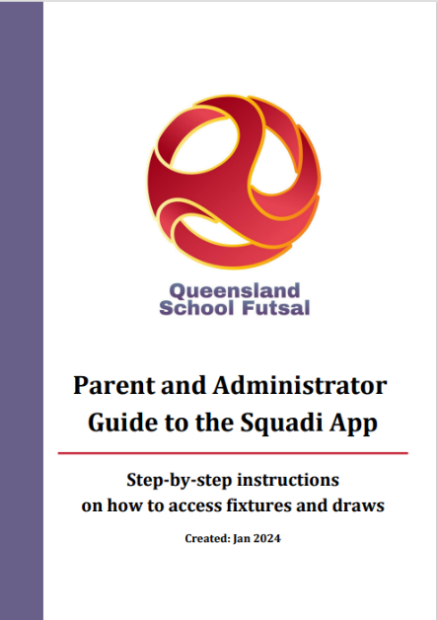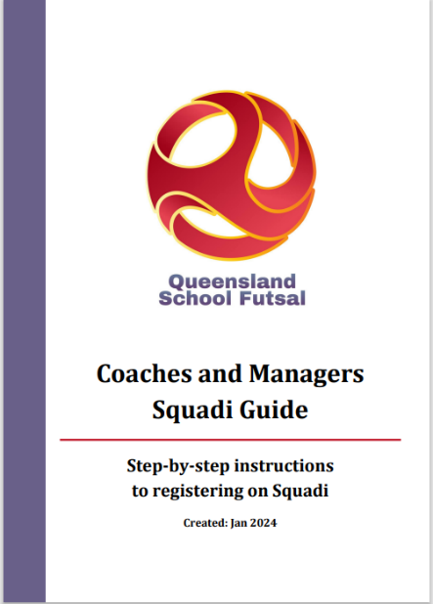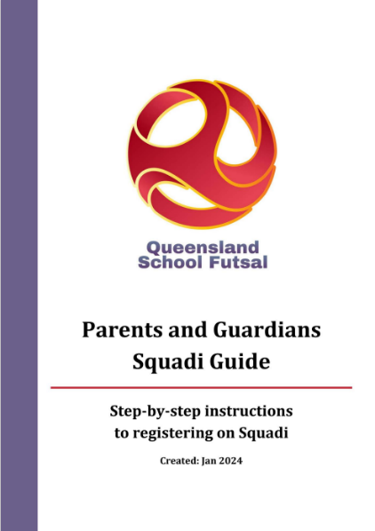
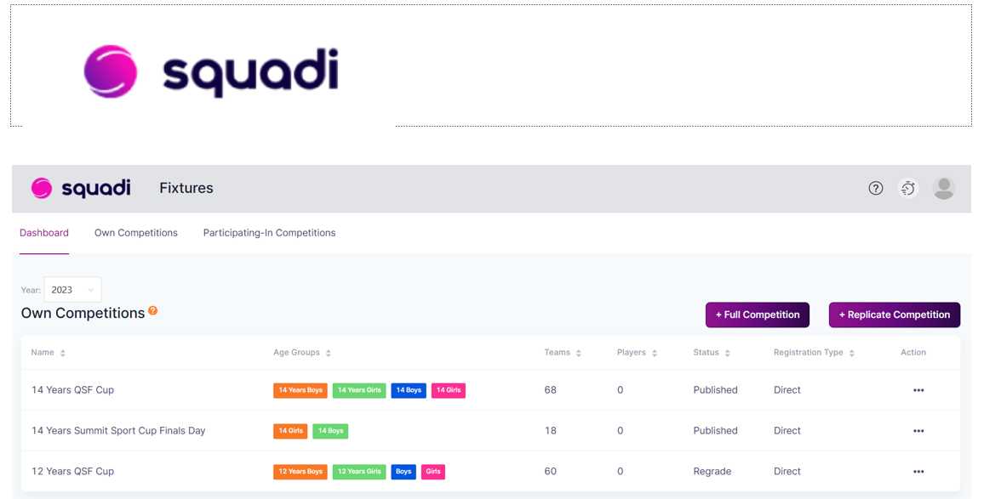

DOCUMENTS
All SFL documents can be found on the QSF Website page



QSF Website – queenslandschoolfutsal.com

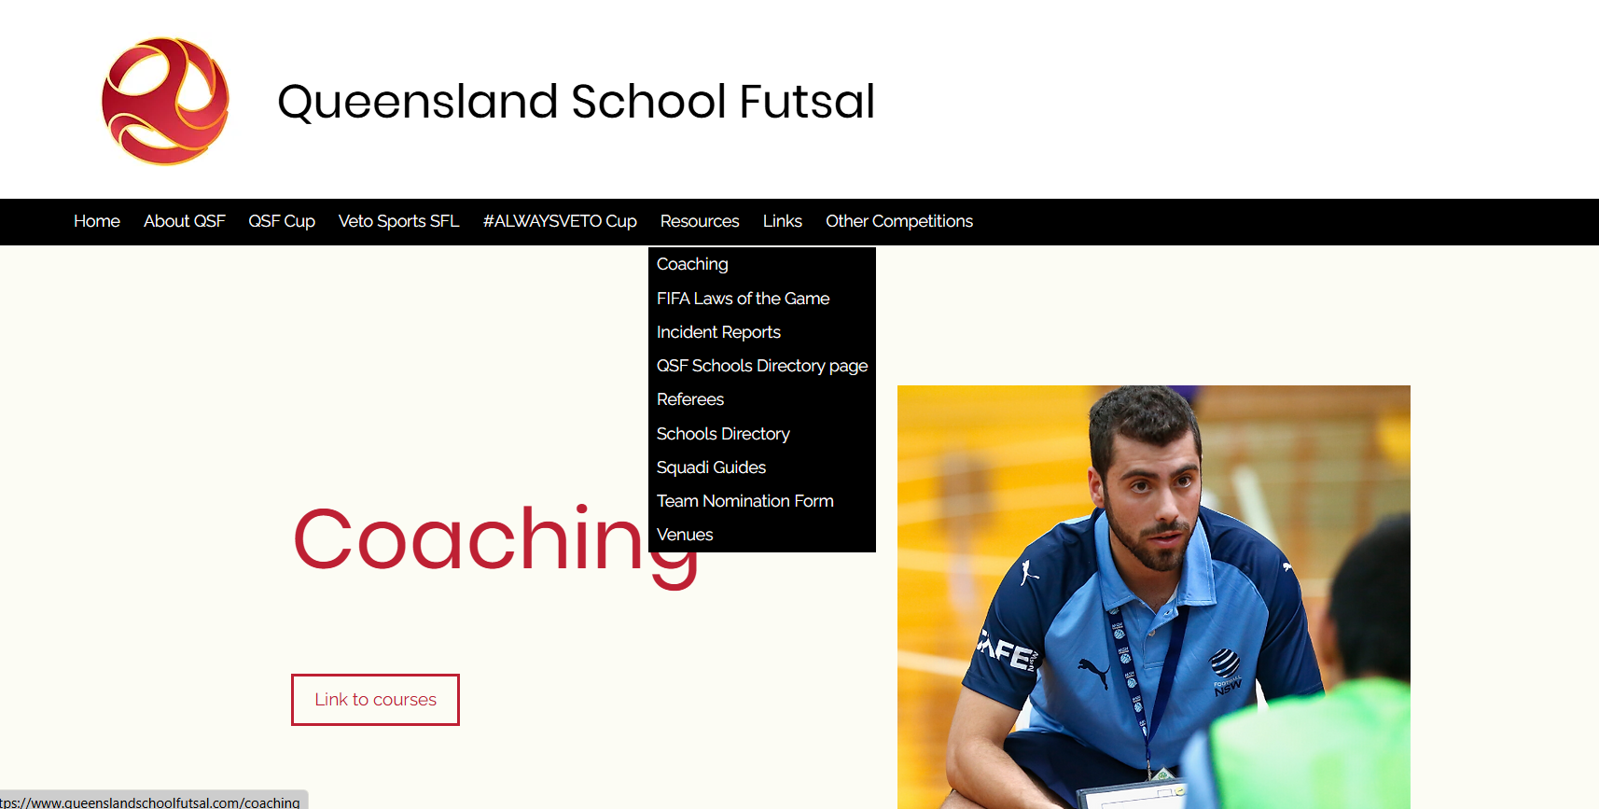

TEAM LISTS
Schools are to complete the QSF competition team list form with names, birthdates and principals’ signature and be brought to every Gala Day and be handed to the convenors on each Gala Day (admin@queenslandschoolfutsal.com)
Team lists are available on the QSF Website.
QSF Team Nomination Form | Queensland School Futsal

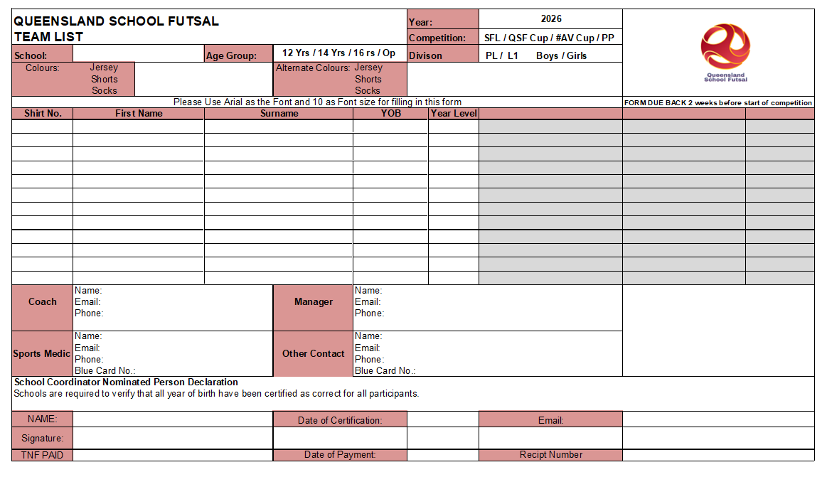

SQUAD LISTS
It is requested that “School Squad lists” be completed with names, birthdates and photos and sent to the convenors (admin@queenslandschoolfutsal.com) before the beginning of the season.

Squad lists are available on the QSF Website

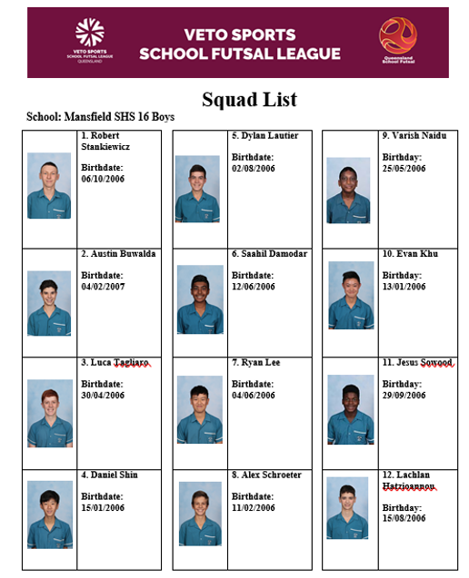

COMMUNICATION
All Coaches and managers are required to join the QSF WhatsApp group for quick communication purposes before and during the season and will provide updated results, Contact points and news

QSF WhatsApp Group


STAFF

Competition Coordinator Referee Coordinator
Alan Pradella Fiona Stevenson



Gala Day Convenors
Stephanie Stanyer Gervais Morton


SOCIAL MEDIA
QSF has a Facebook page and Instagram account for results posts, videos and general advertising purposes. We would like everyone to invite school staff, students, parents and friends to follow the pages.
We also encourage coaches and managers to complete the “Player” and “Coach” Profiles and forward them to the QSF Social Media Coordinator – Matt Pickham at mpick68@eq.edu.au

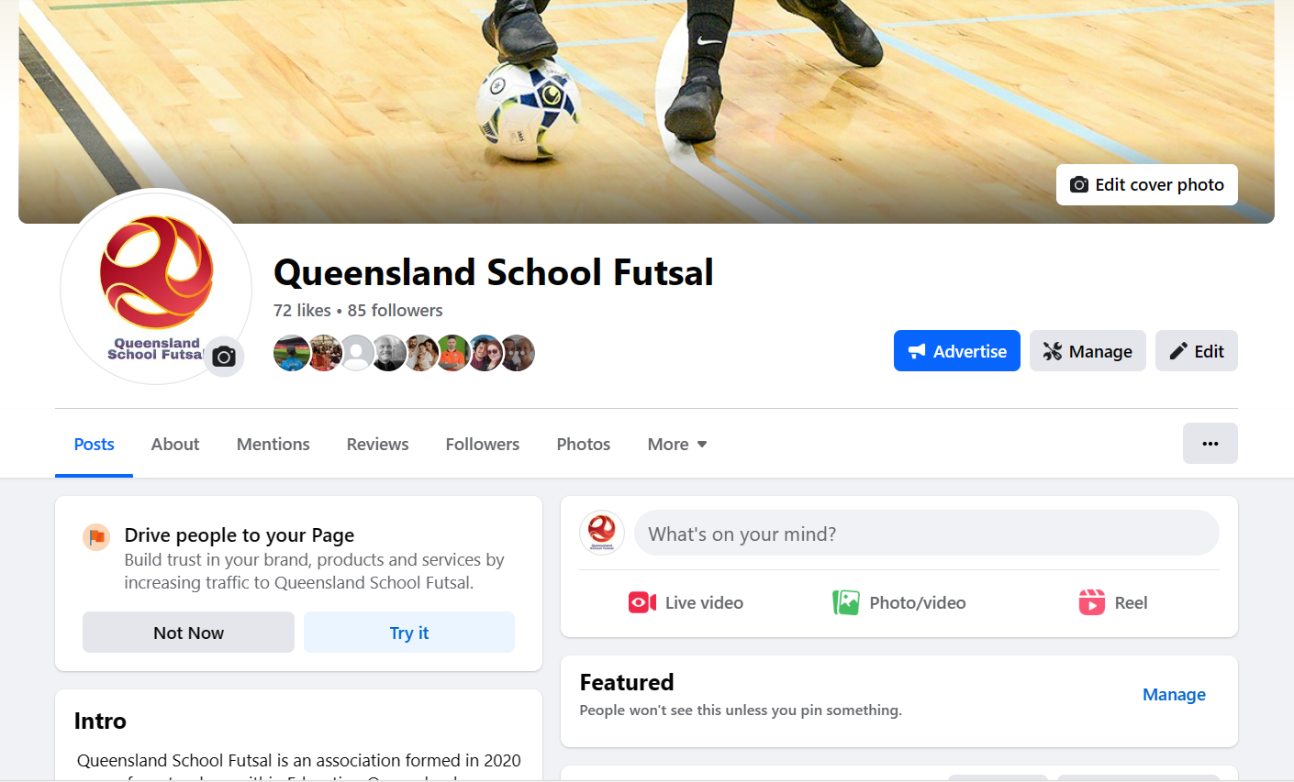


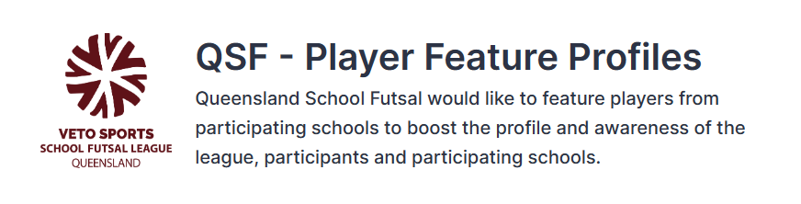
A QSF – Player Feature profile form will be available on the QSF website. Please fill in the questions on behalf of one player who participates in the VETO Sports SFL to be highlighted by QSF on the social media channels. Each school will be featured once throughout the year.
This form must be supplied via email with an image of the feature player – a headshot or action shot. Preferably in portrait version
By submitting this form, you accept that the player and their guardian has given their permission to be featured and for their image to be shared on QSF social media channels and/or the QSF website.
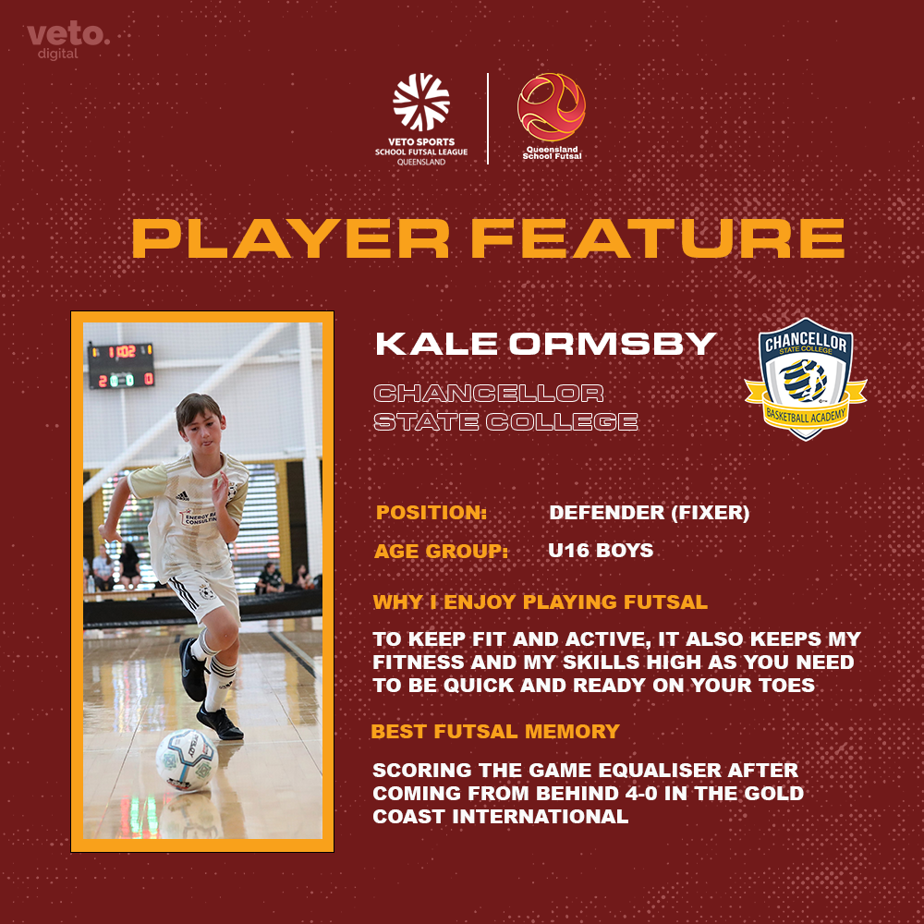
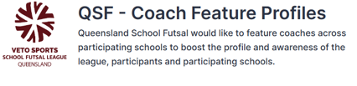
A QSF – Coach Feature profile form will be available on the QSF website. Please fill in the questions on behalf of one teacher or HOD who participates in the VETO Sports SFL to be highlighted by QSF on the social media channels. Each school will be featured once throughout the year.
This form must be supplied via email with an image of the feature player – a headshot or action shot. Preferably in portrait version
By submitting this form, you accept that the player and their guardian has given their permission to be featured and for their image to be shared on QSF social media channels and/or the QSF website.
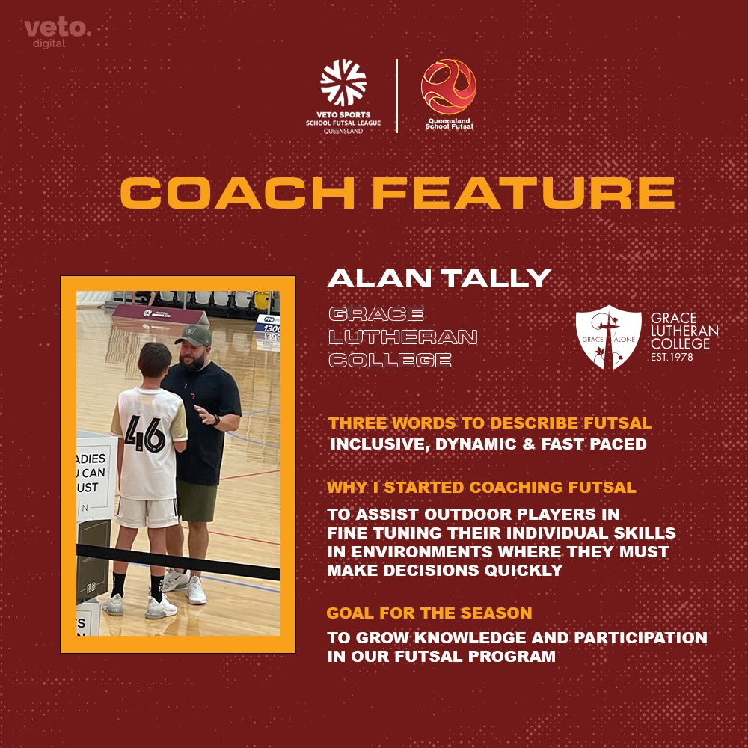

SPONSORS
VETO SPORTS are the official sponsors of the SFL and will supply match balls and official’s polos with SFL logo and School crests. VETO Sports can supply team uniforms and all Futsal related training equipment
Trophies, Medals and Awards
Conference Premiers will receive a Perpetual Premiers trophy.
Veto Sports Champions will receive the Veto Sports Perpetual and a take-home trophy. Champions, Runners up and third place getters will receive medals.

Veto Sports Shield and Plate winners will receive the Veto Sports Perpetual trophy. Shield and Plate Champions, Runners up and third place getters will receive medals

League one Champions will receive a perpetual and take-home trophy. Winner and runners up will receive medals.

A Veto $50 voucher will be awarded to the Player of the Grand Final










All schools are provided with 2 FREE polo shirts which include the school logo heat pressed on the polo with the Queensland School Futsal logo.
Additional polo shirts are $30 inc GST each.

PRO-PLAYER are secondary sponsors of the SFL and will provide coaching programs to all schools

PRO-PLAYER offer unparalleled support to schools through specialised coaching programs and consultancy services. This unique opportunity brings the expertise of ex-professional player directly into the training environment, enhancing the development of young and aspiring players.
The PRO-PLAYER team, comprised of experienced professionals from various football backgrounds, focuses on delivering high-quality training, expert knowledge and the advice for future careers in football or the football industry.
Partnership with PRO-PLAYER not only boosts the skill level of individual athletes but also elevates the overall standard of sports programs, fostering a culture of excellence and ambition. This collaboration represents a significant step forward in nurturing talent and promoting sports as a career path for the youth.



