2027
VETO SPORTS
SCHOOL FUTSAL LEAGUE

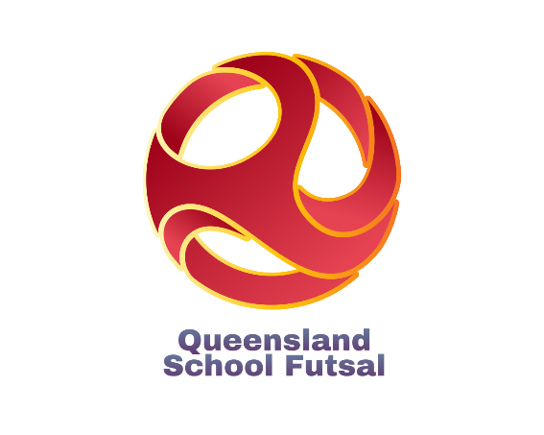

Information
Updated 4 September 2026
Table of Contents

Competition details | ……………………………………….. | 3
2027 Conference Pools & Finals
Open Years | ………………………………………… | 4
16 Years | ……………………………………….. | 8
14 Years | ……………………………………….. | 12
12 Years | ……………………………………….. | 16
Competition Dates
Central Conference | ………………………………………… | 20
Western Conference | ……………………………………….. | 21
Northern Conference | ……………………………………….. | 22
Southern Conference | ……………………………………….. | 23
Competition Procedures:
Match Rules | ……………………………………….. | 24
Costs/Referees | ……………………………………….. | 26
Draws and Results | ……………………………………….. | 26
Documents | ……………………………………….. | 27
Team Lists | ………………………………………. | 27
Squad Lists | ………………………………………. | 28
Communication | ………………………………………. | 29
Staff | ………………………………………. | 30
Social media | ………………………………………. | 31
Sponsors | ………………………………………. | 34
2027 QSF Calendar | ………………………………………. | 35
2027 QSF Dates | ………………………………………. | 36

Competition Details
- The VETO SPORTS 2027 School Futsal League is a competition for Boys and Girls in four age divisions – 12, 14, 16 & Open divided into 2 Divisions – Premier League and League One.
- The competition runs across 4 Conferences
- Each age division will be comprised of pools of 10 or 6 teams and will play “1 round of 9” or “2 rounds of 5” matches over 3 Gala Days (3 -4 Rounds per Gala Day).
- There will be 1 Gala Day in terms 1, 2 & 3 & Finals in Term 4.
- The Open & 14 Years and 16 & 12 Years Premier League & League One Boys and girls' rounds will be designed to be grouped to be played together on the same Gala Days.
- The Finals qualifying format will be dependent on the number of teams in each of the four conferences. (See following pages)

AGE GROUPS: Boys and Girls
- 12 Years (Students cannot turn 13 or older in 2027)
- 14 Years (Students cannot turn 15 or older in 2027)
- 16 Years (Students cannot turn 17 or older in 2027)
- Opens (The open competition will play in Semester 1 only)
Note:
1. Girls cannot play in Boys divisions except in the 12 years age division and only if the school cannot field a girls’ team.
2. Players are allowed to play in more than ONE division for the season. i.e.., a 16 year can play in both the 16 years age division and the Open division etc.,

CONFERENCE PREMIERS & FINALS FORMAT:
- Teams finishing first in each conference pool after the round matches will be crowned “Conference Premiers”.
- The overall VETO SPORTS SFL Champions will be decided in each age group and division depending on the format of the individual conference pools.
- If divisions have Teams in all four conferences, teams finishing 1st & 2nd, 3rd & 4th & 5th & 6th in each pool will qualify for the VETO SPORTS SFL Champion, Shield & Plate finals respectively.
- Finals formats will differ for divisions that do not contain pools in all “Four Conferences” (Finals format on pages 5-18)
NOMINATIONS:
- Nomination forms via links are available on the QSF website.
- Nominations close at the end of Week 4 of Term 4, 2026. (12 Years competition close Week 3, Term 1, 2027)
- All divisions will have a maximum of 10 or 6 Boys and Girls teams, so schools nominating after the competition limits have been filled, will be placed on "Reserve" lists.
- Schools may nominate teams in any of the divisions, in all age brackets (i.e., a school can nominate a 14 Boys team in the Premier League and a separate 14 Boys team in League One) but schools can only nominate “One” team in each separate division (unless there are “Bye” positions).
- Schools must supply 2 separate team lists and nominated League One players may play up in the Premier League but nominated Premier League players cannot play down. (If a registered PL player is found playing in a L1 team the team will forfeit the points)
- After receiving all nominations, QSF will allocate teams from each age division into pools. Schools will then be given the right of reply to the organised divisions and rearrangement will occur if needed.
- A Grading Day will be made available for all schools on Week 3. Nominated teams will be placed in mixed pools of the same age group and all teams will play 3 matches on the day against teams of varied abilities.
- All Nominations below are still incomplete
2027 OPEN BOYS (Premier League)

Northern |  | Southern |  | Western |  | Central
Kawana |  | Coomera AC |  | Ripley Valley |  | Kedron
Chancellor |  | Helensvale |  | St Peter Clav |  | Albany Creek
Good Sam |  | Kingscliff |  | Redbank Plains |  | Redcliffe
Murrumba |  | Kings |  | Kenmore |  | Mansfield
Grace College Rothwell |  | Ormeau Woods |  |  |  | Mabel Park
 |  | St Andrews |  |  |  | Shailer Park
Competition Format
One pool of 6 |  | One pool of 6 |  | One pool of 6 |  | One pool of 6
Two rounds of matches |  | Two rounds of matches |  | Two rounds of matches |  | Two rounds of matches
10 Matches |  | 10 Matches |  | 10 Matches |  | 10 Matches
3 Gala Days |  | 3 Gala Days |  | 3 Gala Days |  | 3 Gala Days
Champions Finals Qualification
1st & 2nd |  | 1st & 2nd |  | 1st & 2nd |  | 1st & 2nd
Shield Finals Qualification
3rd, 4th |  | 3rd, 4th |  | 3rd, 4th |  | 3rd, 4th
Plate Finals Qualification
5th, 6th |  | 5th, 6th |  | 5th, 6th |  | 5th, 6th

Open Boys Premier – Competition & Finals Format
- All four conferences will play 2 rounds (10 matches) within 3 Gala Days
- The teams finishing 1st and 2nd in ALL 4 Conferences will qualify for the Champions Finals.
- Teams finishing 3rd and 4th will qualify for the Shield Finals
- Teams finishing 5th and 6th will qualify for the Plate Finals

2027 OPEN BOYS (League One)
Northern |  | Southern |  | Western |  | Central
Kawana |  | Pimpama |  | Hillbrook |  | Kimberley
 |  | LORDS |  | Lowood |  | BAC
 |  | Helensvale |  |  |  | St James
 |  | Miami |  |  |  | Rochedale
Bribie Island |  | Ormeau Woods |  | DDAC |  | Bellbird Park
 |  | Beenleigh |  |  |  | Mansfield
 |  | Men of Business |  | Beaudesert |  | Clayfield
 |  | Coombabah |  | BSSSC |  | Wisdom
 |  | Mullumbimby |  | Highfields |  | ICB
 |  | Foxwell |  | Indooroopilly |  | Woodridge
 |  |  |  | Springfield Central SHS |  | Calamvale

Competition Format
1 Pools of 6 |  | 1 Pool of 10 |  | 1 Pool of 10 |  | 1 Pool of 10
2 Rounds of matches |  | 1 Round of Matches |  | 1 Round of 9 Matches |  | 9
10 Matches |  | 9 Mathes |  | 9 Matches |  | 9 Matches
3 Gala Days |  | 3 gala Days |  | 3 Gala Days |  | 3 gala Days
Champions Finals Qualification
1st & 2nd |  | 1st & 2nd |  | 1st & 2nd |  | 1st & 2nd
Shield Finals Qualification
3rd, 4th |  | 3rd, 4th |  | 3rd, 4th |  | 3rd, 4th
Plate Finals Qualification
5th, 6th |  | 5th, 6th |  | 5th, 6th |  | 5th, 6th

Open Boys League One - Finals Format
- The Teams finishing 1st and 2nd in ALL Four conferences will qualify for the Champions Finals.
- Teams finishing 3rd and 4th will qualify for the Shield Finals
- Teams Finishing 5th and 6th
2027 OPEN GIRLS (Premier League)

Northern |  | Southern |  | Western |  | Central
Kawana |  | Pimpama |  | Ripley Valley
Chancellor |  |  |  | St Ursulas |  | Albany Creek
Grace College Rothwell |  |  |  | BSSSC
Murrumba |  |  |  | Indooroopilly
 |  | St Andrews
Competition Format
One pool of 6 |  | One pool of 6 |  | One pool of 6 |  | One pool of 6
Two rounds of matches |  | Two rounds of matches |  | Two rounds of matches |  | Two rounds of matches
10 Matches |  | 10 Matches |  | 10 Matches |  | 10 Matches
3 Gala Days |  | 3 Gala Days |  | 3 Gala Days |  | 3 Gala Days
Champions Finals Qualification
1st & 2nd |  | 1st & 2nd |  | 1st & 2nd |  | 1st & 2nd
Shield Finals Qualification
3rd, 4th |  | 3rd, 4th |  | 3rd, 4th |  | 3rd, 4th
Plate Finals Qualification
5th, 6th |  | 5th, 6th |  | 5th, 6th |  | 5th, 6th

Open Girls Premier – Competition & Finals Format
- All four conferences will play 2 rounds (10 matches) within 3 Gala Days
- The teams finishing 1st and 2nd in ALL 4 Conferences will qualify for the Champions Finals.
- Teams finishing 3rd and 4th will qualify for the Shield Finals
- Teams finishing 5th and 6th will qualify for the Plate Finals

2027 OPEN GIRLS (League One)
Northern |  | Southern |  | Western |  | Central
Kawana |  | Ballina Coast |  | Hillbrook |  | Redeemer
 |  |  |  | Lowood |  | BAC
Good Sam |  | Helensvale |  |  |  | St James
 |  |  |  |  |  | Kedron
 |  |  |  | DDAC |  | Shailer Park
 |  |  |  |  |  | Calamvale
 |  |  |  |  |  | Wisdom
 |  | Mullumbimby |  | Springfield Central SHS |  | ICB
 |  | Kingscliff |  | St Peter Claver |  | Woodridge

Competition Format
1 Pools of 6 |  | 1 Pool of 10 |  | 1 Pool of 10 |  | 1 Pool of 10
2 Rounds of matches |  | 1 Round of Matches |  | 1 Round of 9 Matches |  | 9
10 Matches |  | 9 Mathes |  | 9 Matches |  | 9 Matches
3 Gala Days |  | 3 gala Days |  | 3 Gala Days |  | 3 gala Days
Champions Finals Qualification
1st & 2nd |  | 1st & 2nd |  | 1st & 2nd |  | 1st & 2nd
Shield Finals Qualification
3rd, 4th |  | 3rd, 4th |  | 3rd, 4th |  | 3rd, 4th
Plate Finals Qualification
5th, 6th |  | 5th, 6th |  | 5th, 6th |  | 5th, 6th

Open Girls League One - Finals Format
- The Teams finishing 1st and 2nd in ALL Four conferences will qualify for the Champions Finals.
- Teams finishing 3rd and 4th will qualify for the Shield Finals
Teams Finishing 5th and 6th

2027 16 BOYS (Premier League)

Northern |  | Southern |  | Western |  | Central
Kawana |  | Coomera AC |  | Ripley Valley |  | ICB
Chancellor |  | Helensvale |  |  |  | Albany Creek
Good Sam |  | Kingscliff |  |  |  | Rochedale
Murrumba |  | Kings |  | Kenmore |  | Mansfield
Grace College Rothwell |  | Ormeau Woods |  | Redbank Plains |  | Mabel Park
 |  | Graceview AC |  |  |  | Bellbird Park
 |  | St Andrews |  | BSSSC
Competition Format
One pool of 6 |  | One pool of 6 |  | One pool of 6 |  | One pool of 6
Two rounds of matches |  | Two rounds of matches |  | Two rounds of matches |  | Two rounds of matches
10 Matches |  | 10 Matches |  | 10 Matches |  | 10 Matches
3 Gala Days |  | 3 Gala Days |  | 3 Gala Days |  | 3 Gala Days
Champions Finals Qualification
1st & 2nd |  | 1st & 2nd |  | 1st & 2nd |  | 1st & 2nd
Shield Finals Qualification
3rd, 4th |  | 3rd, 4th |  | 3rd, 4th |  | 3rd, 4th
Plate Finals Qualification
5th, 6th |  | 5th, 6th |  | 5th, 6th |  | 5th, 6th

16 Boys Premier – Competition & Finals Format
- All four conferences will play 2 rounds (10 matches) within 3 Gala Days
- The teams finishing 1st and 2nd in ALL 4 Conferences will qualify for the Champions Finals.
- Teams finishing 3rd and 4th will qualify for the Shield Finals
- Teams finishing 5th and 6th will qualify for the Plate Finals

2027 16 BOYS (League One)
Northern |  | Southern |  | Western |  | Central
Kawana |  | Pimpama |  | Ripley Valley |  | Kimberley
James Nash |  | Ballina Coast |  | Hillbrook |  | BAC
Grace Luth Coll |  | Helensvale |  | Concordia |  | St James
Murrumba |  | Tweed River |  | Kenmore |  | Mt Gravatt
Bribie Island |  | Ormeau Woods |  | Beaudesert |  | Clayfield
Nambour SSC |  | Kingscliff |  | Highfields |  | Mansfield
Cooloola CC |  | Kings |  | Bremer |  | Clayfield
 |  | Coombabah |  | Indooroopilly |  | Wisdom
 |  | Coomera |  | Springfield Central SHS |  | Loganlea
 |  | Beenleigh |  |  |  | Woodridge
 |  | Mullumbimby
 |  | St Stephens
 |  | Hillcrest
 |  | Foxwell

Competition Format
1 Pools of 6 |  | 1 Pool of 10 |  | 1 Pool of 10 |  | 1 Pool of 10
2 Rounds of matches |  | 1 Round of Matches |  | 1 Round of 9 Matches |  | 9
10 Matches |  | 9 Mathes |  | 9 Matches |  | 9 Matches
3 Gala Days |  | 3 gala Days |  | 3 Gala Days |  | 3 gala Days
Champions Finals Qualification
1st & 2nd |  | 1st & 2nd |  | 1st & 2nd |  | 1st & 2nd
Shield Finals Qualification
3rd, 4th |  | 3rd, 4th |  | 3rd, 4th |  | 3rd, 4th
Plate Finals Qualification
5th, 6th |  | 5th, 6th |  | 5th, 6th |  | 5th, 6th

16 Boys League One - Finals Format
- The Teams finishing 1st and 2nd in ALL Four conferences will qualify for the Champions Finals.
- Teams finishing 3rd and 4th will qualify for the Shield Finals
- Teams Finishing 5th and 6th
2027 16 GIRLS (Premier League)

Northern |  | Southern |  | Western |  | Central
Kawana |  | Coomera AC |  | Ripley Valley |  | Kimberley
Chancellor |  | Helensvale |  | St Ursulas |  | Albany Creek
Good Sam |  | Tweed Heads |  |  |  | Rochedale
Murrumba |  | Kings |  | Kenmore |  | Mansfield
Grace College Rothwell
Competition Format
One pool of 6 |  | One pool of 6 |  | One pool of 6 |  | One pool of 6
Two rounds of matches |  | Two rounds of matches |  | Two rounds of matches |  | Two rounds of matches
10 Matches |  | 10 Matches |  | 10 Matches |  | 10 Matches
3 Gala Days |  | 3 Gala Days |  | 3 Gala Days |  | 3 Gala Days
Champions Finals Qualification
1st & 2nd |  | 1st & 2nd |  | 1st & 2nd |  | 1st & 2nd
Shield Finals Qualification
3rd, 4th |  | 3rd, 4th |  | 3rd, 4th |  | 3rd, 4th
Plate Finals Qualification
5th, 6th |  | 5th, 6th |  | 5th, 6th |  | 5th, 6th

16 Girls Premier – Competition & Finals Format
- All four conferences will play 2 rounds (10 matches) within 3 Gala Days
- The teams finishing 1st and 2nd in ALL 4 Conferences will qualify for the Champions Finals.
- Teams finishing 3rd and 4th will qualify for the Shield Finals
- Teams finishing 5th and 6th will qualify for the Plate Finals

2027 16 GIRLS (League One)
Northern |  | Southern |  | Western |  | Central
Kawana |  | Pimpama |  | Hillbrook
 |  |  |  | Ripley Valley |  | BAC
 |  | Helensvale |  |  |  | St James
Bribie Island |  | Ormeau Woods |  | St Peter Claver |  | Mabel Park
 |  | Kingscliff |  | Springfield Central SHS
 |  |  |  | Bremer |  | Calamvale
 |  |  |  | BSSSC |  | Wisdom
 |  | Mullumbimby |  | Beaudesert |  | ICB
 |  | Hillcrest |  | Indooroopilly |  | Loganlea

Competition Format
1 Pools of 6 |  | 1 Pool of 10 |  | 1 Pool of 10 |  | 1 Pool of 10
2 Rounds of matches |  | 1 Round of Matches |  | 1 Round of 9 Matches |  | 9
10 Matches |  | 9 Mathes |  | 9 Matches |  | 9 Matches
3 Gala Days |  | 3 gala Days |  | 3 Gala Days |  | 3 gala Days
Champions Finals Qualification
1st & 2nd |  | 1st & 2nd |  | 1st & 2nd |  | 1st & 2nd
Shield Finals Qualification
3rd, 4th |  | 3rd, 4th |  | 3rd, 4th |  | 3rd, 4th
Plate Finals Qualification
5th, 6th |  | 5th, 6th |  | 5th, 6th |  | 5th, 6th

16 Girls League One - Finals Format
- The Teams finishing 1st and 2nd in ALL Four conferences will qualify for the Champions Finals.
- Teams finishing 3rd and 4th will qualify for the Shield Finals
Teams Finishing 5th and 6th

2027 14 BOYS (Premier League)

Northern |  | Southern |  | Western |  | Central
Kawana |  | Coomera AC |  | Ripley Valley |  | Kimberley
Chancellor |  | Helensvale |  | St Peter Clav |  | Albany Creek
Good Sam |  | LORDS |  |  |  | ICB
Murrumba |  | Kings |  |  |  | Mansfield
Grace College Rothwell |  | Ormeau Woods |  |  |  | Shailer Park
 |  | Assisi
Competition Format
One pool of 6 |  | One pool of 6 |  | One pool of 6 |  | One pool of 6
Two rounds of matches |  | Two rounds of matches |  | Two rounds of matches |  | Two rounds of matches
10 Matches |  | 10 Matches |  | 10 Matches |  | 10 Matches
3 Gala Days |  | 3 Gala Days |  | 3 Gala Days |  | 3 Gala Days
Champions Finals Qualification
1st & 2nd |  | 1st & 2nd |  | 1st & 2nd |  | 1st & 2nd
Shield Finals Qualification
3rd, 4th |  | 3rd, 4th |  | 3rd, 4th |  | 3rd, 4th
Plate Finals Qualification
5th, 6th |  | 5th, 6th |  | 5th, 6th |  | 5th, 6th

14 Boys Premier – Competition & Finals Format
- All four conferences will play 2 rounds (10 matches) within 3 Gala Days
- The teams finishing 1st and 2nd in ALL 4 Conferences will qualify for the Champions Finals.
- Teams finishing 3rd and 4th will qualify for the Shield Finals
- Teams finishing 5th and 6th will qualify for the Plate Finals

2027 14 BOYS (League One)
Northern |  | Southern |  | Western |  | Central
Kawana |  | Pimpama |  | Hillbrook |  | Kimberley
James Nash |  | Ballina Coast |  | Lowood |  | BAC
Grace LC |  | Helensvale |  | Ripley Valley |  | St James
Murrumba |  | Tweed River |  | Kenmore |  | Rochedale
Bribie Island |  | Ormeau Woods |  | DDAC |  | Mabel Park
 |  | Kingscliff |  | BSSSC |  | Mansfield
 |  | Kings |  | Beaudesert |  | Clayfield
 |  | Coombabah |  | Bremer |  | Wisdom
 |  | Mullumbimby |  | Springfield Central SHS |  | Bellbird Park
 |  | St Stephens
 |  | Hillcrest
 |  | St Andrews
 |  | Foxwell

Competition Format
1 Pools of 6 |  | 1 Pool of 10 |  | 1 Pool of 10 |  | 1 Pool of 10
2 Rounds of matches |  | 1 Round of Matches |  | 1 Round of 9 Matches |  | 9
10 Matches |  | 9 Mathes |  | 9 Matches |  | 9 Matches
3 Gala Days |  | 3 gala Days |  | 3 Gala Days |  | 3 gala Days
Champions Finals Qualification
1st & 2nd |  | 1st & 2nd |  | 1st & 2nd |  | 1st & 2nd
Shield Finals Qualification
3rd, 4th |  | 3rd, 4th |  | 3rd, 4th |  | 3rd, 4th
Plate Finals Qualification
5th, 6th |  | 5th, 6th |  | 5th, 6th |  | 5th, 6th

14 Boys League One - Finals Format
- The Teams finishing 1st and 2nd in ALL Four conferences will qualify for the Champions Finals.
- Teams finishing 3rd and 4th will qualify for the Shield Finals
- Teams Finishing 5th and 6th
2027 14 GIRLS (Premier League)

Northern |  | Southern |  | Western |  | Central
Kawana |  | Coomera AC |  | Ripley Valley
Chancellor |  | Helensvale |  |  |  | Albany Creek
Good Sam |  | Kings |  |  |  | CB
Murrumba |  | LORDS |  |  |  | Mansfield
Grace College Rothwell |  | Ormeau Woods |  |  |  | Mabel Park
 |  | St Andrews |  | St Peter Claver
Competition Format
One pool of 6 |  | One pool of 6 |  | One pool of 6 |  | One pool of 6
Two rounds of matches |  | Two rounds of matches |  | Two rounds of matches |  | Two rounds of matches
10 Matches |  | 10 Matches |  | 10 Matches |  | 10 Matches
3 Gala Days |  | 3 Gala Days |  | 3 Gala Days |  | 3 Gala Days
Champions Finals Qualification
1st & 2nd |  | 1st & 2nd |  | 1st & 2nd |  | 1st & 2nd
Shield Finals Qualification
3rd, 4th |  | 3rd, 4th |  | 3rd, 4th |  | 3rd, 4th
Plate Finals Qualification
5th, 6th |  | 5th, 6th |  | 5th, 6th |  | 5th, 6th

14 Girls Premier – Competition & Finals Format
- All four conferences will play 2 rounds (10 matches) within 3 Gala Days
- The teams finishing 1st and 2nd in ALL 4 Conferences will qualify for the Champions Finals.
- Teams finishing 3rd and 4th will qualify for the Shield Finals
- Teams finishing 5th and 6th will qualify for the Plate Finals

2027 14 GIRLS (League One)
Northern |  | Southern |  | Western |  | Central
Kawana |  | Pimpama |  | Ripley Valley |  | Kimberley
James Nash |  | Helensvale |  | Lowood |  | BAC
 |  | Kingscliff |  | Hillbrook |  | St James
 |  | LORDS |  | Kenmore |  | Rochedale
Bribie Island |  | Ormeau Woods |  | Beaudesert |  | Mt Gravatt
 |  | Tweed River |  | St Marys
 |  | Mullumbimby |  | Bremer |  | Calamvale
 |  | Hillcrest |  |  |  | Wisdom
 |  | Foxwell
 |  | Coombabah

Competition Format
1 Pools of 6 |  | 1 Pool of 10 |  | 1 Pool of 10 |  | 1 Pool of 10
2 Rounds of matches |  | 1 Round of Matches |  | 1 Round of 9 Matches |  | 9
10 Matches |  | 9 Mathes |  | 9 Matches |  | 9 Matches
3 Gala Days |  | 3 gala Days |  | 3 Gala Days |  | 3 gala Days
Champions Finals Qualification
1st & 2nd |  | 1st & 2nd |  | 1st & 2nd |  | 1st & 2nd
Shield Finals Qualification
3rd, 4th |  | 3rd, 4th |  | 3rd, 4th |  | 3rd, 4th
Plate Finals Qualification
5th, 6th |  | 5th, 6th |  | 5th, 6th |  | 5th, 6th

14 Girls League One - Finals Format
- The Teams finishing 1st and 2nd in ALL Four conferences will qualify for the Champions Finals.
- Teams finishing 3rd and 4th will qualify for the Shield Finals
Teams Finishing 5th and 6th

2027 12 BOYS (Premier League)

Northern |  | Southern |  | Western |  | Central
Kawana |  | Coomera AC |  | Ripley Valley |  | Eatons Hill
 |  | LORDS |  |  |  | ICB
 |  | Kings
 |  | St Andrews
Competition Format
One pool of 6 |  | One pool of 6 |  | One pool of 6 |  | One pool of 6
Two rounds of matches |  | Two rounds of matches |  | Two rounds of matches |  | Two rounds of matches
10 Matches |  | 10 Matches |  | 10 Matches |  | 10 Matches
3 Gala Days |  | 3 Gala Days |  | 3 Gala Days |  | 3 Gala Days
Champions Finals Qualification
1st & 2nd |  | 1st & 2nd |  | 1st & 2nd |  | 1st & 2nd
Shield Finals Qualification
3rd, 4th |  | 3rd, 4th |  | 3rd, 4th |  | 3rd, 4th
Plate Finals Qualification
5th, 6th |  | 5th, 6th |  | 5th, 6th |  | 5th, 6th

12 Boys Premier – Competition & Finals Format
- All four conferences will play 2 rounds (10 matches) within 3 Gala Days
- The teams finishing 1st and 2nd in ALL 4 Conferences will qualify for the Champions Finals.
- Teams finishing 3rd and 4th will qualify for the Shield Finals
- Teams finishing 5th and 6th will qualify for the Plate Finals

2027 12 BOYS (League One)
Northern |  | Southern |  | Western |  | Central
 |  | Pimpama |  | Yugumbir |  | Eatons Hill
 |  | Graceview |  |  |  | Calamvale
Good Sam |  | Kings |  |  |  | Carole Park
Grace Luth |  |  |  |  |  | BAC
 |  | Coomera AC |  |  |  | Kimberley
 |  | Hillcrest |  |  |  | Brighton
 |  | St Andrews |  |  |  | Ithaca Creek
 |  |  |  |  |  | Wisdom
 |  |  |  |  |  | St James

Competition Format
1 Pools of 6 |  | 1 Pool of 10 |  | 1 Pool of 10 |  | 1 Pool of 10
2 Rounds of matches |  | 1 Round of Matches |  | 1 Round of 9 Matches |  | 9
10 Matches |  | 9 Mathes |  | 9 Matches |  | 9 Matches
3 Gala Days |  | 3 gala Days |  | 3 Gala Days |  | 3 gala Days
Champions Finals Qualification
1st & 2nd |  | 1st & 2nd |  | 1st & 2nd |  | 1st & 2nd
Shield Finals Qualification
3rd, 4th |  | 3rd, 4th |  | 3rd, 4th |  | 3rd, 4th
Plate Finals Qualification
5th, 6th |  | 5th, 6th |  | 5th, 6th |  | 5th, 6th

12 Boys League One - Finals Format
- The Teams finishing 1st and 2nd in ALL Four conferences will qualify for the Champions Finals.
- Teams finishing 3rd and 4th will qualify for the Shield Finals
- Teams Finishing 5th and 6th
2027 12 GIRLS (Premier League)

Northern |  | Southern |  | Western |  | Central
 |  | Coomera AC |  | Ripley Valley |  | Eatons Hill
 |  |  |  |  |  | ICB
 |  |  |  |  |  | Stuartholme
 |  | Kings
Competition Format
One pool of 6 |  | One pool of 6 |  | One pool of 6 |  | One pool of 6
Two rounds of matches |  | Two rounds of matches |  | Two rounds of matches |  | Two rounds of matches
10 Matches |  | 10 Matches |  | 10 Matches |  | 10 Matches
3 Gala Days |  | 3 Gala Days |  | 3 Gala Days |  | 3 Gala Days
Champions Finals Qualification
1st & 2nd |  | 1st & 2nd |  | 1st & 2nd |  | 1st & 2nd
Shield Finals Qualification
3rd, 4th |  | 3rd, 4th |  | 3rd, 4th |  | 3rd, 4th
Plate Finals Qualification
5th, 6th |  | 5th, 6th |  | 5th, 6th |  | 5th, 6th

12 Girls Premier – Competition & Finals Format
- All four conferences will play 2 rounds (10 matches) within 3 Gala Days
- The teams finishing 1st and 2nd in ALL 4 Conferences will qualify for the Champions Finals.
- Teams finishing 3rd and 4th will qualify for the Shield Finals
- Teams finishing 5th and 6th will qualify for the Plate Finals

2027 12 GIRLS (League One)
Northern |  | Southern |  | Western |  | Central
 |  | Pimpama |  | Yugumbir |  | Eatons Hill
 |  |  |  |  |  | BAC
Good Sam |  | Hillcrest |  |  |  | St James
 |  |  |  |  |  | Ithaca Creek
 |  |  |  |  |  | Wisdom

Competition Format
1 Pools of 6 |  | 1 Pool of 10 |  | 1 Pool of 10 |  | 1 Pool of 10
2 Rounds of matches |  | 1 Round of Matches |  | 1 Round of 9 Matches |  | 9
10 Matches |  | 9 Mathes |  | 9 Matches |  | 9 Matches
3 Gala Days |  | 3 gala Days |  | 3 Gala Days |  | 3 gala Days
Champions Finals Qualification
1st & 2nd |  | 1st & 2nd |  | 1st & 2nd |  | 1st & 2nd
Shield Finals Qualification
3rd, 4th |  | 3rd, 4th |  | 3rd, 4th |  | 3rd, 4th
Plate Finals Qualification
5th, 6th |  | 5th, 6th |  | 5th, 6th |  | 5th, 6th

Open Boys League One - Finals Format
- The Teams finishing 1st and 2nd in ALL Four conferences will qualify for the Champions Finals.
- Teams finishing 3rd and 4th will qualify for the Shield Finals
Teams Finishing 5th and 6th

Competition Dates

Central Conference | Nissan Arena Indoor Sports Centre - Mains Road, Macgregor
Confirmed 2027 dates are listed below. Refer to the QSF calendar for any subsequent updates.
Date
Premier / League One | All ages | Grading Day | Fri | 12 Feb
Premier / League One | 14 / Opens | Gala Day 1 | Thu | 18 Feb
Premier / League One | Opens | Gala Day 2 | Fri | 12 Mar
Premier / League One | 12 / 16 | Gala Day 1 | Wed | 17 Mar
Premier / League One | 14 / Opens | Gala Day 2 / 3 | Wed | 28 Apr
Premier / League One | 12 / 16 | Gala Day 2 | Thu | 20 May
Premier / League One | Opens | Finals series | Tue-Thu | 25-27 May
Premier / League One | 14 | Gala Day 3 | Wed | 18 Aug
Premier / League One | 12 / 16 | Gala Day 3 | Thu | 19 Aug
Premier / League One | 12 | Finals | Mon | 11 Oct
Premier / League One | 16 | Shield / Plate & Champions Finals | Tue-Wed | 12-13 Oct
Premier / League One | 14 | Plate, Shield & Champions Finals | Thu-Fri | 14-15 & Thu 21 Oct

Western Conference | Nissan Arena Indoor Sports Centre - Mains Road, Macgregor
Confirmed 2027 dates are listed below. Refer to the QSF calendar for any subsequent updates.
Date
Premier / League One | All ages | Grading Day | Fri | 12 Feb
Premier / League One | 14 / Opens | Gala Day 1 | Mon | 15 Feb
Premier / League One | Opens | Gala Day 2 | Thurs | 11 Mar
Premier / League One | 12 / 16 | Gala Day 1 | Mon | 15 Mar
Premier / League One | 14 / Opens | Gala Day 2 / 3 | Tue | 27 Apr
Premier / League One | 12 / 16 | Gala Day 2 | Tue | 18 May
Premier / League One | Opens | Finals series | Tue-Thu | 25-27 May
Premier / League One | 14 | Gala Day 3 | Tue | 17 Aug
Premier / League One | 12 / 16 | Gala Day 3 | Fri | 20 Aug
Premier / League One | 12 | Finals | Mon | 11 Oct
Premier / League One | 16 | Shield / Plate & Champions Finals | Tue-Wed | 12-13 Oct
Premier / League One | 14 | Plate, Shield & Champions Finals | Thu-Fri | 14-15 & Thu 21 Oct

Northern Conference | Caloundra Indoor Stadium - North Street, Golden Beach
2027 dates listed below are to be confirmed. Refer to the QSF calendar for any subsequent updates.
Dates
Premier / League One | All ages | Grading Day | Fri | 12 Feb
Premier / League One | 14 | Gala Day 1 | Wed | 17 Feb
Premier / League One | Opens | Gala Day 1 | Thu | 18 Feb
Premier League | 12 / 16 | Gala Day 1 | Fri | 19 Feb
Premier / League One | Opens | Gala Day 2 | Wed | 10 Mar
League One | 12 / 16 | Gala Day 2 | Wed | 16 Mar
Premier / League One | 14 | Gala Day 2 | Tue | 27 Apr
Premier / League One | Opens | Gala Day 3 | Wed | 28 Apr
Premier / League One | 16 | Gala Day 2 | Thu | 29 Apr
Premier / League One | 12 | Gala Day 2 | Wed | 19 May
Premier / League One | Opens | Finals series | Tue-Thu | 25-27 May
Premier / League One | 14 | Gala Day 3 | Thu | 22 Jul
Premier / League One | 12 | Gala Day 3 | Tue | 17 Aug
Premier / League One | 16 | Gala Day 3 | Wed | 18 Aug
Premier / League One | 12 | Finals | Mon | 11 Oct
Premier / League One | 16 | Shield / Plate & Champions Finals | Tue-Wed | 12-13 Oct
Premier / League One | 14 | Plate, Shield & Champions Finals | Thu-Fri | 14-15 & Thu 21 Oct

Southern Conference | Coomera Indoor Sports Centre - Beattie Road, Coomera
2027 dates listed below are to be confirmed. Refer to the QSF calendar for any subsequent updates.
Date
Premier / League One | All ages | Grading Day | Fri | 12 Feb
Premier / League One | 14 / Opens | Gala Day 1 | Tue | 16 Feb
Premier / League One | Opens | Gala Day 2 | Tue | 9 Mar
Premier / League One | 12 / 16 | Gala Day 1 | Thu | 18 Mar
Premier / League One | 14 / Opens | Gala Day 2 / 3 | Fri | 30 Apr
Premier / League One | 12 / 16 | Gala Day 2 | Mon | 17 May
Premier / League One | Opens | Finals series | Tue-Thu | 25-27 May
Premier / League One | 14 | Gala Day 3 | Mon | 9 Aug
Premier / League One | 12 / 16 | Gala Day 3 | Mon | 16 Aug
Premier / League One | 12 | Finals | Mon | 11 Oct
Premier / League One | 16 | Shield / Plate & Champions Finals | Tue-Wed | 12-13 Oct
Premier / League One | 14 | Plate, Shield & Champions Finals | Thu-Fri | 14-15 & Thu 21 Oct

Procedures and Rules
1. | Each game shall consist of two periods of 20 minutes with a maximum 5-minute half time break
2. | Standard "FIFA - Laws of the Game” will apply to all matches (except that the clock will not be stopped every time the ball goes out of play and restarted when play resumes)
3. | Teams are entitled to a one-minute time-out in each period. A team that does not request a time-out in the first half of the match is only entitled to one time-out during the second half. Time outs can be taken at any time during both halves. The clock will not stop for all timeouts in 50-minute match timeslots but will stop in 60 mins timeslots. In the last 2 minutes of the match, additional time will be determined at the referee’s discretion.
4. | A maximum of 10 players is allowed in each team on match days. (School squads can have a maximum of 24 players and can use different players from the squads in separate matches)  All 10 players can be used in unlimited interchange. All substitutions are to be Rolling substitutions. Substitutions may be made at any time, whether the ball is in play or not, but only in the specially demarcated substitution zones. (G/K's should only be substituted during a stoppage in play).
5. | Yellow Cards - Two yellow cards in the same game will mean the player is sent from the field an automatic suspension for next game plus any punishment met by Disputes committee. Three yellow cards awarded in separate matches across a gala day or final series will also mean suspension of one match. Red cards - Sent off and automatic suspension for next game plus any punishment meted by the Disputes committee. (Dispute committee will be the gala day convenors and the referee coordinator)
6. | All players must wear non-marking soled shoes, shin pads covered by long socks and matching numbered shirts and shorts (except goalkeepers). (referees can prevent players entering the court if not dressed correctly) If there is a clash of colors, it is the "HOME" teams (first named on the draw) responsibility to have an alternate strip or wear bibs.
7. | Home teams will run left to right of the team benches and kick off all matches.
8. | Any Team not on court 5 mins after the scheduled kick off time will start with a 2-goal deficit. i.e., 2 goals will automatically be awarded to the opposition. If there are circumstances out of the team’s control, decided by the dispute committee, then the match time will be reduced to allow a result. Forfeits recorded as 5-0 scores.
9. | Positions in pools will be determined firstly by “Points”, then in the following order - Goal Difference / Goals For / Number of Red & Yellow Cards / Round matches results, then either a 3 Penalty shootout if time permits or “flip” of a coin.  If a match is drawn at full time in a Quarter Final, Semi Final or Grand Final there will be two periods of 5 minutes extra time with no intervals or time-outs, then “FIFA - Laws of the Game” penalty kicks to decide the winner. There are no time-outs in “extra time”, and fouls continue into extra time from the second half of the match.
10. | There will be a “10 Goal Max Goal difference for all results i.e., a 16–1 result will be entered as 11-1. When teams are leading by 10 goals the opposition will be allowed an extra player to join the match and then exit the match if the goal difference falls below 10.
11. | All teams MUST have a teacher present as coach or manager wearing a school crested polo, otherwise teams will not be allowed to participate and will forfeit the match.
12. | Student misbehaviour will not be tolerated. Misbehaviour is any behaviour that is contrary to the Venue rules and Convenors instructions. Initial and all incidents will be reported to the team teacher. If the misbehaviour occurs a second time, the player “in question” will be not allowed to participate in the remaining matches on the day. If 3 “team” incidents are reported, (i.e., 3 separate incidents from players within the team) teams may be liable for a reduction of competition points.


Futsal Laws of the Game 2025-2026

DRAWS
- The Draws for all four conferences will be conducted at the 2027 QSF Term 1 Online meeting in Week 2, Term 1, (Week 4 for the 12 Years) and then posted on the QSF Website.

COSTS
- Schools will be invoiced by QSF in Term 1, 2027 for all three gala days and the Champions & Shield Finals Day.
- Team Nomination fee for 3 Gala Days and Finals Day - $800 per team (GST not included)
- Nomination fees cover venue hire, referees, sports trainers, convenors and admin fees.
- Competition Invoices will be sent in Week 1, Term 1, 2027.
- (Once nomination fees have been paid, any withdrawals from the competition will incur cancellation fees unless substitute schools are found)

REFEREES
- It is intended to have 1-2 FQ Referees for all matches, with 2 referees allocated to Premier League matches.

SPORTS MEDICINE
- A qualified sports trainer will be available at every QSF event. The sports trainer’s primary role is player welfare and in the absence of a doctor has the ultimate decision-making power. Coaches, administrators, teachers, parents and players MUST comply with the trainer’s advice if they rule a player is unfit to play.

DISCIPLINE COMMITTEE
- A discipline committee will decide consequences on all incidents. Incident report sheets can be found on the QSF Website and must be completed by both coaches and sent to the committee by the end of the following day after the match.

RESULTS and TABLES
- Results for Gala Day Conference matches will be recorded on the Referee Match templates and then transferred and recorded on “Squadi” and/or the QSF Website.
- Results for all matches and updated tables can be found on “Squadi” and the QSF Website. Results will be updated after each gala day. (A Squadi link via a QR code will be available at the convenors desk at each venue)
- A “10 goal” max winning GD applied to all matches.
- Squadi guides available on the QSF website

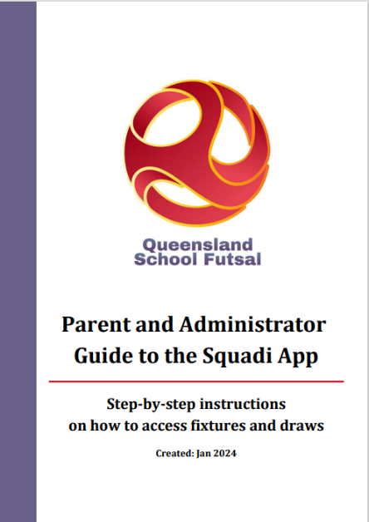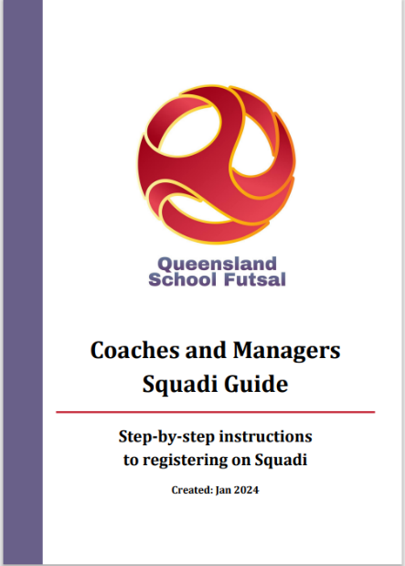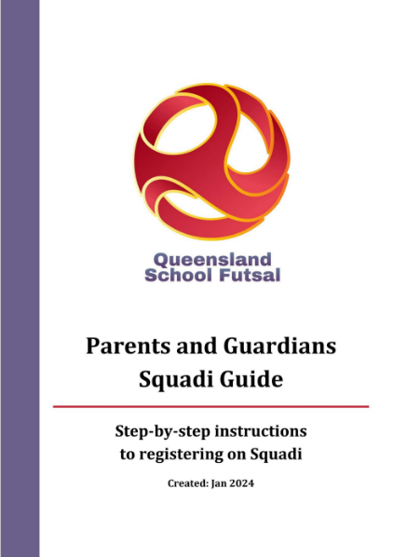

DOCUMENTS
- All SFL documents can be found on the QSF Website page under resources
QSF Website
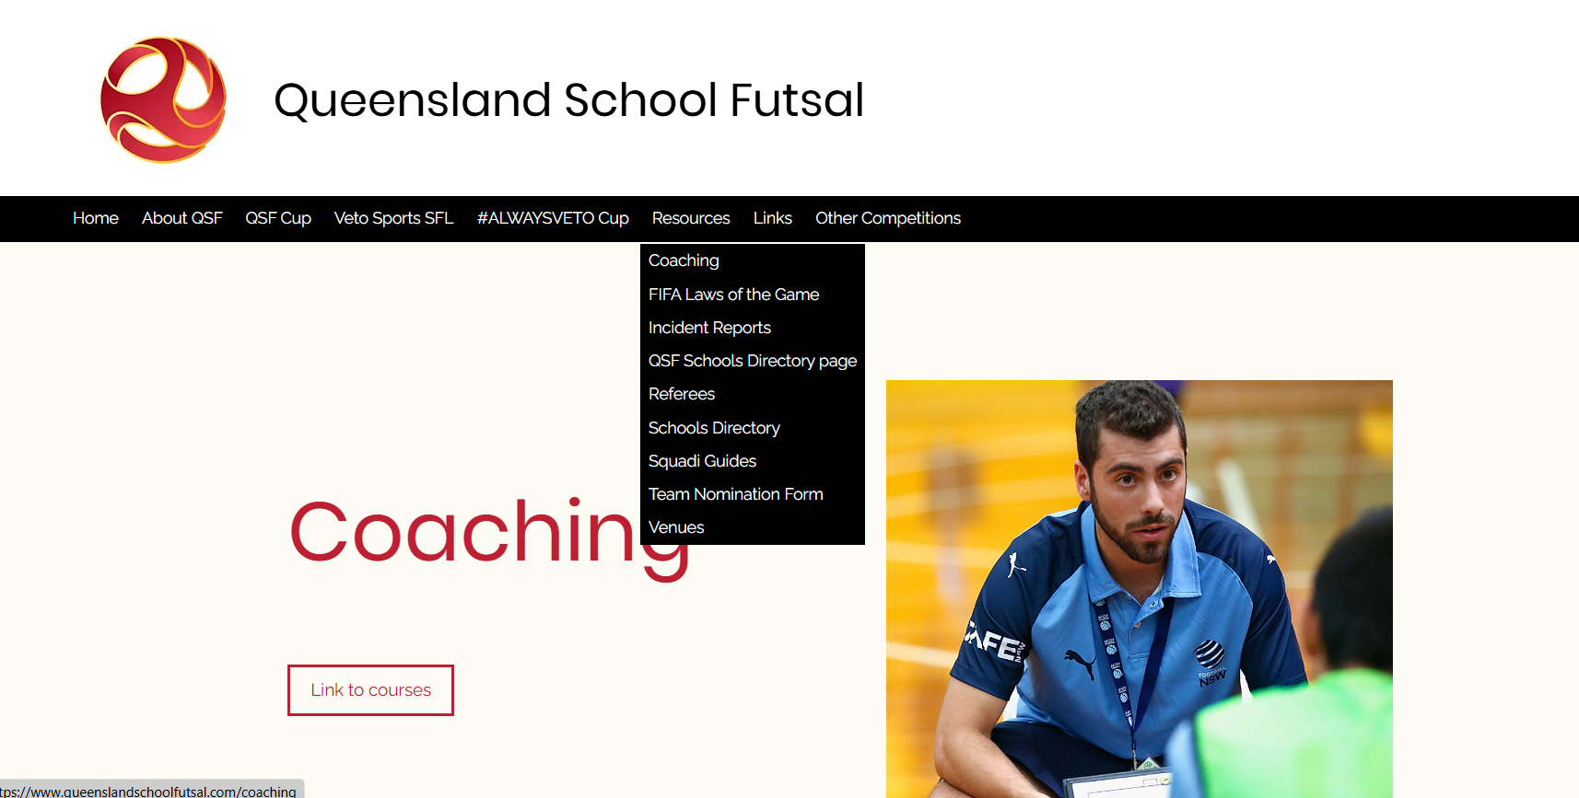

TEAM LISTS
- Schools are to complete the QSF competition team list form with names, birthdates and principals’ signature and be brought to every Gala Day and be handed to the convenors on each Gala Day (admin@queenslandschoolfutsal.com)
- Team lists are available on the QSF Website.
QSF Team Nomination Form | Queensland School Futsal
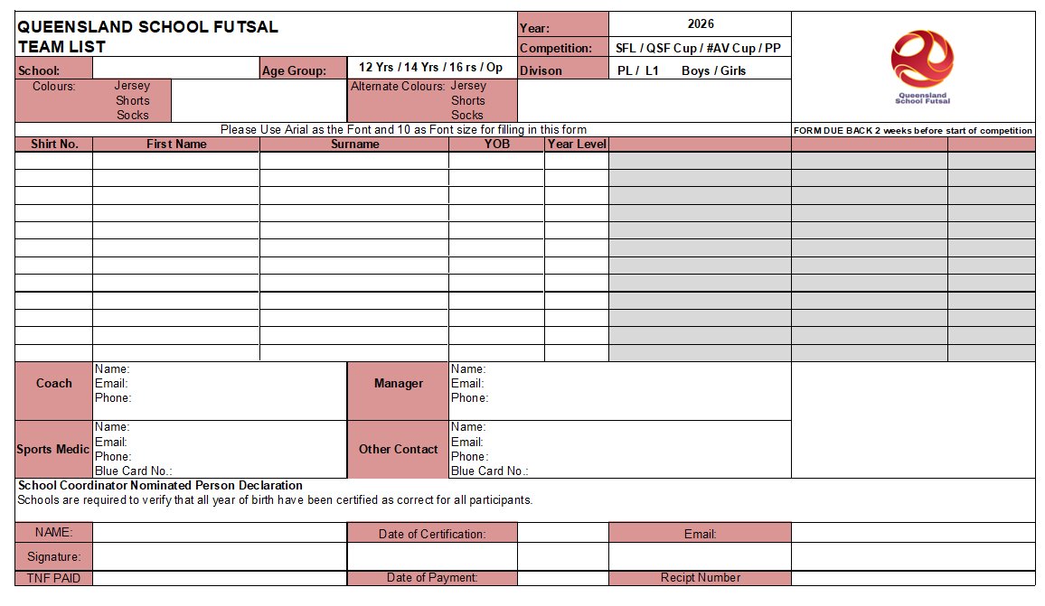

SQUAD LISTS
- It is requested that “School Squad lists” be completed with names, birthdates and photos and sent to the convenors (admin@queenslandschoolfutsal.com) before the beginning of the season.
- Squad lists are available on the QSF Website

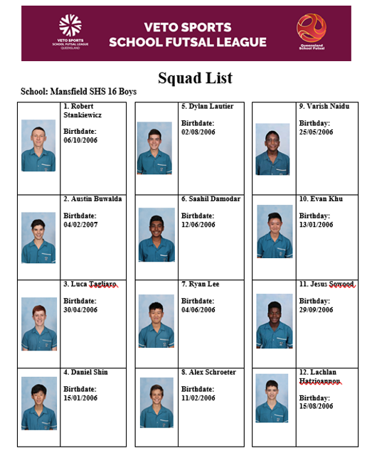

COMMUNICATION
- All Coaches and managers are required to join the QSF WhatsApp group for quick communication purposes before and during the season and will provide updated results, contact points and news

- QSF WhatsApp Group


STAFF

Competition Coordinators Referee Coordinator




Alan Pradella Gervais Morton Fiona Stevenson

Gala Day Convenors

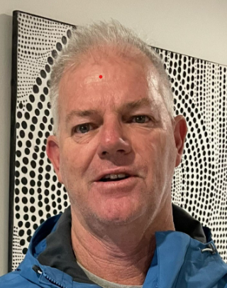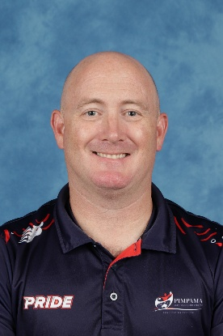
Carl Classen Tony Rapello Michael Brynes Fernando Olivieri

SOCIAL MEDIA
QSF has a Facebook page and Instagram account for results posts, videos and general advertising purposes. We would like everyone to invite school staff, students, parents and friends to follow the pages.
We also encourage coaches and managers to complete the “Player” and “Coach” Profiles and forward them to the QSF Social Media Coordinator – Matt Pickham at mpick68@eq.edu.au

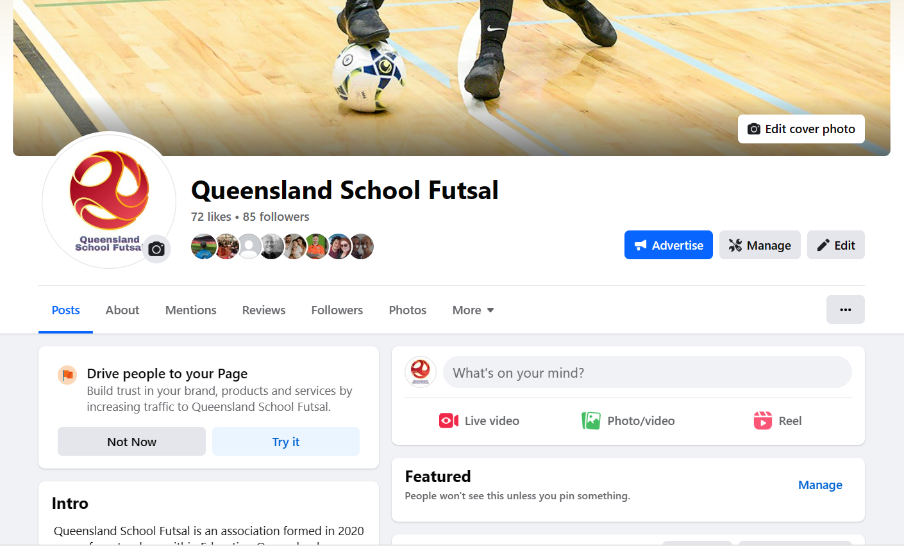



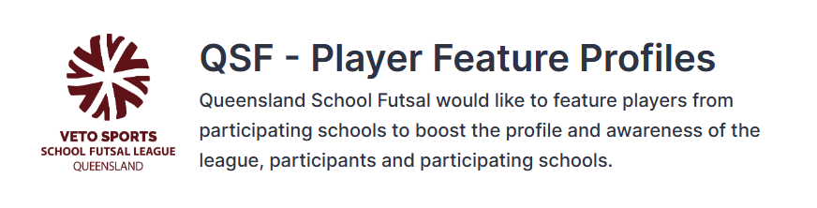
A QSF – Player Feature profile form will be available on the QSF website. Please fill in the questions on behalf of one player who participates in the VETO Sports SFL to be highlighted by QSF on the social media channels. Each school will be featured once throughout the year.
This form must be supplied via email with an image of the feature player – a headshot or action shot. Preferably in portrait version
By submitting this form, you accept that the player and their guardian have given their permission to be featured and for their image to be shared on QSF social media channels and/or the QSF website.

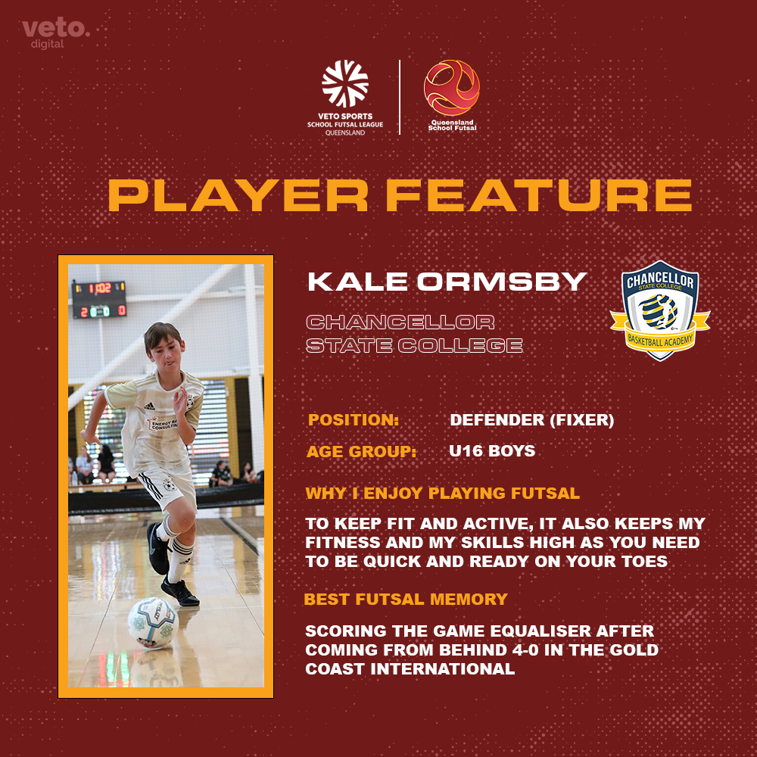

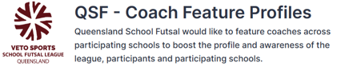
A QSF – Coach Feature profile form will be available on the QSF website. Please fill in the questions on behalf of one teacher or HOD who participates in the VETO Sports SFL to be highlighted by QSF on the social media channels. Each school will be featured once throughout the year.
This form must be supplied via email with an image of the feature player – a headshot or action shot. Preferably in portrait version
By submitting this form, you accept that the player and their guardian have given their permission to be featured and for their image to be shared on QSF social media channels and/or the QSF website.

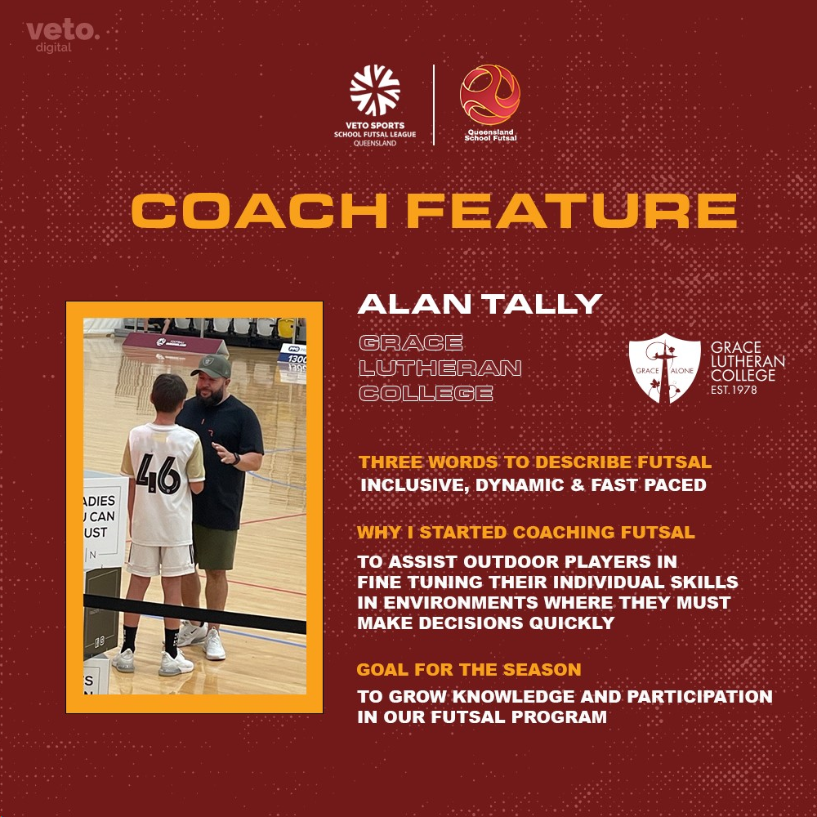

SPONSORS
VETO SPORTS are the official sponsors of the SFL and will supply match balls and official’s polos with SFL logo and School crests. VETO Sports can supply team uniforms and all Futsal related training equipment

Trophies, Medals and Awards
Conference Premiers will receive a Perpetual Premiers trophy.
VETO Sports Champions will receive the VETO Sports Perpetual trophy. Champions, Runners-up and third place getters will receive medals.

VETO Sports Shield and Plate winners will receive the VETO Sports Perpetual trophy. Shield and Plate Champions, Runners-up and third place getters will receive medals

League One Champions will receive a perpetual trophy. Winner and runners up will receive medals.
A Veto $50 voucher will be awarded to the Player of the Grand Final






All schools are provided with 2 FREE polo shirts which include the school logo heat pressed on the polo with the Queensland School Futsal logo.
Additional polo shirts are $30 inc. GST each.
Futsal Kingdom
are proud sponsors of the QSF referees and provide an exclusive and ever-growing library of innovative, game-changing drills designed to elevate your coaching. Their platform also offers modern and relevant articles, presentations, and coaching insights to help you can guide your athletes with clarity and purpose.


All Dates below are Draft dates

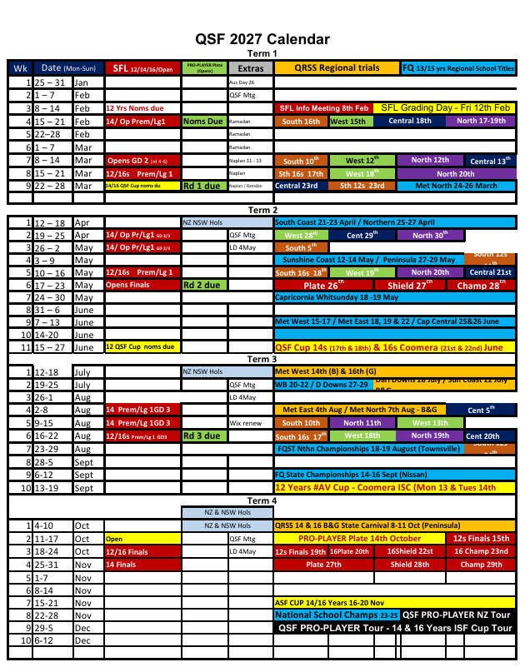

All Dates below are Draft dates

